Once upon a time a crow was perched on a branch, holding a piece of cheese in his beak. A fox looked up and saw him. His tummy rumbled. "Mmm," he thought to himself, "I do love a nice bit of cheese."
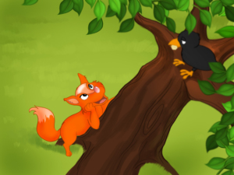
Now the crafty fox, who could smell that delicious cheese, walked up to the tree. He said in a sneaky voice, "Good day to you, Mr Crow! How well you look today. I have never seen such a silky set of feathers! And what a beautiful colour, so luscious and dark. If all the other animals in the wood hadn't said that you have a terrible voice I would have called you the most beautiful and graceful of all the birds in the wood. But it can't be true what they say, I'm sure that your voice must be just as good as your looks! Oh, if only I could hear it…”
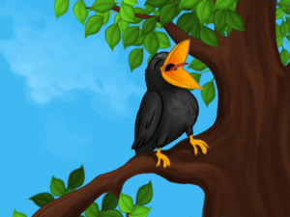
The crow, flattered to hear such kind words, couldn't resist the desire to show off his voice. He opened his beak and at that very moment the cheese fell out.
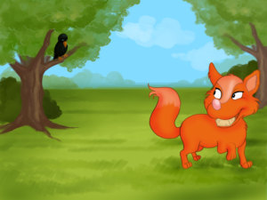
"Thank you," the fox said and quickly grabbed the cheese. "That's just what I wanted. In the future, if somebody flatters you, think hard before you trust them.”

