One day a Fox caught his tail in a trap.
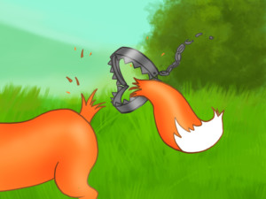
He struggled and struggled to free himself, and was left with just a stump in place of a tail.
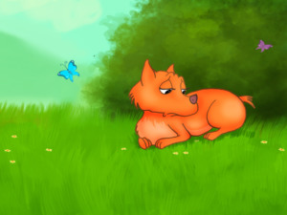
At first he was ashamed to show himself among his fellow foxes.
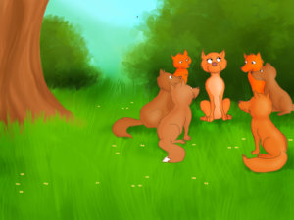
But at last he was determined to put on a brave face. He called all the foxes to a meeting. He had a suggestion to make.
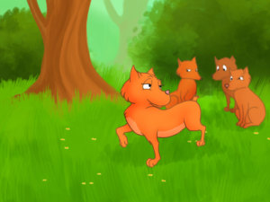
When they had assembled the Fox proposed that they should all cut off their tails. He pointed out how inconvenient a tail was when they were being pursued by dogs; how in the way they were when all you wanted was to sit down and have a friendly conversation with someone. "I can't see any good use for a tail," he said, "they're useless!"
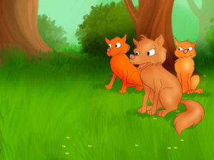
"That's all very well," said one of the older foxes, "but I don't think you would have suggested we cut off the most beautiful part of our bodies if you hadn't gone and lost yours first."

