TEST 16

PART I. LISTENING ( 20 minutes)
Question 1. Listen and number
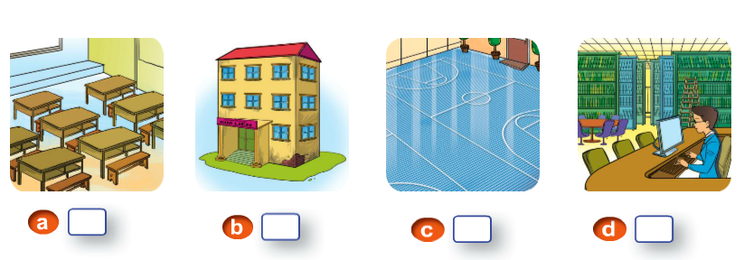
Question 2. Listen and tick.
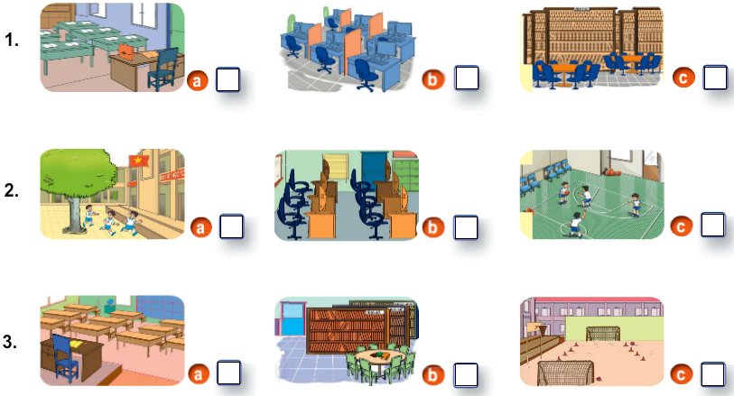
4. 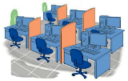 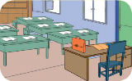 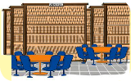

Question 3: Listen and draw the line.
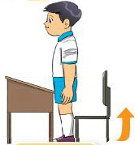
1
2
3
4
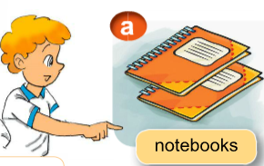
Question 4: Listen and circle.
1.This is…………….  a. a ruler  b. two rubbers | 2. This is……………….  a. my school  b. your school bag
3. What colour……………?  a. is this  b. is that | 4.What ………….?  a. are these  b. are there

Question 5: Listen and complete.
Are | pens | Those | pencil
Nam : Hello, Mr Zomboss. These are my rulers.
Zomboss : (1) they?
Linda : Hi, Mr Zomboss. These are my notebooks.
Zomboss : Really ?
Peter : Hello, Mr Zomboss. These are my (2) .
Zomboss : Wow. Looking good!
Mai : Hello, Mr Zomboss. (3) are my (4) cases.
Zomboss : Great!
PART II: READING AND WRITING (15 minutes)
Question 6: Look and read. Put a tick () or a cross (x) in the box.
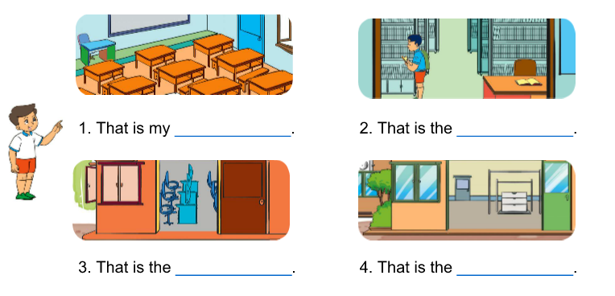

computer room
class room
Music room
gym

Question 7: Read and write the suitable words in the gaps.
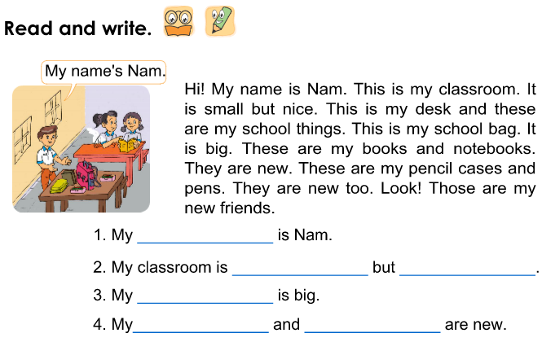

Question 8: Look at pictures. Look at the letters. Write the words.

1. | urebbr | …………....
2. | urelr | ………….... | 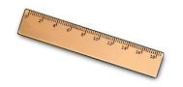
3. | bonetook | …………....
4 . | sobacholg | …………....

Question 9: Label each school thing with a suitable word from the box.
RUBBER | PENCIL SHARPENER | PENCIL CASE | PENCIL

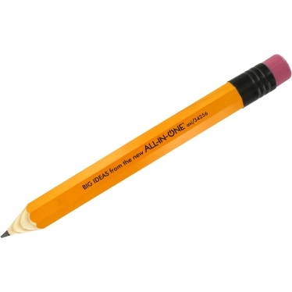
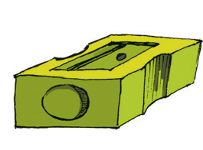
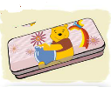

THE END

