Part 1:Listening ( 5 points)
Question 1: Listen and number.
a. b.

c. d.
Question 2: Listen and write T (true) or F (false).
- My birthday is on the seventh of April.
- My birthday is on the sixth of March.
- My birthday is on the fifteenth of January.
- My birthday is on the twentieth of June.
Question 3: Listen and draw the lines.
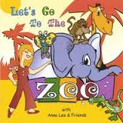
A B C D

1 2 3 4
Question 4: Listen and tick.
1
a b. c.
2. 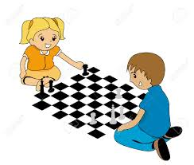
a. b. c.
3. 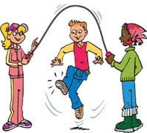 a b. c.
4..
a. b. c.
Question 5: Listen and write.
1. My birthday is on the - - - - - of December.
2. His birthday is on the twenty-first of - - - - -.
3.Her birthday is on the - - - - - - of October.
4.My friend’s birthday is on the thirtieth of - - - - .
Question 6: Look and read. Put a tick V or a cross X in the box.
1. She is England 2. Tony is from Australia
2.
3. He can sing. 4. Today is the fourth of March.
Question 7: Look and read. Choose the best answer.
1. My name’s Linda. I’m from __________ (America / England)
2. I’m Mai. I’m ___________ ( Malaysian / Vietnamese)
3. She can’t __________ ( cook / cooks)
4. My birthday is on the __________ ( fifth / fiveth ) of August.
Question 8: Look at the pictures. Look at the letters. Write the words.
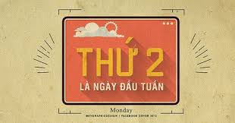
1. nomayd - - - - - - 2. etska - - - - -
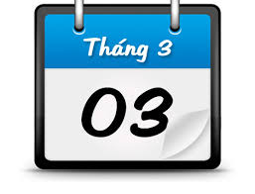
3. andleng - - - - - - - 4. charm - - - - -
Question 9: Choose a word from the box and write it next to numbers from 1-4
Mary’s activities
Monday | Tuesday | Wednesday | Thursday | Friday | Saturday | Sunday
play chess | go to the zoo | listen to music | watch TV | visit my friends | read books | help my parents

1. Today is (1)………………………………… Mary listens to music.
2. Today is (2)………………………………… She visits her friends.
3. Today is (3)………………………………… She goes to the zoo.
4. Today is (4)………………………………… She reads books.
Part 3: Speaking ( 1 point)
Question 10: Answer the questions about Ss’ nationalities/ birthdays / abilities.

------------The end----------

