UNIT 12: ROBOTS

I. Find the word which has a different sound in the part underlined

1. | A. house |  |  |  |  |  |  |  |  | B. shout |  |  |  |  |  |  |  | C. ought
2. | A. noise |  |  |  |  |  |  |  |  | B. soil |  |  |  |  |  |  |  | C. boil
3. | A. could |  |  |  |  |  |  |  |  | B. should |  |  |  |  |  |  |  | C. would
4. | A. told |  |  |  |  |  |  |  |  | B. so |  |  |  |  |  |  |  | C. now
5. | A. noisy |  |  |  |  |  |  |  |  | B. sound |  |  |  |  |  |  |  | C. house
6. | A. laugh |  |  |  |  |  |  |  |  | B. because |  |  |  |  |  |  |  | C. taught
7. | A. what |  |  |  |  |  |  |  |  | B. walk |  |  |  |  |  |  |  | C. water

II. Put the words into two groups (/ / and / /)

- mouse D. doing D. our D. go

D. lesson D. sauce D. wall

 |  | boil | boy | shout | house | around | flower
 |  | down | noisy | toy | voice | south | shout
 |  | round | coin | town | out | cow | how
 |  |  | / / |  |  | / /

III. Find which word does not belong to each group.

1. | A. run | B. can | C. will | D. could
2. | A. hate | B. enjoy | C. like | D. love
3. | A. waste | B. useful | C. helpful | D. careful
4. | A. noisy | B. costly | C. useful | D. expensive
5. | A. activities | B. emotion | C. thinking | D. felling

IV. Give the names of the following, then read the words aloud (the first letter of each word is given).

1. r____________
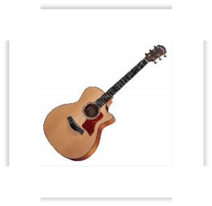

2. c____________

3. f____________
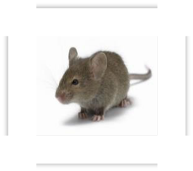

4. c____________
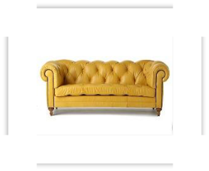

5. g____________

6. f____________

7. m____________

8. c____________

V. Match one word in A with one in B. Then write the phrase in C.

 | A | B |  | C
1. | make | the palace |  | make the bed
2. | guard | a voice
3. | lift | heavy boxes
4. | understand | the dishes
5. | recognize | the bed
6. | do | the lesson

VI. Choose the best answer (A, B, C or D).

1. Robots will be very useful for our lives but they use __________ energy.

A. Very B. Too much C. A little D. Some

- My father always __________ coffee at home instead of going to the coffee shop.

A. Do B. Does C. Make D. Makes

3. Robots will be able to __________ the personal computer in the future.

A. Do B. Replace C. Recognize D. Make

- Nowadays robots can’t talk to people or play sports, but in the future I think they __________.

A. Can B. Could C. Will D. Do

5. Will robots be able __________ our voices?

A. To recognize B. Recognizing C. recognized D. Recognizes

- Robots can’t talk to people or recognize our voices, but scientists are working __________ the solution.

 | A. At | B. On | C. In | D. With
7. | Many people think sending money on robots is a complete __________ of
 | time and money.
 | A. Cut | B. Number | C. Waste | D. Amount
8. | __________ you walk when you were two?
 | A. Can | B. Could | C. Will | D. Do

- These robots can do many things for the __________ such as cleaning streets of watching plants.

A. Common B. Best C. Human D. Public

- Home robots can do things __________ repairing things around the house or looking after the garden.

 | A. Such | B. Like | C. With | D. Of
11. | __________ do you think about the new kinds of robots?
 | A. What | B. How | C. When | D. Why
12. | Our future robots will be able to to help us __________ the gardening.
 | A. Do | B. Make | C. Try | D. Plant
13. | Robots can __________ our houses when we are away.
 | A. See | B. Guard | C. Look at | D. Look
14. | In the future, robots will be able to do more __________ things for us.
 | A. Harder | B. Easy | C. Complicated | D. Much difficult
15. | Do you think robots can work longer than people __________ getting tired?
 | A. But | B. Of | C. With | D. Without

- They will be very useful because they will be able to do __________

everything for us.

A. Most B. Most of C. Almost D. Almost of

- I don’t agree __________ you that robots will be able to write letter to an

English friend.

A. Of B. About C. To D. With

18. We must be careful because some people may use robots __________.

A. Do good things C. Do bad thing

B. To do good things D. To do bad things

- - “Robots are helping us a lot in industry, education, and in our house”. - “__________”

A. I agree with you C. I hope not

B. What about you? D. Do you agree with that?

- - “We waste a lot of money and time researching and making robots”. - “__________”

A. I think not. C. I agree with.

B. I don’t think so. D. I don’t hope so.

VII. Complete the following sentences, using couldn’t and the verbs in the box.

 | listen | find | finish | play
 | understand | sleep | go | hear

- We ___________________ tennis because the weather was bad.

- Tom ___________________ to music because his CD player was broken.

- I was very tired but I __________________.

- My dad ___________________ to work because he was ill.

- I ___________________ Jane because I don’t speak German.

- We ___________________ the teacher because the students were very noisy.

- Phong ___________________ his pen. It wasn’t in his school bag.

- Mai wasn’t hungry. She ___________________ her lunch.

VIII. Write questions using Could.

6. Read / four?

Could you read when you were four?

- Walk / one?

________________________________________________________?

- Ride a bike / ten?

________________________________________________________?

- Speak English / twelve?

________________________________________________________?

10. Count to ten / three?

________________________________________________________?

11. Write your name / two?

________________________________________________________?

IX. Use the phrases given to answer the questions “What could or couldn’t children do

when they were 5 years old?”

1. Stay at home alone.

Children couldn’t stay at home alone.

  - Eat by themselves.

________________________________________________________

  - Write a letter.

________________________________________________________

  - Go to school alone.

________________________________________________________

  - Sing songs.

________________________________________________________

  - Recognize strange people.

________________________________________________________

X. Use the words given and will / won’t be able to to make future abilities.

  - Teaching robots / check your health.
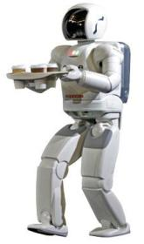

- Computers / do the laundry.

________________________________________________________

- Smart phones / recognize a voice.

________________________________________________________

- Worker robots / play sports.

________________________________________________________

- Home robots / make breakfasts.

________________________________________________________

- Teaching robots / give lessons.

________________________________________________________
