UNIT 11: OUR GREENER WORLD

I. Find the word which has a different sound in the part underlined

1. | A. stand |  |  |  |  |  |  |  | B. apple |  |  |  |  |  | C. hand |  |  |  |  |  | D. father
2. | A. dark |  |  |  |  |  |  |  | B. cancel |  |  |  |  |  | C. action |  |  |  |  |  | D. travel
3. | A. fantastic |  |  |  |  |  |  |  | B. part |  |  |  |  |  | C. fact |  |  |  |  |  | D. camera
4. | A. automatic |  |  |  |  |  |  |  | B. had |  |  |  |  |  | C. activity |  |  |  |  |  | D. yard
5. | A. calm |  |  |  |  |  |  |  | B. bag |  |  |  |  |  | C. cat |  |  |  |  |  | D. bad
6. | A. animal |  |  |  |  |  |  |  | B. card |  |  |  |  |  | C. heart |  |  |  |  |  | D. cart
7. | A. thanks |  |  |  |  |  |  |  | B. cancer |  |  |  |  |  | C. channel |  |  |  |  |  | D. smart
8. | A. land |  |  |  |  |  |  |  | B. start |  |  |  |  |  | C. stand |  |  |  |  |  | D. plastic
9. | A. bag |  |  |  |  |  |  |  | B. that |  |  |  |  |  | C. can |  |  |  |  |  | D. star
10. | A. plant |  |  |  |  |  |  |  | B. hat |  |  |  |  |  | C. far |  |  |  |  |  | D. plan

II. Put the words into two groups (/ a: / and / æ /)

 |  | car | start | map | hand | castle | rapid
 |  | fat | aren’t | park | man | natural | calm
 |  | bag | dark | cat | apple | father | stand
 |  |  | / a: / |  |  | / æ /

III. Find which word does not belong to each group.

1. | A. | bag | B. | metal | C. | glass | D. | plastic
2. | A. | garbage | B. | litter | C. | rubbish | D. | floods
3. | A. reusable | B. recycled | C. repair | D. refillable
4. | A. bin | B. paper | C. bag | D. bottle
5. | A. reuse | B. reduce | C. repeat | D. recycle

IV. Give the names of the following, then read the words aloud (the first letter of each word is given).
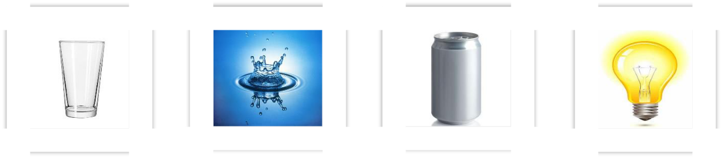

1. g____________ 2. w____________ 3. c____________ 4. b____________
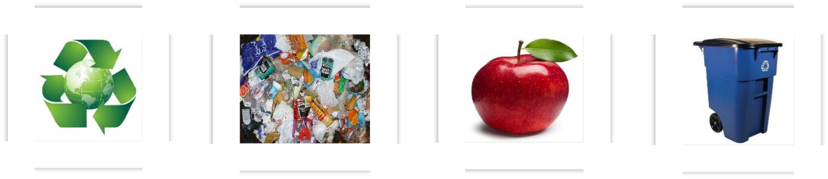

5. r____________

6. r____________

7. a____________

8. r____________

V. Choose the best answer (A, B, C or D).

1. | If we __________ waste paper, we will save a lot of trees.
 | A. Repeat | B. Recycle | C. Rewrite | D. Remark
2. | You can save money while shopping by only buying __________ you need.
 | A. What | B. This | C. It | D. That
3. | What can we do __________ air pollution?
 | A. Reduce | B. To reduce | C. Reducing | D. To reducing
4. | Why do you often forget to __________ the lights when you go out of the
 | classroom?
 | A. Turn on | B. Turn off | C. Close | D. Shut down

- If we plant more trees in the schoolyard, the school will become a

__________ place.

A. Darker B. Greener C. Dirtier D. More polluted

- Do you think we should put a __________ bin in every classroom in order to keep it clean?

A. Reusable B. Recycled C. Recycling D. Recyclable

- My brother and I will give last year’s clothes to __________ instead of

 | throwing them away.
 | A. Shop | B. People | C. Charity | D. Survey
8. | Next week our class is having a discussion about finding __________ ways
 | to reuse old items before throwing them away.
 | A. Interested | B. Surprising | C. Useless | D. Creative
9. | It is a good idea to __________ our clothes with our friends or cousins.
 | A. Change | B. Swap | C. Turn | D. Send

- If people turn off all electric appliances in one hour all over the world, they can save lots of __________.

 | A. Electric | B. Electrical | C. Electrician | D. electricity
11. | You should put the food in a reusable box __________ plastic bags.
 | A. By | B. Instead of | C. Because of | D. Without
12. | If we use __________ paper, we will save a lot of trees.
 | A. Fewer | B. Less | C. More | D. Much

- Don’t throw rubbish into the river because you will make it __________.

A. Greener B. Dirty C. Cleaner D. Fresher

- If there is a rubbish bin in every class, the classroom will become

__________.

 | A. Harmful | B. Lighter | C. Dirtier | D. Cleaner
15. | If we all use__________ bags, we will help the environment.
 | A. New | B. Cheap | C. Reusable | D. Reduced
16. | This newspaper is made of __________ paper.
 | A. Recycle | B. Recycled | C. Old | D. Waste

- Please collect all the recyclable materials, and take them to the __________

factory.

 | A. Recycle | B. Recycled | C. Recyclable | D. Recycling
18. | Reduce, reuse, recycle is said to encourage people to waste less, by using
 | less and using things again, in order to __________ the environment.
 | A. Harm | B. Damage | C. Pollute | D. Protect
19. | These three Rs __________ reduce, reuse and recycle.
 | A. Stand up | B. Stand for | C. Ask for | D. Means
20. | If you have old clothes, will you give them to those __________?
 | A. Needs | B. To need | C. For needing | D. In need

VI. Complete the sentences with the correct form of the verb.

- We (do) _______________________ this for you if you want.

- If we (need) _______________________ some help, we will ask.

- If Peter stays with his grandparents, Susan (not be) ______________________

happy.

- If we win the money, we (buy) _______________________ a new house.

- She (not write) _______________________ to you if she leaves.

- We (go) _______________________ on holiday if there is time.

VII. Match the phrases to form a sentence in the first conditional, and write the answer in each blank.

 |  |  | A |  |  |  |  | B
1. | If we leave now |  |  |  |  |  |  | a. it’ll bite you.
2. | If I give you some money |  |  |  |  |  |  | b. I’m sure she’ll say “yes”.
3. | If you wear that shirt |  |  |  |  |  |  | c. we’ll go to the beach.
4. | If you invite her to the cinema |  |  |  |  |  |  | d. will you buy some chocolate for me?
5. | If he drives that car fast |  |  |  |  |  |  | e. you’ll look really good.
6. | If I phone you at nine |  |  |  |  |  |  | f. we’ll be home by ten.
7. | If it’s hot tomorrow |  |  |  |  |  |  | g. he’ll have an accident.
8. | If you touch that dog |  |  |  |  |  |  | h. will you be at home?
 |  |  |  | 2.______ |  | 3. ______ 4. ______ 5. ______
 |  |  | 1. ______
 | 6. ______ |  |  | 7. ______ |  | 8. ______

VIII. Choose the correct word.

- If we miss/ will miss the bus, we take/ will take the taxi.

- I come/ will come over to your house if you rent/ will rent a DVD.

- They see/ will see the new Lara Croft film if they go/ will go to the cinema.

- She goes/ will go to the party if you invite/ will invite her.

- You are/ will be on time if you run/ will run.

- If he doesn’t stop/ won’t stop smoking, he has/ will have problems later.

- If you help/ will help me, I lend / will lend you that Beyonce’ CD.

- If you don’t eat/ won’t eat fruit, you get/ will get a cold.

IX. Match the column A with column B to complete the sentences.

 |  |  | A |  |  |  |  | B
1. | If the soil is polluted |  |  |  |  |  |  | a. We will save our money.
2. | If people use more car |  |  |  |  |  |  | b. We will have more oxygen to
3. | If we plant more trees |  |  |  |  |  |  | breathe.
4. | If we borrow books from the library |  |  |  |  |  |  | c. The plants will die.
 | instead of buying |  |  |  |  |  |  | d. They will make the air more
5. | If we have a shower instead of a |  |  |  |  |  |  | polluted.
 | bath |  |  |  |  |  |  | e. We will save a lot of water.
 |  |  |  |  |  | 3. ______ 4. ______ 5. ______
 |  |  | 1. ______ | 2.______

X. Write the conditional sentences from the following statements.

1. We will plant more trees. The air will be fresher.

If __________________________________________________________

2. We will use fewer cars. We will reduce pollution.

If __________________________________________________________

3. We will cycle to school every day. We will keep fitter.

If __________________________________________________________

4. We will use recycled products. We will save money.

If __________________________________________________________

- People will throw rubbish into the right bin. They will keep the environment clean.

If __________________________________________________________

- We will turn off the tap when brushing the teeth. We will save a lot of water. If __________________________________________________________

- People will travel more by public transport. The harmful gases in big cities will be reduced.

If __________________________________________________________

- We will start at six. We will arrive there before noon.

If __________________________________________________________

9. The boy eats so may green apples. He will be ill.

If __________________________________________________________

10. We will use reusable bags for shopping. We will reduce waste.

If __________________________________________________________

