I. Choose the correct word for the picture ( 20 p ) :
 | A | B | C | D
1 | scientist | doctor | dentist | engineer | 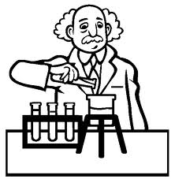
2 | drum | cymbal | plate | circle
3 | museum | cinema | stage | play | 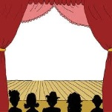
4 | ship | box | alien | spaceship | 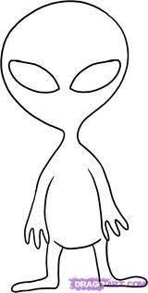
5 | leaf | vegetable | cabbage | flower
6 | torch | candle | tree | fire | 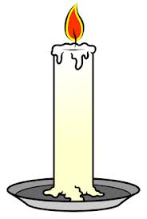
7 | mango | orange | oval | banana | 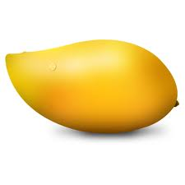
8 | see | watch | hole | circle | 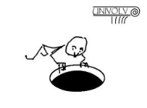
9 | tennis | football | basketball | volleyball | 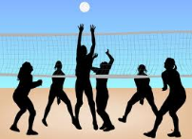
10 | hill | soil | rock | mountain | 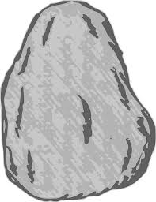
11 | skeleton | bone | people | man | 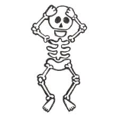
12 | lights | traffic lights | yellow | red | 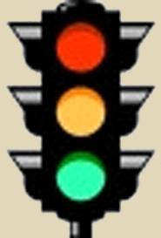
13 | play football | through a ball | boy | kick a ball | 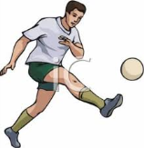
14 | table | stool | chair | wood | 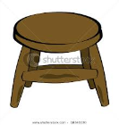
15 | roundabout | streets | cars | roads | 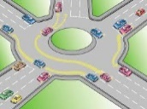
16 | light | soft | cheap | expensive | 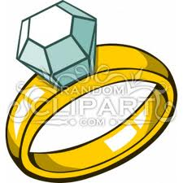
17 | water | trees | beach | coconut
18 | pagoda | citadel | tomb | temple | 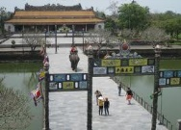
19 | tree | pen | feather | leaf
20 | grape | strawberry | heart | tomato
II. Odd one out ( 25p )
 | A | B | C | D
1 | Coat | Scarf | Gloves | Shorts
2 | Trousers | Shirt | Shorts | Jeans
3 | Pen | Paper | Chair | Rubber
4 | Window | Table | Wall | Floor
5 | Paper | Chair | Desk | Table
6 | Cow | Horse | Chicken | Frog
7 | Bedroom | Classroom | Kitchen | Living room
8 | Spoon | Disk | Knife | Fork
9 | Cake | Potato | Cookie | Apple pie
10 | Grill | Roast | Cut | Fry
11 | America | UK | German | Australia
12 | Tea | Coffee | Coke | Cake
13 | Table | Hand | Door | Window
14 | Man | Brother | Dad | Girl
15 | Beef | Pork | Apple | Chicken
16 | Cheese | Fish | Yogurt | Milk
17 | Pizza | Taco | Pasta | Spaghetti
18 | Apple | Cucumber | Pear | Peach
19 | Lobster | Fish | Hamburger | Tuna
20 | Table | Chair | Fridge | Stool
21 | Danced | Invited | Stopped | Cooked
22 | Pens | Hats | Maps | Books
23 | Far | Car | Star | War
24 | Put | But | Shut | Cut
25 | Low | Slow | Know | Now

III. Chose the correct answer : ( 25p )
1.Bangkok is ......................capital of Thailand.
 |  | A. a |  | B. one | C. the D. X
2.I am ...................... in the story
 |  | A.very interested |  | B. interested very much | C. much interesting D. like
3. ......................time will they spend in Hue ?
 |  | A. How much |  | B. How many | C. How long D. How often
4.There are ...................... any girls in our class.
 |  | A.no |  | B. not | C. none D. X
5.This orange tastes ...................... .
 |  | A. sweetly |  | B. sweety | C. sweet D. salty
6.I have had a headache ...................... yesterday.
 |  | A. for |  | B. since | C. until D. at
7.My mother ...................... me to get up early.
 |  | A. says |  | B. tells | C. speaks D. tell
8.My mother ...................... I should get up early.
 |  | A. says |  | B. tells | C. speak D. asks
9.My watch is slow and ...................... is my sister's
 |  | A. either |  | B. too | C.so D. neither
10. ...................... without milk is yours.
 |  | A. The coffee |  | B. Coffee | C. A coffee D. X
11.Susan's watch ...................... 12: 25
 |  | A. says |  | B. tells | C. speaks D. asks
12.The radio is ...................... loud. I can't bear the noise.
 |  | A. too many |  | B. too much | C. much too D. many too
13.The weather is ...................... today than yesterday.
 |  | A. much better |  | B. very better | C. too better D. better much
14.On ...................... we went out.
 |  | A. Tuesday night |  | B. night of Tuesday | C. Tuesday 's night D. night
15.I 'd like a ...................... .
 |  | A. cup of tea |  | B. tea cup | C. tea's cup D. cup’s tea
16.My ...................... is broken.
 |  | A. cup of tea |  | B. tea cup | C. tea's cup D. cup’s tea
17.People usually ...................... early for the show.
 |  | A. arrive |  | B. arrives | C. arriving D. arrived
18. ......................any of your brothers here ?
 |  | A.Is |  | B. Are | C. Be D. Do
19. $ 2000 ...................... very much.
 |  | A. is |  | B. are | C.be D. was
20.Somebody left ...................... school bag on my table.
 |  | A. her |  | B. their | C. theirs D. his
21.Everyone had ...................... at the picnic.
 |  | A. good time |  | B. a good time | C.good times D. a time good
22.We have to wait ...................... tomorrow.
 |  | A. while |  | B. until | C. before D. on
23.His father has not seen him ...................... five years.
 |  | A. for |  | B. since | C. during D. last
24.We buy ......................
 |  | A.many furnitures |  | B. some furniture | C. a furniture D. funitures
25.She ate two large......................
 |  | A. bowls of soups |  | B. bowls of soup | C. bowl of soups D. bowls soup

IV. Put the words in the right order to make questions: ( 20p )
1.  2.  3.  4.  5.  6.  7.  8.  9.  10.  11.  12.  13.  14.  15.  16.  17.  18.  19.  20. | grammar / a / confusing / find / sometimes / bit / English / I .  to / yet / parents / written / they / have / their / ?  passed / my / happy / was / exam / I / the / mother / when / very /  off / had / station / to / next / get / the / we / at  breakfast / what / have / for / you / usually / do / ?  go / rain forest / to / a / like / you / to / would /? /  volcano / at / tomorrow / is / a / to / she / look / going / .  children / likes / smile / teacher / making / the /  of / contains / because / good / milk / lots / it / calcium / is  are / ones / yellow / than / the / beautiful / less / the / flowers / red/  family / Who / youngest / in / is / person / the / your / ? /  team / your / what / least / is / football / favourite / ? /  four / could / was / he / when / play / soccer / he / ?  at / last / you / what / were / doing / night / 7p.m / ?  bicycle / Japan / made / this / was / in / ?  should / when / you / not / to / you / go / have / cold / school / a / bad/.  the / office / the / railway / is / on / left / opposite/ post/ station/ the/ .  you / thank / birthday / very / for / much / present / your/ /  learn / the / we / computer / to / during / informatics / use / how / lesson / . /  high / the / is / how / building / highest/ the / world / in / ? /
V. Fill in the blank with a suitable word ( 10 p )
Bears
The bear can ……………… a dangerous animal. The adult bear is very strong and it can kill a person. Bears are good at ………………. trees and they can run very fast. But they can not see well and …………. most animals, they find food by using …………………. noses.
There are seven …………. of bear. The …………. is the white polar bear, which is almost three meters tall. There are two kinds of black bear . . ………………… lives in the forest of North America, and the other lives in South – East Asia. But not ………………. black bears are black. They may be dark brown or a reddish brown. Everyone loves the black and white panda bear, which comes from China. Not ……………. pandas live in the forest today because …………….. is difficult to find food.

