PHIẾU KIỂM TRA HỌC KÌ I
Năm học 2017 - 2018
Môn: Tiếng Anh Lớp 4
Thời gian làm bài: 35 phút

Họ và tên: .................................. Lớp: 4............ Trường: ......................................

Part I. Listening (2,5 points)
I.Listen and tick

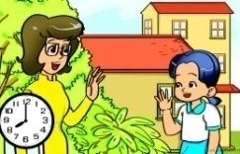
1.
c
b
a

2.
c
a
b

3.
b
c
a

II.Listen and number

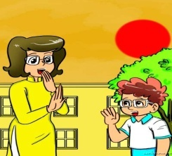

d
c
b
a

Part II. Reading and Writing (5 points)
I.Find the word having the different sound in the undreline word
1. A. doll B.dog C. on D. to
2.A.theatre B.there C.three D.think
3.A.play B.stay C.say D.park
4. family B.far C.father D.garden
II. Choose the best answer A,B,C or D
1. Where is Mai from? - She is from ……......................….......
A. England B. Singapore C. America D. Vietnam
2. June, July, August, ……......................….......
A. November B. December C. September D. October
3. ……......................…...... subjects do you have on Thursday?
A. When B. Why C. Where D. What
4. Mary ……......................…....... like singing.
A. do B. can C. doen’t D. can’t
III.Read and match
1.What can you do? a. It's on the seventh of December.
2.When's your birthday? b. I can ride a bike.
IV.Read and write
This is my new friend. His name is Jack. He is nine years old. He is from Australia. He is a pupil at Hoang Hoa Tham Primary School. He likes music very much. He can play the piano and play badminton. He goes to the Music Club on Saturdays.
1.Where is Jack from?
=>………………………………………………………………………………………………………………………………………………………..
2. Does he go to the Music Club on Saturdays?
=>………………………………………………………………………………………………………………………………………………………..
3.What can he do?
=>………………………………………………………………………………………………………………………………………………………..
V: Order the words to make sentences
1. Subject / do / have / you / What / today?/
……………………………………………………………………………………………………………………………………
2. at/ the weekend/ what/ do/ they/ do/?/
……………………………………………………………………………………………………………………………………
3. can’t / I / football. / play
……………………………………………………………………………………………………………………………………
4. She/ up/ gets/ often/ early/ morning/ in/ the.
…………………………………………………………………………………………………………………………………
Part III. Speaking (2,5 points)
I. Tell some thing about yourself ( name, old, your school, class, hobby, …… )
II. Discribing your pig.

