 | KÌ THI CHỌN HSG
ĐỀ 40 | MÔN: TIẾNG ANH

Thời gian làm bài 120 phút không kể thời gian giao đề

Unit 11: TRAVELLING IN THE FUTURE

I. Choose the word having the underlined part pronouced differently in each line.

1. | A. space | B. pack | C. safe | D. make
2. | A. look | B. scooter | C. moon | D. food
3. | A. button | B. funny | C. success | D. function
4. | A. mean | B. pleasant | C. easy | D. heat
5. | A. popular | B. flop | C. hover | D. programme
II. Choose the word in each line has a different stress pattern.
1. | A. believe | B. avoid | C. prefer | D. happen
2. | A. expensive | B. wonderland | C. favourite | D. driverless
3. | A. system | B. transport | C. future | D. traffic
4. | A. appearance | B. pollution | C. personal | D. opinion
5. | A. teleporter | B. available | C. environment | D. electrical

III. Put the words in the box under the appropriate pictures.

balloon

airship
flying

rocket
car

space
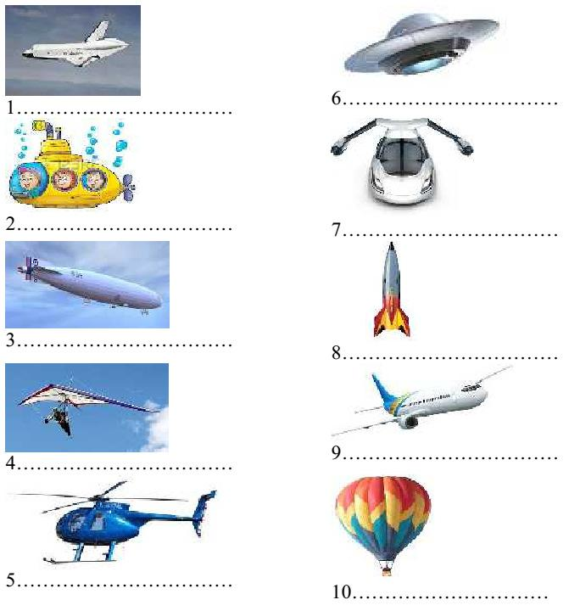

submarine glider shuttle airplane
ufo

helicopter

IV. Give the correct form of the words given to complete the sentence.

1. Tom rode his bike ……………and had an accident. |  | CARE
2. We couldn’t see airplane because it ……………behind the cloud. |  | APPEAR
3. We are talking about the real ……………of flying cars |  | EXIST
4. | I don’t think it will come true soon; however, your idea is really ……………
 |  | IMAGINE
5. | Thomas Edison is one of the greatest …………… in history. | INVENT
6. | The hover scooter is our new …………… It can foat above the ground and travel at
50 kph. |  | CREAT

I like travelling by motorbike, but it is …………… in bad weather. PLEASE

SSS is a sky ……………system; it’ll stop everyone from crashing. SAFE

9. Bob feels ver tired after two continuous nights of …………… SLEEP

10.Many streets will be ……………at the beginning of next year. WIDE

V. Look at the pictures and use the words given to write the sentences with possessive pronouns.

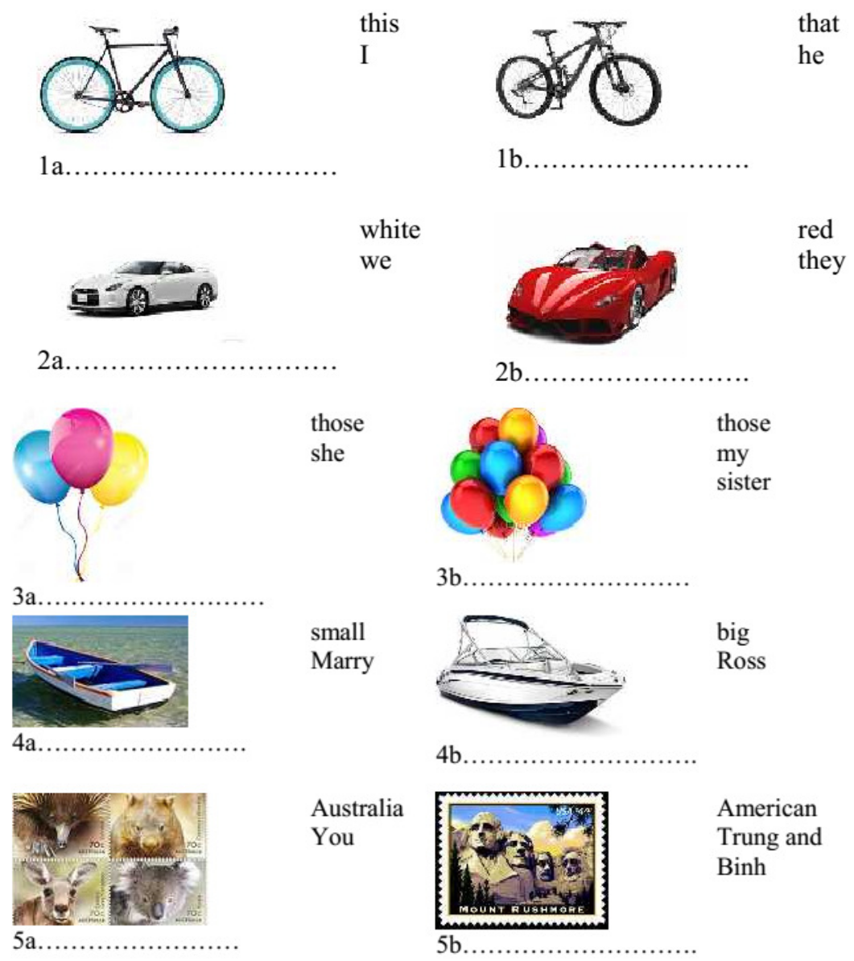

VI. Look at the pictures and use the words given to write sentences with will ( ) or won’t ( ).
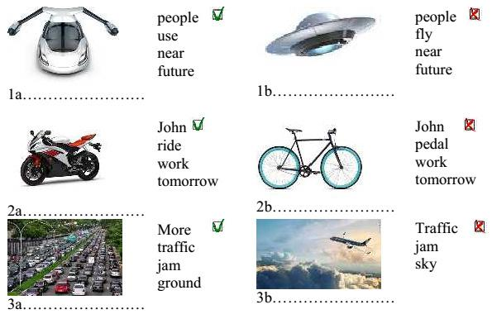

VII. Choose the correct answer A, B, C or D to finish the sentences.

1. You can use a jet pack to ……………anywhere easily.

A. drive B. sail C. ride D. fly

The driver pulls the handle of the Segway to go back or ……………it to go forward.

A. pushes B. brakes C. circles D. turns

A ……………makes you disappear and then you reappear in another place seconds later.

A. scooter |  | B. monowheel | C. teleporter | D. spaceship
4. | The cars which are generated by solar energy are called ……………cars.
A. solar-wasted |  | B. solar-powerd | C.solar-friendly | D. solar-daily
5. | The driver sits inside the wheel of the monowheel and …………to go forward.
A. pedals |  | B. floats | C. presses | D. hovers
6. | An aircraft without a human pilot abroad is called a ……………aircraft.
A. pilotless |  | B. single-pilot | C. double-piloted | D. three-piloted
7. | The black hover scooter is Tom’s; …………is red.
A. I |  | B. me | C. my | D. mine
8. This is ……………smart vehicle; ……………is over there.
A. her-our |  | B. her-ours | C. hers-ours | D. hers-our
9. | I think means of transport in the future ……………petrol.
A. aren’t using |  |  | C. won’t use
B. aren’t going to use |  |  | D. won’t be using
10.At this time next month, we ……………the new flying boat.
A. are testing |  | B. are going to test C. will test |  | D. will be testing

VIII. Fill each numbered blank with a suitable word to finish the passage. Non-stop MTR System (The Train That Never Stops)

The developer of the Non-stop MTR System believes that (1)……………..greatest

inefficiencies when it comes to train travel is the (2)…………….. that trains have to

stop to (3) ……………..people up. The “train that never stops” has pods (4)

……………. the roof that passengers can enter or (5)…………….. At each stop, the

pod with the people disembarking is (6)……………..at the station, while the pod on

the platform filled with waiting (7)……………..is picked up, all without the train having

to stop.

These non-stop trains would (8) …………….. time, as those minutes spent waiting at

each station have a habit of adding up to hours at the (9)……………..of the day and

they would save energy. Te constand acceleration and deceleration that trains go through each time they stop at a station requires a huge (10)……………..of power.

IX. Read the following passage and answer the questions below.

How does a rocket get to outer space?

A rocket uses fuel to make power for the engine. The fuel is set on fire inside the rocket. As the fuel burns, it creats gases that have great pressure. These gases are blasted out of the rocket engines.

These gases all go out the bottom of the rocket engine where it is open. They come out so fast and with so much power that the rocket is pushed up. It is pushed up so hard that the rocket overcomes the force of gravity, which tries to keep everything on the ground. The force that pushes up against the front of the rocket is called thrust.

Unlike an airplane, a rocket does not use wings to help it fly. It just uses the power and force created by the burning fuel to make enough thrust.

Where is the fuel set on fire?

………………………………………………………………………………..

How do the gases come out to make the rocket be pushed up?

………………………………………………………………………………..

What does the force of gravity try to do?

………………………………………………………………………………..

What is thrust?

………………………………………………………………………………..

What does an airplane use to help it fly?

………………………………………………………………………………..

X. Find a mistake in the four underlined parts of each sentence and correct it.

My jet pack is on the ground and her is on the table.

A B C D

2. I think more people will be using skycycling tubes in the future.

A B C D

This is Mr. and Mrs. Evers’ house and those are theirs children.

A B C D

4. My brother will pedal his monowheel to work at this time next week.

A B C D

Will we travelling in driverless and high-speed cars in the future?

A B C D

XI. Complete the second sentence so that it has similar meaning to the first sentence.

1. These are our pictures.

=>These pictures…………………………………………………………….

2. It is Julia’s thirteenth birthday next Friday.

=> Julia ………………………………………………………………………

3. Is your motorbike black, Peter?

=> Is the ……………………………………………………………………..

4. That is not his invention.

=> That invention …………………………………………………………….

5. They predict a 10% car price increase.

=> They predict that ………………………………………………………….

XII. Use the words given to write a passage about solar-powered cars. Solar-powered cars

General description:

Cars/ power/ solar energy/ call/ solar-powered cars/ solar cars

Have/ many/ similarity/ regular car//

Have / motor/ steering wheel/ seats/ brakes/…….

Use/ solar cells/ surface/ produce/ electricity/ make/ motor / turn/ turns/ wheel

Advantages

Unlike/ regular car/ able / utilize/ full power/ any speed

Not/ require/ expense/ run

Quite / not make/ pollution Disadvantages

Not/ have/ speed/ power/ regular cars

Only operate/ limited/ distances/ if / no sun/ very little/ sun light

Expensive/ (good car/ cost > or =$200,000)

Conclusion

Why solar car not popular?

…………………………………………………………………………………………………...

…………………………………………………………………………………………………...

…………………………………………………………………………………………………...

…………………………………………………………………………………………………...

…………………………………………………………………………………………………...

…………………………………………………………………………………………………...

…………………………………………………………………………………………………...

…………………………………………………………………………………………………...

…………………………………………………………………………………………………...

…………………………………………………………………………………………………...

…………………………………………………………………………………………………...

