WEEK 35- Period: 137
Date of planning: 06/05
Date of teaching: 4a1, 4a2(08/05), 4a3, 4a4(09/05), 4a5(10/05)

The final term test(review)
Reading
Read and do the tasks
Hi, my name is Hoa. There are four people in my family: my parents, my brother and me. My father is a doctor. He is forty-four. My mother is a teacher. She is forty-two. She is shorter than my father. Nam is my brother. He is fifteen years old. He is slimmer than me. He and I are students. I am nine. I am big and short. We are a happy family.
I. Tick Yes or No Yes No

1. There are four members in Hoa’s family.
2. Hoa’s father is taller than Hoa’s mother.
3. Her mother is a doctor.
4. Hoa is a student.
II. Read the passage again and answer the questions:
1. What does Hoa’s brother do?
He is a student.
2. Who is bigger, Hoa or her brother?
_______________________________________________________________.
3. How old is Hoa?
_______________________________________________________________.
4. What does Hoa look like?
_______________________________________________________________.
Writing
I. Look at the picture and the letters. Write the words as example:
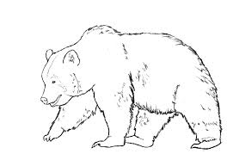
1. m i l k 2. d _ _ tor 3. r _ c _ 4. b _ _ r
II. Complete sentences
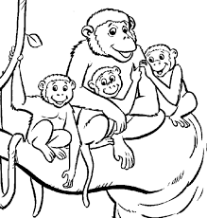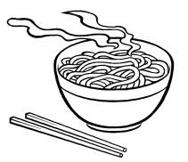
1. A: What animal do you like? 2. A: Would you like some n___________?
B: I want to see monkeys. B: Yes, please.
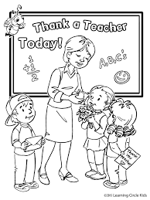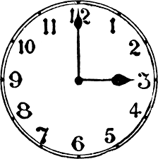
3. A: When is T__________’ Day? 4. A: What t___________ is it?
B: It’s on the twentieth of November. B: It’s three o’clock.
WEEK 35- Period: 138
Date of planning: 06/05
Date of teaching: 4a1, 4a2(08/05), 4a3, 4a4(09/05), 4a5(11/05)

The final term test
Bài kiểm tra kèm theo

WEEK 35- Period: 139
Date of planning: 06/05
Date of teaching: 4a1, 4a2,4a3, 4a4(10/05), 4a5(11/05)

Tổng kết năm học

I . Objectives
- By the end of this lesson, students will know how they do their test and through their test , they have to study hard if the marks are not good.
II. Language contents
III. Techniques:
IV. Teaching aids :
V. Procedures
Give some comments for the test the Ss do
Give the answers for the test:
PART 1: LISTENING
Question 1 : Listen and number(1m)

1. C 2. A 3. D 4B
Question 2: Listen and circle (1m)
1. B 2. A 3. B 4C
Question 4: Listen and write (1m)
1. FISH 2. ORANGE JUICE 3. CHICKEN/ ORANGE JUICE
PART 2: READING AND WRITING(5ms)
Question 5: Look and read. Write T(True) or F (False)(1m)
1, F 2, T 3, F 4. T
Question 6: Look and read. Choose the words to fill in the blanks. (1m)
2, family 3, drinking 4, orange juice 5, seven
Question 7: Look at the pictures and the letters. Choose the correct words (1pt)
1a 2c 3c 4b
Question 8: Order the words to make sentences(2 ms)
- Would you like some bread?
- Why do you want to go to the zoo ?
- They want to buy something .
- What time do you get up ?
- Tom can’t go to the supermarket because he has to do his homework
- She often gets up early in the morning.
7. What day is today it?
8. What animal do you want to see?

WEEK 35- Period: 140
Date of planning: 06/05
Date of teaching: 4a1, 4a2,4a3, 4a4, 4a5(12/05)

Tổng kết năm học (tt)

I . Objectives
- By the end of this lesson, students will know how they learn English in grade 4.
II. Language contents
III. Techniques:
IV. Teaching aids :
V. Procedures
There are 4 skills they learned at Tieng Anh 4: listening, reading, writing and speaking.
There are 10 units in each term, Ss knew about school things, colours, family, house, pets, weather, numbers, location in Viet Nam....
Through the final test, I have the results:
- 37 % students have best marks.
- 39,6% students have rather good marks.
- 23,4% students have average marks.
All of students are smart, hard-working, obedient. But some students are sometimes lazy, and they sometimes forget their homework.
Hoping students will study hard in next year.

