|  |  |
| --- | --- |
| **Tan Hung Primary School**  **Class: 4/** ….  **Full name**: …………………………………… | **TERM TEST I/**  **School2015- 2016**  **Subject: English 4**  *Time: 40 minutes* |

|  |  |  |  |  |  |  |  |  |  |  |  |
| --- | --- | --- | --- | --- | --- | --- | --- | --- | --- | --- | --- |
| ***Marks:*** | ***Listening*** | | | | | ***Reading and Writing*** | | | | ***Speaking*** | ***Total*** |
| ***Q.1*** | ***Q.2*** | ***Q.3*** | ***Q.4*** | ***Q.5*** | ***Q.6*** | ***Q.7*** | ***Q.8*** | ***Q.9*** | ***Q.10*** |
|  |  |  |  |  |  |  |  |  |  |  |
| **Remarks** |  | | | | | | | | | | |

**Part I/ Listening (20 *minutes)***

***Question 1.Listen and tick (1pt)***

***1.***

***a.  b.  c.*  

***2.***

***a. . b.  c. ***

***3.***

***a.  b.  c. ***



***Question 2.Listen and number (1pt)***

***a. b. ***





***c.*  *d. ***





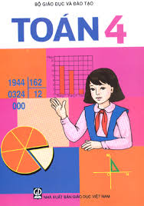***Question 3: Listen and match (1 pt)***

a.

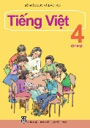 ***One***

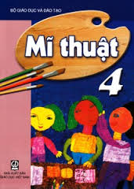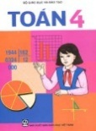

***Two***

c.

b.

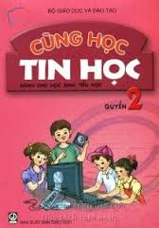***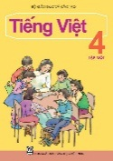 Three***

e.

***Four*** 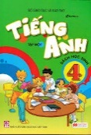

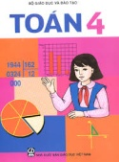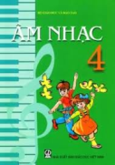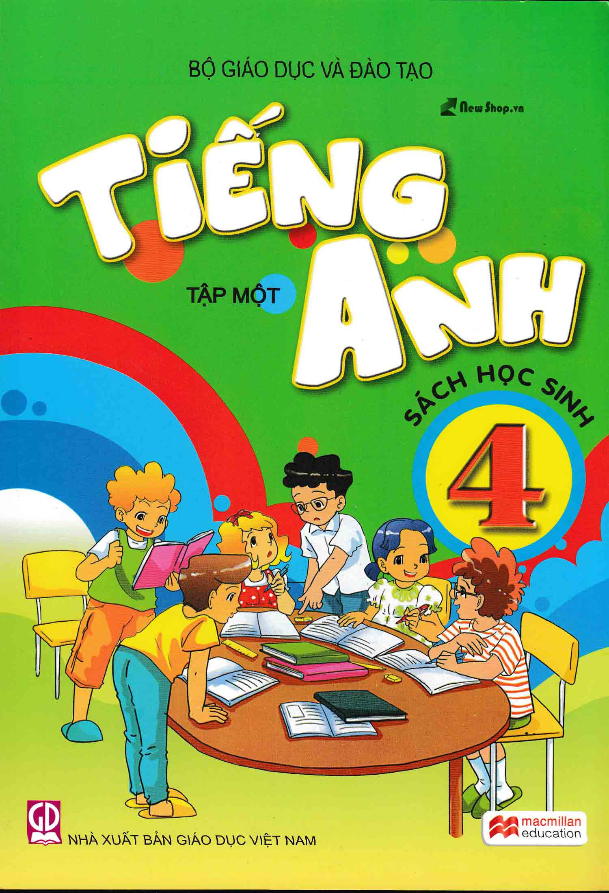

d.

***Five***

***Question 4 : Listen and circle. (1 pt)***

***1. a. I’m very well. b. I’m fine. c. I’m well.***

***2. a. English b. Japanese c. Vietnamese***

***3. a. Monday b. Tuesday c. Sunday***

***4. a. Nguyen Trai Street b. Nguyen Hue Street c. Nguyen Du Street***

***5. a. reading b. swimming c. cooking***

***Question 5: Listen and complete (1pt)***

***Peter: What (1) ___ is it today, Tom?***

***Tom: It’s Monday***

***Peter: Do you have (2) ________ today?***

***Tom: Yes, I do.***

***Peter: What (3) ________ do you have today?***

***Tom: I have Vietnamese, Maths and (4) ________.***

***Peter: Oh, we’re (5) ________ for school!***

***Tom: Let’s run***

**Part II/ Reading and Writing (15 *minutes)***

***Question 6 : Read and complete (1pt)***

***My name is Nga. I go to school from Monday to Friday. I have Vietnamese and Maths every day. I have English on Mondays, Tuesdays, Thursdays and Fridays. On Wednesdays and Thursdays, I have Science. I have PE on Mondays and Wednesdays. I have Music on Tuesdays and Art on Friday.***

***Timetable***

|  |  |  |  |  |
| --- | --- | --- | --- | --- |
| ***Monday*** | ***Tuesday*** | ***Wednesday*** | ***Thursday*** | ***Friday*** |
|  |  | ***Vietnamese*** | ***Vietnamese*** |  |
| ***Maths*** | ***Maths*** |  |  | ***Maths*** |
| ***English*** |  | ***Science*** | ***English*** |  |
|  | ***Music*** |  |  | ***English*** |

***Question 8: Look at the pictures and the letters. Write the right words (1 pt)***

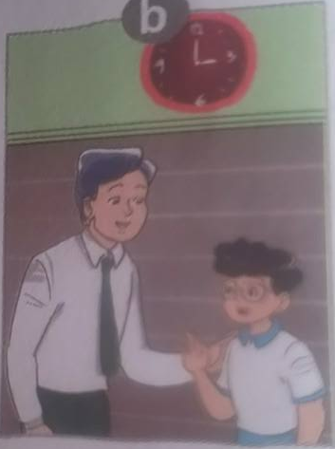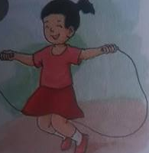

***She is from J_ _ _ _ Good _ _ _ _ _ __ She can _ _ _ _ She like _ _ _ _***

***Question 8 : Look and read. Put a tick (🗸 ) or cross (X) in the box(1pt)***

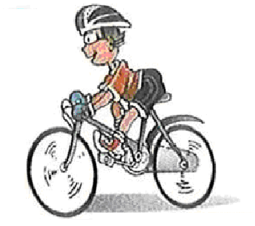***He can dancing***

***It’s on the sixteen of October***

***I have Maths, Vietnamese and Music***



 ***I am from England***

***Question 9 : Reorder the words(1pt)***

***1. is/birthday /when/ your 🖝_____________________________________***

***2. what/doing/she/is 🖝_____________________________________***

***3. subjects/do/have/what/today/you 🖝_____________________________________***

***4. I/Australia/from/ am 🖝_____________________________________***

***5./piano/I/played/the/yesterday 🖝_____________________________________***

***6. are/you/where/from 🖝_____________________________________***

***7./am/play/guitar/I/the 🖝_____________________________________***

***8. meet/to/you/nice 🖝_____________________________________***

***9. swim/you/can 🖝_____________________________________***

***10. class/4B/am/I/in 🖝_____________________________________***

***PART III : SPEAKING (****5 minutes****)***

***Question 10.***

|  |  |
| --- | --- |
| ***1. Listen and repeat*** | ***2. Point, ask and answer*** |
| ***3. Listen and comment*** | ***4. Interview*** |

***----------The end----------***