|  |  |
| --- | --- |
| **Name:** ……………………………………… | **Mark:** |

**Bài 1: Translate into English:**

a. Chào bạn. Mình là Minh ………………………………………………………….

b. Xin chào. Tớ là Lili ……………………….......................................................

c. Bạn có khoẻ không …………………………………………………………....

d. Mình khỏe. Cảm ơn bạn …………………………………………………………….

**Bài 2: .Complete the dialogue:**

Lien: I Lien.

Tung: Lien. I Tung. are you, Lien?

Lien: thanks. And how you?

Tung: I fine, you. to meet Lien.

Lien: Nice to you, too.

**Bài 3:  *Look at the letters. Write the words*.**

**Ví dụ: etem ⇒ meet**

1. okbo **⇒** …………….. 2. fnei **⇒** ……………..

3. pne **⇒** …………….. 4. woh **⇒** ……………..

5. pneilc **⇒** …………….. 6. uoy **⇒** ……………..

7. lreur **⇒** …………….. 8. earsre **⇒** ……………..

9. khtans **⇒** …………….. 10. neci **⇒** …………….

**Bài tập 4:. *. Read and complete.***

Nam: Peter . How you?

Peter: Hi, Nam. I am , thank you. And are you?

Nam: , thanks. Goodbye, you later.

Peter: Bye, see you .

**Bài tập 5: Put the words in order**

1. Are/ you/ hello/ how? ………………………………………………….

2. Fine/ thanks/ I/ am ………………………...................................................

3. See/ later/ good-bye/ you ………………………………………………………..

4. Tung/ is/ this

……. ……..…………………………………………...

5. Trang/ she/ is ........................................................................................

6. name/ your/ what's?

.......................................................................................

7. my/ this/ sister/ is

........................................................................................

8. brother/ this/my/ is

........................................................................................

9. too/ meet/ nice/ you/ to

…………………………………………………………

10. am/ I/ fine. ………………………………………………………....

***Bài 6: Choose A,B,C,D***

1. How \_\_\_\_\_\_\_\_\_ you?

A. am B. is C. are D. It

2. Good bye. \_\_\_\_\_\_\_\_\_ you later.

A. What B. See C. How D. Are

3……….. It a pen?

A. is B. See C. am D. bye

4. It is \_\_\_\_\_\_\_\_\_\_\_ table

A. is B. a C. an D. you

5. \_\_\_\_\_\_\_\_\_\_. I am Linda

A. Hello B. Good-bye C. It D. You

6. How \_\_\_\_\_\_\_\_\_ you?

A. am B. is C. are D. It

7. Good bye. \_\_\_\_\_\_\_\_\_ you later.

A. What B. See C. How D. Are

8. It \_\_\_\_\_\_\_\_ a dog?

A. is B. See C. am D. bye

9. It is \_\_\_\_\_\_\_\_\_\_\_ table

A. is B. a C. an D. you

10. \_\_\_\_\_\_\_\_\_\_. I am Linda

A. Hello B. Good-bye C. It D. You

11. \_\_\_\_\_\_\_\_\_\_ your name?

A. What B. What’s C. That D. That’s

12. This\_\_\_\_\_\_\_\_\_ my sister.

A. is B. am C. not D. no

13. Nice\_\_\_\_\_\_\_\_\_\_ you, Minh.

A. meet B. to meet C. meets D. hello

14. \_\_\_\_\_\_\_\_\_\_ are you today, Mai?

A. Hello B. How C. What D. That

15. How \_\_\_\_\_\_\_\_\_ you spell your name?

A. do B. are C. is D. not

**Bài 7. Write the missing words.**

1. This ………. my bedroom.
2. ……boy ……David and ……girl is Jane.
3. This ……………… a chair.
4. This is ……………. bathroom.
5. ……………. is my house.
6. My name …… Nam. This is……… brother.lk
7. This………..my garden

**Bài 8: Put the words in order:**

|  |
| --- |
| 1: is/ this / school/ my.  ----------------------------------------------- ----------------  2: my/friend/ is/ this.  ----------------------------------------------- ----------------  3: boy/ the/ friend/ my/is.  ----------------------------------------------- ----------------  4: name/ my/ Long/ is. You/ and?  ----------------------------------------------- ----------------  5: my/ this/ classroom/ is.  ----------------------------------------------- ----------------  6: school/ is/ this/ my.  ----------------------------------------------- ---------------- |
| 7: How/ do/ your / spell / you/ name?  ----------------------------------------------- ----------------  8: my/ is/ Hi / name / Jane.  ----------------------------------------------- ----------------  9: Hello/ are/ how/ today/ you?  ----------------------------------------------- ----------------  10: I/ Mai/ am. you/ And?  ----------------------------------------------- ----------------  11: later/ you/ Goodbye/ see.  ----------------------------------------------- ----------------  12. fine/ I/ and/ you/ am?  ----------------------------------------------- ----------------  13.skating/she/likes.  ----------------------------------------------- ----------------  14. at/play/break time/hide and seek/they.  ----------------------------------------------- ----------------  15.do/table tennis/like/you?  ----------------------------------------------- ----------------  16.break time/do/play/at/you/what?  ----------------------------------------------- ---------------- |

**Bài tập 7:. Translate into English:**

1.Chào Minh, bạn khoẻ không?

….. . ………………………………………………….

2. Cảm ơn bạn, mình khoẻ ………………………...................................................

3. Tạm biệt, hẹn gặp lại

………………………………………………………..

4. Kia là bạn Tùng

……. ……..…………………………………………...

5. Đây là bạn Trang

........................................................................................

6. Tên bạn là gì?

.......................................................................................

7. Đây là chị gái mình

........................................................................................

8.Đây là anh trai của tớ

........................................................................................

1. Mình rất vui được gặp bạn
2. …………………………………………………………

10.Bạn đánh vần tên thế nào?

………………………………………………………....

**Bài 9. Nối**

|  |  |  |
| --- | --- | --- |
| * 1. Who is she?   2. How are you ?   3. What is your name?   4. Goodbye. See you again.   5. How do you spell your name? | a. I’m fine. Thank you  b. She is Lan. She is my sister  c. That is B-E-T-T-Y.  d. I am Tung. And you?  e. Bye. See you later | 1 –  2 –  3 –  4 –  5 – |

**Bài 10: Choose correct words:**

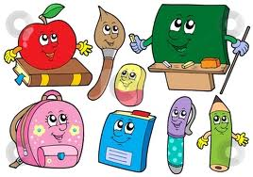 bag pen book

 pen pencil ten

 eight six four

 pencil ruler bag

 car desk bag

 pen pencil ruler

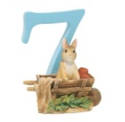 six seven five

 nine four five

 one six ten

 two three eight

**Bài 10: Điền các số viết bằng tiếng Anh vào chỗ trống**

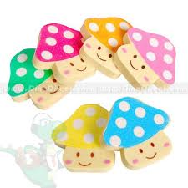 ………six….. erasers

 ………….……… pencils.

……………..……..balloons

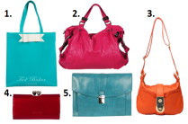 ……………… .bags

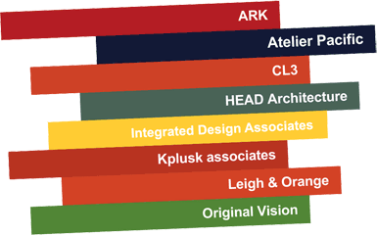 ……………….. books

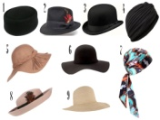……………………… hats

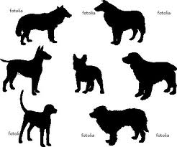……………………….. dogs

……………………… umbrellas

……………………… rulers

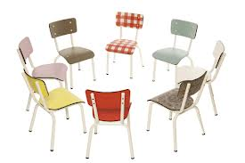……………………. Chairs

**Bài 11: Look at the pictures and the letters.**

**Write the words**

    

**Bo \_\_k Pe \_\_ Penc\_\_l b\_\_g \_raser**

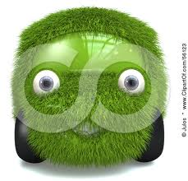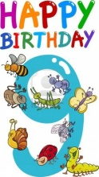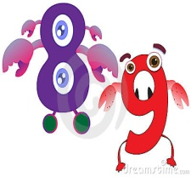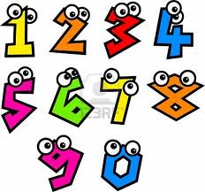

**c\_\_r ru\_\_er \_\_ine e\_\_ght se\_\_**

**Bài 12: Look and coplete:**

|  |  |
| --- | --- |
| 1. That is a p **e n.** |  |
| 2. This is my ru\_ \_ \_ \_ | index12 |
| 3. What’s that? –It’s a pe\_ \_ \_ \_ | images |
| 4. These are my ru\_ \_ \_ \_. | images |
| 5. My cla\_ \_ \_ \_ \_ \_ is big. | images |

**Bài 13: Read and Match:**

|  |  |  |
| --- | --- | --- |
| **A** |  | **B** |
| 1. How do you spell your name? | 1 - | a. No, you can’t. |
| 2. May I come in, Sir? | 2 - | b. Bye. |
| 3. What’s that? | 3 - | c. I play hide-and-seek. |
| 4. Goodbye | 4 - | d. T-O-N-Y. |
| 5. What do you do at break time? | 5 - | e. It’s a book. |

**Bài 14 *Look and read. Put a tick (* Description: MC900434665[1]) *or cross (X) in the box***

|  |  |  |
| --- | --- | --- |
|  | 1. This is a pen. | 🗆 |
|  | 2. This is a pencil. | 🗆 |
|  | 3. This is a book | 🗆 |
| 1_pencil_sharpener | 4. This is a ruler. | 🗆 |
| 2011_Boys_School_Bags_Kids_Cartoon_Boys | 5. This is a school bag. | 🗆 |
|  | 6. This is a pen. | 🗆 |

**Bài 15: Read and coplete:**

|  |
| --- |
| ***nice computer old No*** |

Mai: This is my (1)\_\_\_\_\_\_\_\_.

Mary: Really? Is it (2) \_\_\_\_\_\_\_\_\_?

Mai: (3)\_\_\_\_\_\_\_. It’s new.

Mary: It’s also (4)\_\_\_\_\_\_\_\_\_\_\_\_.

**Bài 16: Read and tick yes(Y) or no (N):**

Hi. My name is Nga. This is Dong Khoi Primary School. It is my new school. It is big. That is my classroom. It is very large. My computer room is big, too. Those are my pens. They are new and nice.

1. Her name is Mai …………………………………………………………..

2. Dong Khoi Primary School is old.

…………………………………………………………..

3. The classroom is large.

…………………………………………………………..

4. The computer room is small

…………………………………………………………..

5. The pens are long.

…………………………………………………………..

**Bài 17: *Choose A,B,C,D***

1. Nice to ………....you.

a. meet b. go c. for d. come

2. What’s …………..name?

a. your b. you c. she d. he

3. Sit…………., please.

a. down b. up c. in d. on

4. What’s your name?

a. Her name is Mary b. His name is Alan

c. My name is Phong d. This is Duyen

5. This is ……. classroom.

a. my b. me c. you d. you’re

6. Hi. My name ……Nam.

a. is b. are c. am d. and

7. How are….?

a. your b. you c. she d. he

**Bài 18. Odd one out:**

1. name she he they

2. classroom library it book

3. small It’s big new

4. book that pen pencil

5. my your brother his

6. your I you we

**Bài 19. Write the missing letters.**

1. Th\_s \_s my schoo\_.

2.What’s \_is n\_m\_?

3.M\_ nam\_ \_s Phong.

4. \_ hat's y \_ ur name?

**Bài 20. Fill the given words in the blanks**

**small big name it’s no school**

A: Hi, Linda. This is my (1) \_\_\_\_\_\_\_.

B: What’s its (2) \_\_\_\_\_\_\_\_.

A: (3) \_\_\_\_\_\_\_\_Thang Long school.

B: Is it (4) \_\_\_\_\_\_\_\_?

A: (5)\_\_\_\_\_\_\_\_\_\_, it isn’t. My school is small.

B: Oh, it’s \_\_\_\_.

**Bài 21. *Look at the letters. Write the words*:**

|  |  |
| --- | --- |
|  | 1.npe = ……………………….. |
| d_121 | 2. roomlassc = ……………………… |
| cartoon football players black and white | 3. balltfoo= ……………………….. |
| 1950435-57915-child-reading-in-the-library-cartoon | 4. brarily= ……………………….. |

**Bài 21: Fill in the blanks.**

1. This ………. my bedroom.
2. This is…….. bedroom
3. How………….you spell …………name?
4. That ………my bathroom.
5. ………...is my garden.
6. My name …… Nam. This ……….. my brother.
7. That………..my house. It …………big.
8. This……………my school. It …………new.
9. ………………is …………….. fan.
10. This is ……….. desk

**Bài 22: Put the words in order.**

1: my/friend/ is/ This. is/ He/ a/ teacher.

-------------------------------------------------------------

2: is/ this / teacher/ my/too.

-------------------------------------------------------------

3: 10 /I / years old/ am. You/ and?

-------------------------------------------------------------

4: school/ Is/ this/ your/ new?

-------------------------------------------------------------

5: my/ This/ classroom/ is.

-------------------------------------------------------------

* 1. you/ how/ are?

-------------------------------------------------------------

**Bài 23. Put the words in order**

1. name’s / Li Li/ my.

…………………………………

2. I’m/ thank/ you/ fine.

…………………., ……………

3. your/ please/ book/ open.

…………………………………

4. in/ may/ out/ I/ ?

…………………………………

5. this/ school/ my/ is.

…………………………………

6. name / your / is / what?

…………………………………

7. she / my / is / sister.

…………………………………

8. is / he / tall.

…………………………………

9. color / it / what /is?

…………………………………

10. blue / this / a / is / book.

…………………………………

11. don’t / watch / TV.

………………………………

12. your/ this/ is/ crayons?

………………………………