 | KÌ THI CHỌN HSG
ĐỀ 37 | MÔN: TIẾNG ANH

Thời gian làm bài 120 phút không kể thời gian giao đề

Unit 9: FESTIVALS AROUND THE WORLD PRACTICE

I. Choose the word in each line that has different stress pattern.

1. | A. discuss | B.gather | C. perform | D. attend
2. | A. ticket | B. constume | C. event | D. number
3. | A. return | B.happen | C.differ | D.visit
4. | A.yourself | B.thirteen | C.abroad | D.village
5. | A.Japan | B.Thailand | C.Norway | D.Turkey

Read the following sentences and marks (’) the stressed syllable in the underlined words. Then put them in the correct column.

1. The festival is held on the third week of August.

2. Rice is one of Vietnam’s main exports.

3. Britain imports a lot of food during the winter.

4. You will progress a lot with English if you practise using it regularly.

5. There has been a decrease in the number of visitors to the museum.

6. The students organised a march to protest against rising tuition fees.

7. Thousands of people were present at the festival.

8. He travelled around the country to take pictures of festivals.

9. They are going to organise a big campaign to advertise the festival. 10.Tom can’t decide whether to go to the party this weekend.

Stress on 1st syllable Stress on 2nd syllable

III. Put the names of the festivals under the appropriate pictures.

New Year’s Eve, Tet Holiday, Thanksgiving, Easter, Running of the Bulls, Halloween, Carnival of Venice, Christmas, Water Festival,

Mid-August Festival
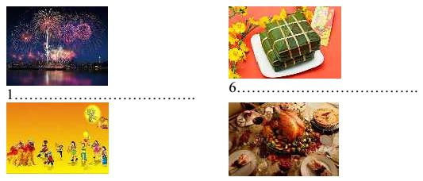

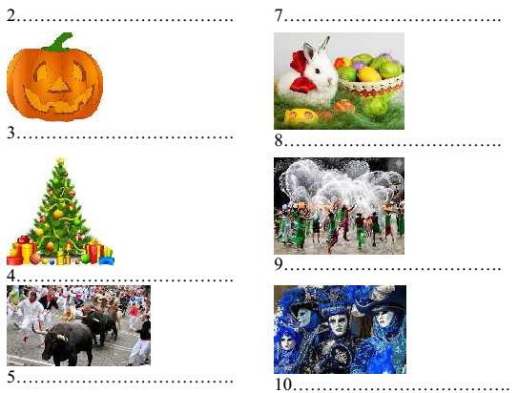

IV. Match one question in Column A with a correct answer in Column B

 | Column A | Column B
1. | Where is the festival celebrated? | A.They throw tomatoes at each other.
2. | Where is the festival held? | B. In Bunol, a small town in Spain.
3. | How far is it from the capital city? | C. Twenty thousand people, I think
4. | How long does it take to get there by | D. On last Wednesday of August.
car? |  | E. It is free. You just join and have
5. | How often does the festival take | fun.
place? |  | F. To celebrate the tomato harvest.
6. | Why do people hold this festival? | G. Anyone. However, small children
7. | How do people celebrate this festival? | should not come.
8. | Who can attend this festival? | H. About three hours and a half.
9. | How much does it cost to attend this | I. Annually
festival? |  | J. More than three hundred kilometers.
10.How many people attended this
festival
V. Give the correct form of the words given to complete the sentences.
1. Vesak Day is a ………….festival for those who follow Buddism. |  |  | RELIGION
2.I think it is a good …………..in this circumstance. |  |  | CHOOSE

We are having an interview with Mr. Phong, one of the Elephant Race…………..

ORGANISE

4.The Carnival of Rio de Janeiro is a very ………festival FESCINATE

5.Thanksgiving is a …………festival held in the USA and some other countries.

SEASON

6.We have become regular ………….at Da Lat Flowers Festival ATTEND

7.There are a lot cultural and …………activities held as part of this festival. ART

8.Tet holiday is the most important…….for Vietnamese people. CELEBRATE

9.Hoi Mua Festival is held by people of ethnic ……….in Phu Yen Province. MINOR

10.It is very………..to participate in Songkran Water Festival. JOY

IV. Make questions for the underlined parts of the following sentences.

The Flower Festival is celebrated every year.

………………………………………………………………………

We always have turkey on Thanksgiving.

………………………………………………………………………

Peter went to Da Nang last month with his parents.

………………………………………………………………………

They participated in La Tomatina in 2013.

………………………………………………………………………

These are my brother’s pictures.

………………………………………………………………………

The Elephant Race Festival will be held in Don Village next year.

………………………………………………………………………

The festival organisers’ clothes are red, purple and yellow.

………………………………………………………………………

People organise this festival to pray for better crops.

………………………………………………………………………

We decided the winners by tasting the dishes they cooked.

………………………………………………………………………

10.The festival lasts only one hour and a half.

………………………………………………………………………

VII.Choose the correct answer A, B, C or D to finish the sentences. 1.The village always ………………its harvest festival in the spring.

A. holds |  | B. makes | C. joins | D.takes
2. | Christmas songs are …………for people in towns and villages.
A. enjoyed |  | B. described | C. performed | D. appeared
3. | Easter is a/ an …………festival which is celebrated in many countries.
A. enjoy |  | B. interest | C. amused | D. joyful
4. | Tet is a time for Vietnamese families to clean and …………their houses.
A. hang |  | B. decorate | C. enjoy | D. prepare
5. | Burning Man is a …………festival held at the end of August.
A. music |  | B. musical | C. musician | D. musicians’
6. | On Passover Day, people…………freedom from slavery.
A. choose |  | B. celebrate | C. participate | D. contribute
7. | During Tet holiday the …………atmosphere is felt about around the country.
A. local |  | B. ethnic | C. thankful | D. festive

Every year Cannes …………its international film festival called Cannes Film Festival.

A. attends B. gathers C. hosts D.plays

9. “…………” are you going to Phu Yen? – To attend Hoi Mua Festival

A. How B. What C. When D. Why

10. “…………” is this festival celebrated?

A. How often B. How far C. How long D. How much

VIII. Fill each blank with a suitable word to finish the passage.

In Canada and the United States, …………(1) of the most popular days in the year is

Halloween. Halloween is on October 31st. It’s a day …………(2) some people dress

up in strange or unusual costumes. For example, they may dress up to look …………

an animal, a person from a book or film or a famous person from history. In some places, children go to school in …………(4) Halloween costumes. After dark, many young children …………(5) on thei costumes and visit their neighbours. They knock on the …………(6) and shout “Trick or treat!”. Then the neighbours …………(7) them some candy and the children go on to the …………(8) house. Adults also enjoy dressing up for Halloween. There …………(9) usually Halloween parties in the evening and usually there is a prize for the best or …………(10) unusual costume.

IX.Read the passage and choose the best answer to each statement.

Every year, thousands of people come to Edinburgh, the capital city of Scotlland, to be part of the Edinburgh Festival. For three weeks every August and September the city is filled with actors and artists from all over the world. They come to Edinburgh for the biggest arts festival in Britain. During this time, the streets of the city are alive with music and dance from early in the morning until late at night. You can see artists painting pictures on the streets!

Tens of thousands of tourists come to the Festival to see new films and plays and to hear music played by famous musicians. This year, you can see over five hundred performances with actors from more than forty countries. The tickets for these performances are quite cheap, and it is usually easier to see your favourite star in Edinburgh than it is in London. So come to Edinburgh next summer.

1.The Edinburgh Festival takes place annually.

A. Right |  | B.Wrong | C. Doesn’t stay
2. | The Edinburgh Festival is a month long.
A. Right |  | B.Wrong | C. Doesn’t stay
3. | The Edinburgh Festival is in October.
A. Right |  | B.Wrong | C. Doesn’t stay
4. | Actors come to the Edinburgh Festival from lots of different countries.
A. Right |  | B.Wrong | C. Doesn’t stay
5.You can hear music all day.
A. Right |  | B.Wrong | C. Doesn’t stay
6. | Edinburgh Festival is the biggest art festival in Great Britain.
A. Right |  | B.Wrong | C. Doesn’t stay
7. | The artists on the streets only paint pictures of scenery.
A. Right |  | B.Wrong | C. Doesn’t stay
8. | More than ten thousand students come to the Edinburgh Festival every year.
A. Right |  | B.Wrong | C. Doesn’t stay
9. | It is expensive to go to the theatre in Edinburgh.
A. Right |  | B.Wrong | C. Doesn’t stay

10. It is usually more difficult to see famous actors in London than in Edinburgh

A. Right B.Wrong C. Doesn’t stay

X. Read the following passage and answer the questions below.

Christmas is almost here. Holiday music fills the air. Colourful lights shine brightly in windows. The stores are crowded with people buying last-minute gifts. All these are Christmas traditions. Another tradition is snow. Christmas in the northern part of the world comes a few days after the start of winter. So, in many places, a blanket of clean white snow covers the ground on Christmas Day. This is what is meant by a “White Christmas”.

Of course, many places do not get snow in December. In fact, they may be very warm at that time of year. People who like snow- but live where it is warm –dream of having a white Christmas. American songwriter Irving Berlin captured these feelings in his song “White Christmas”. “White Christmas” is one of the most popular songs of all times. Hundreds of singers and musicians have recorded it.

Perhapss the most famous version was sung by Bing Crosby. Songwriter Irving Berlin was Jewish. He did not celebrate Christmas as a religious holiday. But in his Christmas song, he shares a message of peace and happiness which all people can joy. So from all of us – to all of you – we wish the happiest and most joyful holiday.

What are the stores crowded with?

………………………………………………………………………………

Which part of the world does Christmas come a few days after the start of winter?

………………………………………………………………………………

What do people in warm places dream at Christmas?

………………………………………………………………………………

By whom was the famous song “White Christmas” written?

………………………………………………………………………………

What does he share with us in his famous song?

. ………………………………………………………………………………

XI. Use the words given and other words, complete the second sentence so that it has a similar meaning to the first sentence. Do not change the word given.

1.Whose luggage is this?

………………………………………………………… BELONG

2.It took us three months to prepare for this festival

…………………………………………………………SPENT

3.How much is the entry fee?

………………………………………………………… PRICE

People hold the festival to thank the Rice God for the crop.

………………………………………………………… HELD

Why are you going to Da Lat in December?

………………………………………………………… FOR

XII. Use the words given to write about the Songkran Water Festival in Thailand. - Thai New Year festival / fall/ some/ hottest/ day/ Thailand

- People/ celebrate/ throw/ water/ other

- Use/ whatever/ get/ hands/ water guns/ buckets/ hoses - Sometimes/ chalk/ menthol/ mix/ water/ create/ paste - Use / smear/ faces/ good fortune

- Elephants / see/ walk around/ splash/ water jets

……………………….…………………………………………………………………………

……………………….…………………………………………………………………………

……………………….…………………………………………………………………………

……………………….…………………………………………………………………………

……………………….…………………………………………………………………………

……………………….…………………………………………………………………………

……………………….…………………………………………………………………………

……………………….…………………………………………………………………………

……………………….…………………………………………………………………………

