 | KÌ THI CHỌN HSG
ĐỀ 36 | MÔN: TIẾNG ANH

Thời gian làm bài 120 phút không kể thời gian giao đề

Unit 8: FILMS

I. Choose the word having the underlined part pronouced differently in each line.

1A. wished | B.gripped | C.loved | D.liked
2A.excited | B.enjoyed | C.bored | D.amazed
3A.laughed | B.ended | C.shocked | D.missed
4A.advertised | B.murdered | C.performed | D.approached
5A.produced | B.terrified | C.entertained | D.engaged

Write the correct verb in Past simple (the first letter of each verb is given) under each picture. After that put the verbs in the correct column.
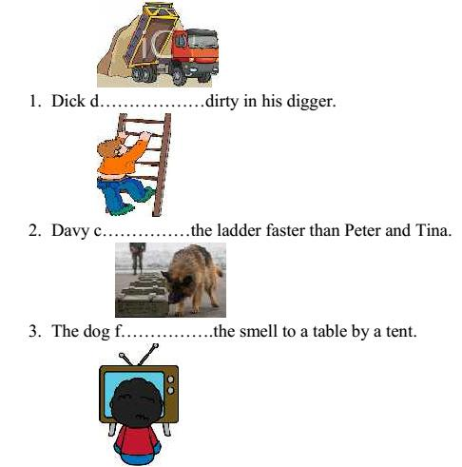

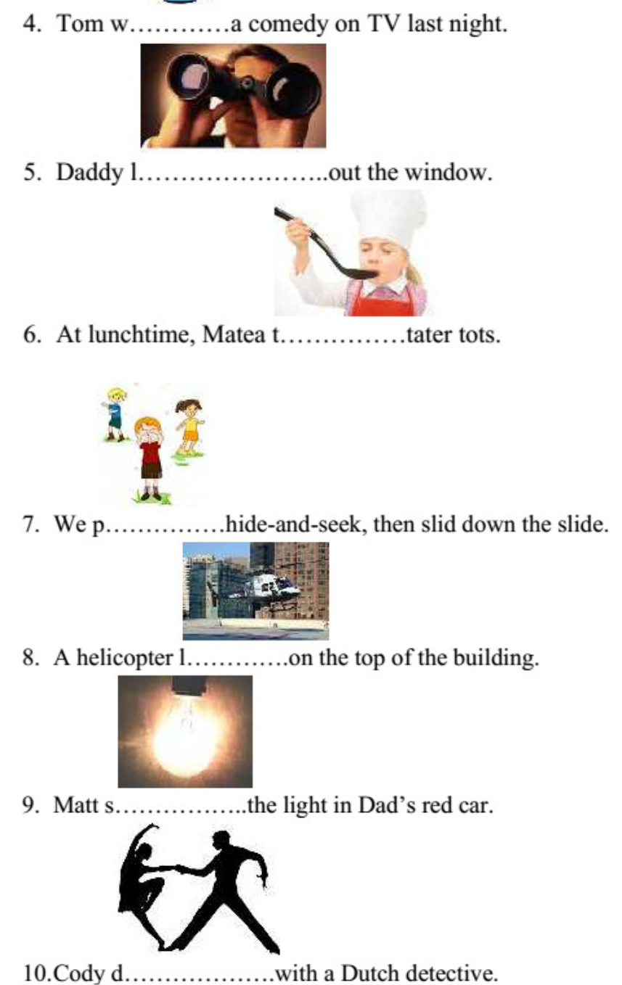

II. Put the types of films under their pictures. (Use each type once only)
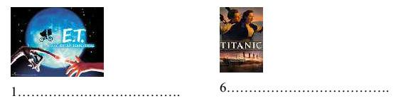

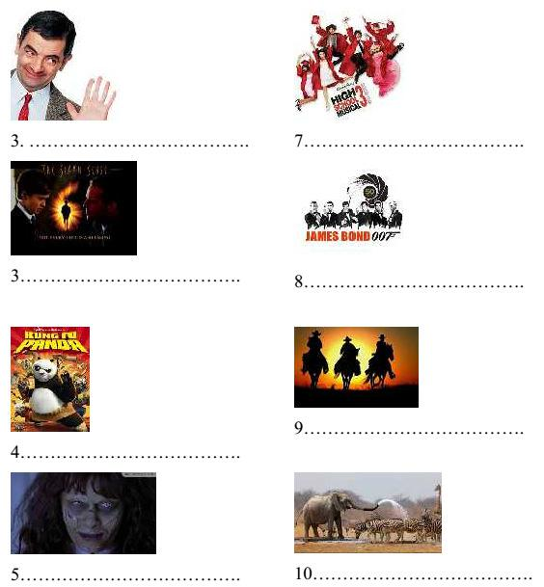

IV. Give the correct form of the words given to complete the sentence.

Although Titanic is a ……….film, it has a sad ending. ROMANCE

His recent film received a lot of …….from the public. CRITIC

I don’t like horror films because they are too …………….for me. FRIGHT

Do you know Daniel Day-Lewis? He has won three Oscars for Best …………….

ACT

The film was …………….though they spent millions of dollars making it.

SUCCEED

Big Ben Down is about a group of …………….who take control of Big Ben.

TERROR

We were …………….with the service at the cinema. Everything was terrible.

SATISFY

The film is a big ……………It is boring from beginning to end. DISAPPOINT

The film is about two hijackers who ……………to blow up the plane. THREAT

10.I don’t think it is good for young kids to see ……………on TV. VIOLENT

V. Complete the following sentences with the adjective ending –ing or – ed from of the italicized word.

E.g: The trip tired everybody.

Everybody was tired. (b) The trip was tiring. 1. The book interests me.

It is an …………..book. (b) I am ………..in it. 2. That chemical irritates your skin.

The chemical is ………... (b) Your skin is ………….

3. The instructions on the box for assembling the tool confuse me.

They are ………….. (b) I am thoroughly…………… 4. Bob’s grades disappointed his parents.

His grades were………. (b) His parents were…………... 5. My father often reassured me.

He was a very …………..person.

I always felt …………when I was around him.

I waited for two hours to see the doctor, and it really frustrated me!

(a) Long waits such as that can be very ……………

(b) I was ……………..

Anna has a noise in her car that disturbs her.

It is a ……….noise (b) She is ……….when she hears it. 8. Jessica’s argument convinced us.

She presented ………arguments. (b) we were………….. 9. The tender love story moved the audience.

It was a ………..story (b) The audience felt…………..

10. The sad movie despressed me.

I was ………… (b) It was a …………..movie

VI. Combine the sentences. Use the words in brackets.

1. It was a comedy. Almost audience fell asleep. (ALTHOUGH)

……………………………………………………………………………….

2. The film was made twenty years ago. Many people have enjoyed seeing it. (HOWEVER)

……………………………………………………………………………….

3. She has been nominated for Best Actress five times. She has never won once.

(IN SPITE OF)

……………………………………………………………………………….

4. This is his first role. His acting is excellent. (NEVERTHELESS)

……………………………………………………………………………….

5. The film didn’t receive good investment. The film was a great success. (DESPITE)

……………………………………………………………………………….

VII.Choose the best answer for each of the following sentences. 1. The movie on TV last night laugh me………………

A. bore B. boring C. bored D. Boredom

2. They were very disappointed …………..her acting.

A. of B.with C.in D.on

We are really …………about going to the cinema tonight.

A. excited |  | B.interested | C.amused | D.pleased
4. The cinema changed completely at ……….end of ………1920s.
A. an-the |  | B.the - | C.- the | D.the -the
5. | I ……….thrillers to action films.
A. like |  | B.prefer | C.would rather | D.enjoy
6. | A film in which strange and frightening things happen is called a/an…….
A. thriller |  | B.comedy | C.drama | D.animation
7. | Trung finds horror films really…………..
A. disgust |  | B.disgusts | C.disgusting | D.disgusted
8. | In Titanic, it ….......Leonardo DiCaprio as Jack Dawnson, a poor artist.
A. like |  | B.prefer | C.would rather | D.enjoy
9. | ………beginning with a terrible disaster, the film has a happy ending.
A. In spite |  | B. Despite | C. Although | D. However
10.The film has a silly plot. ……………., many people enjoyed it.
A. Though |  | B. Moreover | C. Because | D. Nevertheless

VIII. Read the following passage and choose the best answer for each blank. The world’s first film was shown in 1895 by two French brothers, Louis and Auguste Lumiere. Although it only (1)…………of short, simple scenes, people loved it and

films have (2) ……….popular ever since. The first films were silent, with titles on the

screen to (3)………..the story. Soon the public had (4) ………..favourite actors and

actresses and , in this (5) ……….., the first film stars appeared. In 1927, the first

“talkie”, a film with sound, was shown and from then on, the public (6) ………..only

accept this kind of film.

Further improvements continued, particularly in America, (7) ………..produced 95%

of all films. With the arrival of television in the 1950s, 8) ………..people went to see

films, but in (9) ………..years cinema audiences have grown again. More countries

have started to produce films that influence film-making and there are currently (10)

………..national film industries.

1. | A. consisted | B. contained | C.belonged | D. held
2. | A. gone | B. been | C. made | D. kept
3. | A. join | B.read | C. explain | D. perform
4. | A. your | B. his | C. our | D. their
5. | A. reason | B. way | C. method | D. result
6. | A. should | B. would | C. might | D. will
7. | A. who | B. where | C. when | D. which
8. | A. other | B. each | C. fewer | D. any
9. | A. recent | B. now | C. modern | D. present
10.A. many |  | B. lots | C. much | D. plenty

IX. Read the passage and choose the best answer to each question.

My first visit to the cinema was a very unhappy one. I was taken there by some friends when I was only seven years old. At first there were bright lights and music and I felt quite happy. When the lights went out, I felt afraid. Then I saw a train on the screen. The train was coming towards me. I shouted out in fear and got down under my seat. When my friends saw me, they started to laugh. I felt ashamed and sat back in my seat. I was very glad when the film ended.

Who took the writer to the cinema for the first time?

A. His father |  | C. His parents’ friends
B. His parents |  | D. His friends
2. How did he feel at first?
A. excited | B. unhappy | C. sad | D. quite unhappy
3. He was frightened when …………..
A. There was music |  | C. the train ran
B. The cinemas had no light |  | D. his friends saw him
4. Where did he hide when he saw the train coming towards him?
A. Under the seat |  | C. on his friends’ back
B. On the screen |  | D. under the train seat
5. How did he feel when the film finished?
A. Very sad | B. very unhappy | C. quite happy | D.quite right

X. Find a mistake in the four underlined parts of each sentence and

correct it.

Example:

There isn’t two chairs in the living room.

ABCD

The children felt very terrifying when they watched that horror film.

ABCD

Lots of people enjoy Titanic despite it has an unhappy ending.

We found the film bored, so we left halfway through it.

ABCD

Although his old age, Mark performed excellently in his latest film.

ABCD

Almost people were shock by the way the film star behaved.

ABCD

XI. Complete the second sentence so that it has similar meaning to the first sentence.

In spite of having to work the next day, Tom watched films on DVD till midnight.

=> Even though……………………………………………………………

The ending of the film was quite disappointing. =>We……………………………………………………………………….

Although she performed well, she didn’t receive good comments from critics.

=>Despite her……………………………………………………………

We were so interested in the comedy that we laughed from beginning to end.

=>The comedy……………………………………………………………..

I’m frightened by horror films; however, I enjoy watching them.

=>In spite…………………………………………………………………..

XII. Think of a film you have seen. Write film review. Your review should be at least 100 words long. Use the following guides to help you in your review.

In the first paragraph, introduce the title of the film and say what kind of

film it is.

In the second paragraph, introduce the main characters.

In the third paragraph, introduce the plot. (tell the story briefly)

In the fourth paragraph, write about one part of the film that you like.

In the last paragraph, write what you think of the film.

……………………………………………………………………………….

……………………………………………………………………………….

……………………………………………………………………………….

……………………………………………………………………………….

……………………………………………………………………………….

……………………………………………………………………………….

