 | KÌ THI CHỌN HSG
ĐỀ 35 | MÔN: TIẾNG ANH

Thời gian làm bài 120 phút không kể thời gian giao đề

Unit 7: TRAFFIC

I. Choose the word having the underlined part pronouced differently in

each line.
1. | A. station | B. mistake | C. lane | D. many
2. | A. ready | B. break | C. ahead | D. dead
3. | A. freight | B. vein | C. ceiling | D. neighbour
4. | A. pretty | B. depend | C. left | D. expensive
5. | A. straight | B. pain | C. said | D. afraid

Reorder the letters under each picture to make a meaning word then say it aloud.
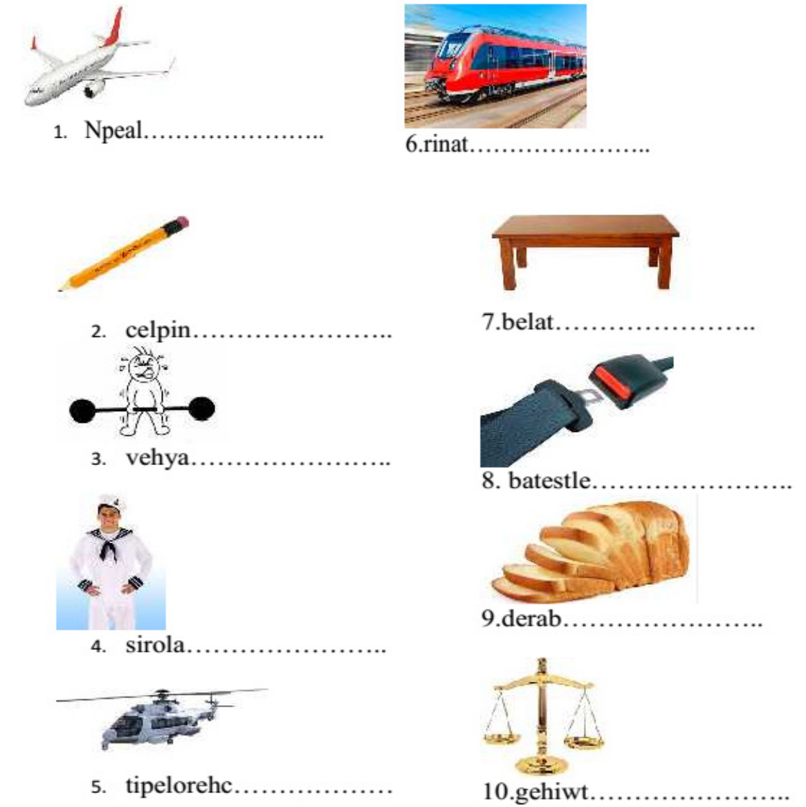

Put the correct meanings under the appropriate road signs.

Crossroads, No U-turn, Road works, No left turn,

Pedestrian crossing, Oneway traffic, No stopping,

Slippery road, Roundabout, School crossing patrol.
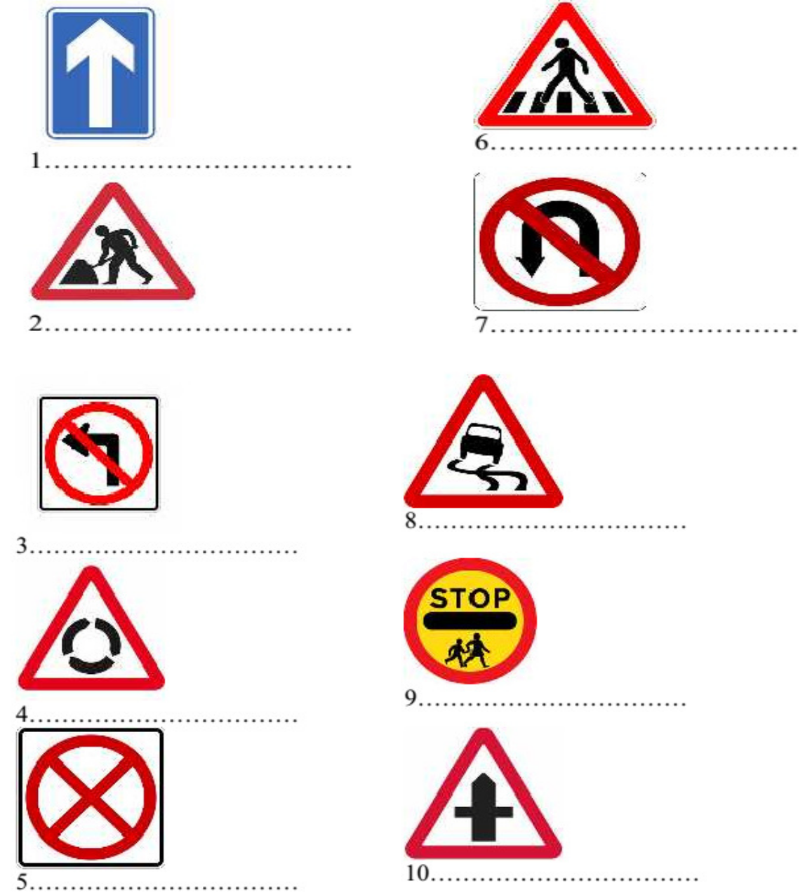

IV. Match one question in Column A with a correct answer in Column B

 | Column A | Column B
1. | How far is it from here to the nearest | a. Four dollars and sixty
market? |  | cents.
2. | How often do you go to the post office? | b. About one hour and a

3. | How much is a one-way ticket to the | half.
airport? |  | c. It’s about one kilometer
4. | How do you get there from your home? | d. I walk.
5. | How long does it take to get there by bus? | e. About twice a month.

1…………. 2…………. 3……………. 4……………. 5 ……………

V. Look at the pictures and choose the best answer to complete each sentence.

My uncle travelled to Japan by…………….. A. boat

B. ship C. canoe D. barge

This sign says “………………..”
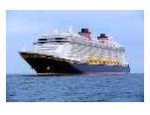
A. You must stop

B. You must not slow down

C. You can enter that road

D. You cannot go straight ahead

There are usually ………….on my way to school. A. accidents

B. road works C. railways D. traffic jams

This road sign means “………………...”

A. Cycle route ahead

B. No cycling

C. Route for pedal cycles

D. Give way to bikes

Kelvin sometimes goes to university by ………

A. train B. bus C. tram D. coach

You should wear a ……..when you ride a bike. A. mask

B. helmet C. scarf

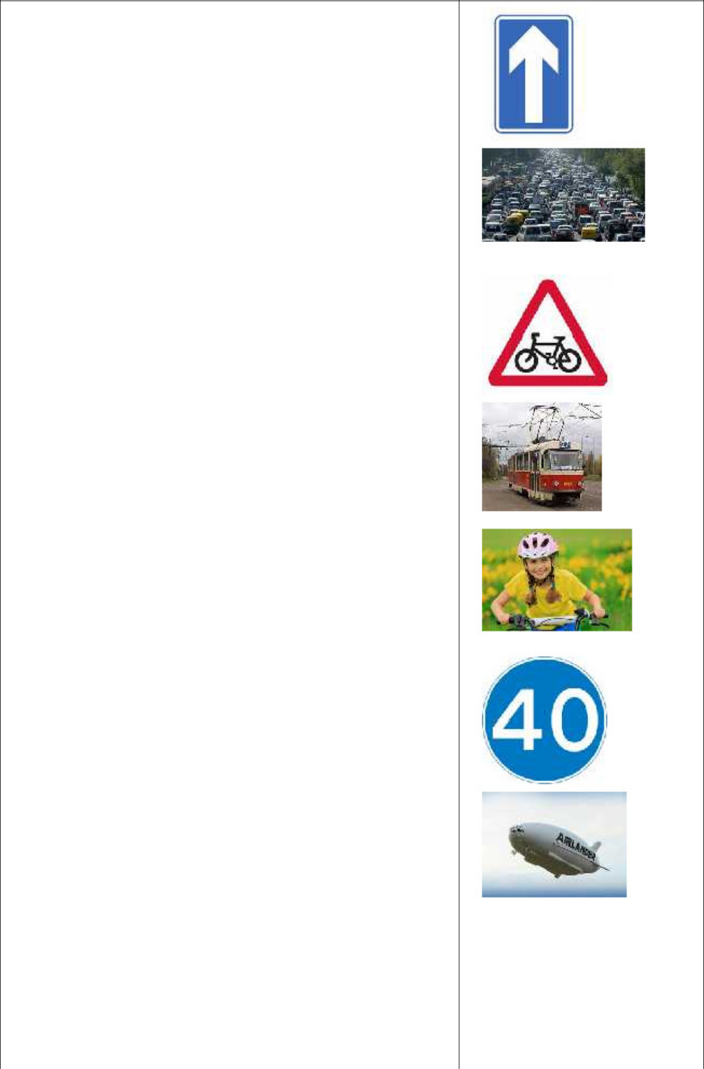
D. seatbelt

This road sign shows “……………” A. maximum speed

B. minimum speed C. average speed D. overtaking speed

Mr. Brown sometimes goes sightseeing by……. A. flying boat

B. rocket C. balloon D. airship

This road sign means “…………….”

bump

no traffic

danger

give way

10.You must walk across the street at the………..

pavement

zebra crossing

footpath

roundabout
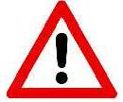

VI. Look at the following pictures. Use “used to” to write about the past and present simple tense to write about the present.
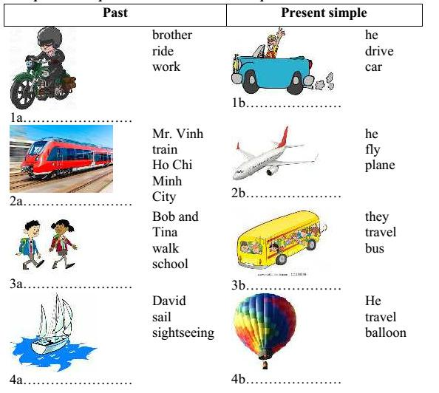

Ex 1a My brother used to ride to work. 1b. Now he drives to work.

2a……………………………………..…… 2b……………………………………..……

3a……………………………………..…… 3b……………………………………..……

4a……………………………………..…… 4b……………………………………..……

5a……………………………………..…… 5b ……………………………………..……

VII. Match a sentence in Column A with an appropriate sentence in Column B.

(Use each sentence once only).

 | Column A |  | Column B
1. | I was very fit when I was young. |  | A. He used to smoke a lot.
2. | The teachers at my school were kind |  | B. He used to play for the local team.
3. | My brother’s room was so messy. |  | C. It used to follow me everywhere.
4. | I had a dog when I was a kid. |  | D. We used to go everywhere by bus.
5. | My family had some lovely holidays. |  | E. We used to freeze on winter
6. When I was young, we didn’t have a car. |  |  | mornings.
7. | And we didn’t have central heating. |  | F. He used to fly Airbus.
8. | My uncle was a pilot for Vietnam |  | G. He never used to tidy it at all.
Airlines. |  |  | H. I used to do a lot of exercises.
9. | My father was weak. |  | I. They used to help pupils.
10.My brother was a soccer player. |  |  | J. We used to go camping all over the
 |  |  | country.
1….. 2….. 3….. 4….. 5….. 6….. |  | 7….. 8 ….. 9….. 10…..

VIII. Read the following dialogue and choose the best answer for each blank.

Mr. Minh: The traffic (1)…………….much worse now.

Mr. Thanh: Yes, it (2) …………….easy to park in the city centre.

Mr. Minh: That’s right.

Mr. Thanh: I remember when you could park outside (3) …………….shop you were

going to.

Mr. Minh: Yes, you could park (4) …………….at all at one time, but now

there (5) …………….parking meters everywhere.

Mr. Thanh: And they turned so many of the roads (6) ………….one-way streets now.

Mr. Minh: I know.

Mr. Thanh: It will take a while before everyone becomes (7) …………….with it.

Mr. Minh: Actually, I miss the good old days when (8) …………….to the shops. (9)

…………….were no cars at all on the roads then.

Mr. Thanh: Mind you, I must stay I prefer (10) …………….by car!

1. | A. got | B. is getting | C. used to get | D. getting
2. | A. would be | B. used to be | C. is being | D. use being
3. A. some |  | B. any | C. much | D. many
4. | A. anywhere | B. somewhere | C. nowhere | D. everywhere
5. | A. is | B. are | C. was | D. were
6. | A. to | B. to | C. into | D. onto
7. | A. friendly | B. usual | C. common | D. familiar
8. | A. cycle | B. cycled | C. used to cycling | D. used to cycle
9. | A. There | B. That | C. Their | D. These
10.A. travel |  | B. travelled | C. travelling | D. to travelling

IX. Arrange these sentences to make a conservation.

On a street in an English town, a policeman stops a car. In the car there is a visitor from another country who does not know that traffic in England keeps to the left.

But you said I was driving on the right side.

Stop!

Why are you driving on the right side of the road?

It’s like a looking-glass! But I’ll try to remember.

A strange country! If right is wrong, I’m right when I’m on wrong side. So why did you stop me?

That’s right! You are on the right, and that’s wrong.

Do you want me to drive on the wrong side?

What’s the matter?

You are driving on the wrong side.

10.My dear sir, you must keep to the left. That right side is left.

Your answer:………………………………………………….

X. Read the following passage and answer the questions below.

An Accident.

“Let’s race down the slop at the park!”, Tom said to Fred. The two boys

went to the top of the slope. “Ready, go!”, Tom yelled as the two boys cycled as fast as they could. The bicycles went down the slope at great speed. Then, the boys realised that they had lost control of the bicycles. They were going so fast that it was too dangerous to use the brakes. CRASH! BANG! The bicycles hit a curb and crashed into a fence and a tree. The boys were in great pain. Luckily, some joggers saw what had happened and came to help. Someone called their parents who soon came to bring them home. Tom and Fred had learnt their lesson. They promised never to do something so dangerous again.

How did the bicycles go down the slope?

…………………………………………………………………………

Why didn’t Tom and Fred use the brakes?

…………………………………………………………………………

Where did the bicycles crash?

…………………………………………………………………………

How were Tome and Fred after the crash?

…………………………………………………………………………

Who brought Tom and Fred home?

…………………………………………………………………………

XI. Finish each of the following sentences in such a way that it is as similar as possible in meaning to the original sentence. Use the word given and other words as necessary. Do not change the form of the given word.

Mr. and Mrs. Smith are flying to Ha Noi now. TRAVELLING

…………………………………………………………………………

Van hand a motorbike once, but he doesn’t any more. USED

…………………………………………………………………………

My father usualy goes to work by car. DRIVES

…………………………………………………………………………

This part of the city didn’t have traffic jams very often. USE

…………………………………………………………………………

I used to walk to school when I was young. FOOT

…………………………………………………………………………

XII. Use the words given to complete each of the following sentences.

Traffic jam/ one/ most common/ issue/ big city/ world//.

…………………………………………………………………………

There /many/ people/use/ road/and/ one/ main reason/ cause/ traffic jam//.

…………………………………………………………………………

We / solve/ traffic problem/ by / encourage/ people/ use/ bicycle/ rather/ car/ short trip//.

…………………………………………………………………………

People/ use/ public transports/ reduce/ number/ private vihicles/ road//.

…………………………………………………………………………

Move/ big/ company/ factory/ city/ countryside/ help reduce/ traffic jam//.

…………………………………………………………………………

