200 câu IOE Lớp 5 VÒNG HUYỆN, CẤP HUYỆN
ĐỀ THI TIẾNG ANH TRÊN INTERNET – OLYMPIC TIẾNG ANH – LỚP 5 - VÒNG HUYỆN
Question 1:
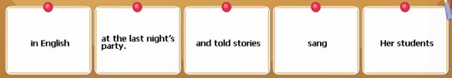
Question 2:
Question 3:
Question 4:
Question 5:
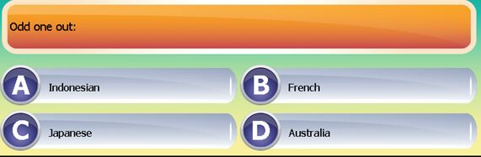
Question 6:
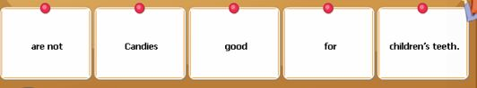
Question 7:
Question 8:
Question 9:
Question 10:
Question 11:
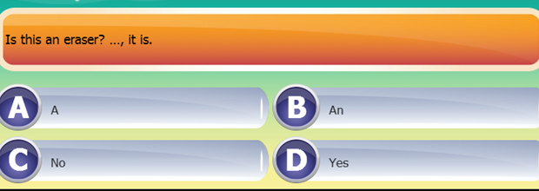
Question 12:
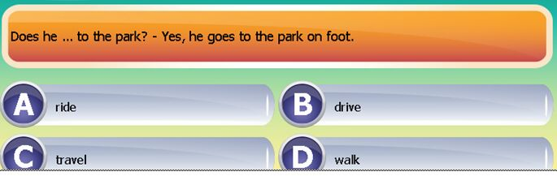
Question 13:
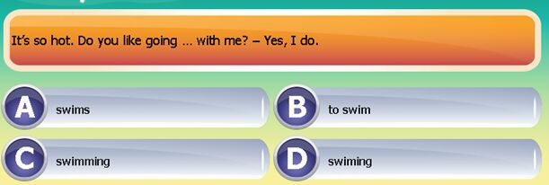
Question 4:
Question 15:
Question 16:
Question 17:
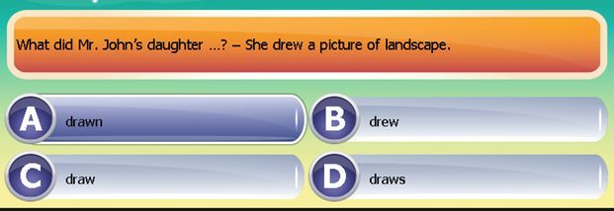
Question 18:
Question 19:
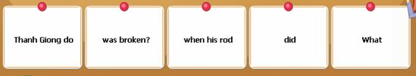
Question 20:
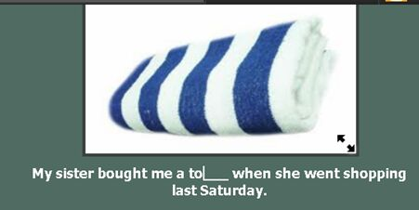
Question 21:
Question 22:
Question 23:
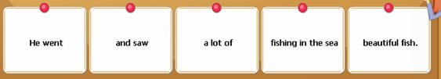

Question 24:
Question 25:
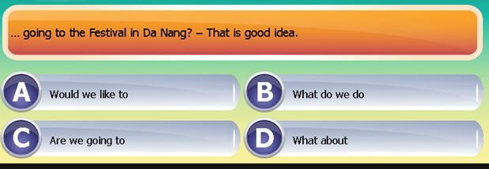
Question 26:
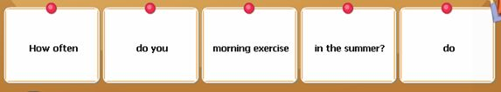
Question 27:
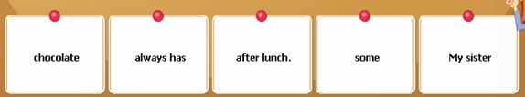
Question 28:
Question 29:
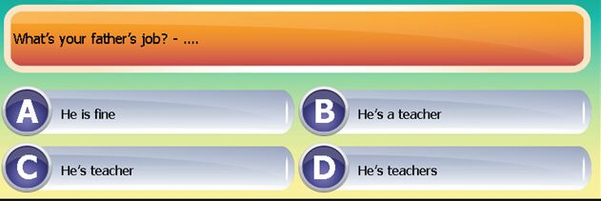
Question 30:
Question 31:
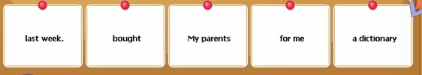
Question 32:
Question 33:
Question 34:
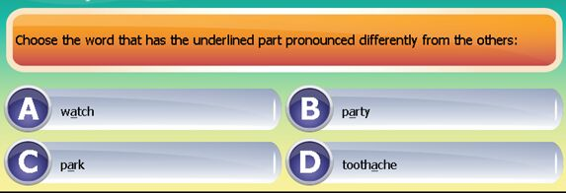
Question 35:
Question 36:
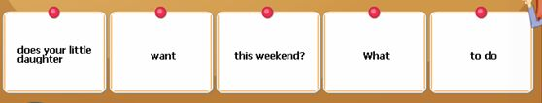
Question 37:
Question 38:
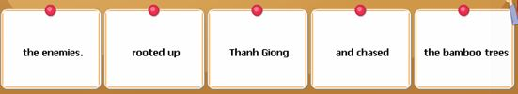
Question 39:
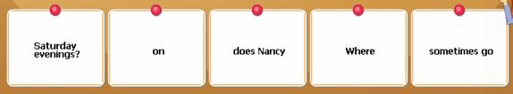
Question 40:
Question 41:
Question 42:
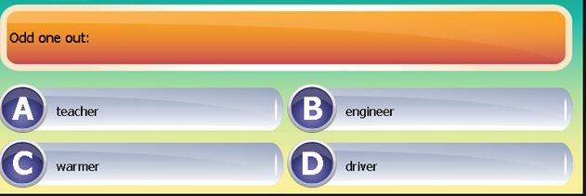
Question 43:
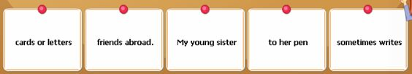
Question 44:
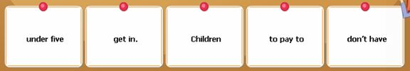
Question 45:
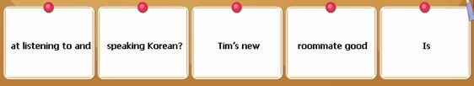
Question 46:
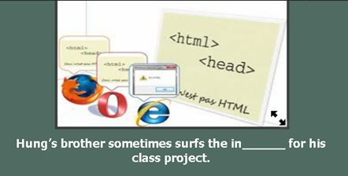
Question 47:
Question 48:
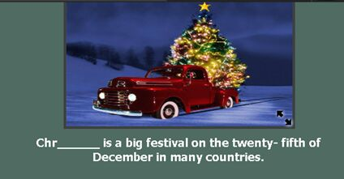
Question 49:
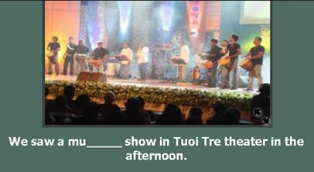
Question 50:
Jim and Sam are _ _ _ _ _ _ _ _ _ _ in Arts. They say it is very interesting.
Question 51:
What _ _ _ _ does your family have breakfast? - At 7 o’clock.
Question 52:
The museum _ _ behind the park.
Question 53:
Look! The boys are talking _ _ _ _ _ the football match.
Question 54:
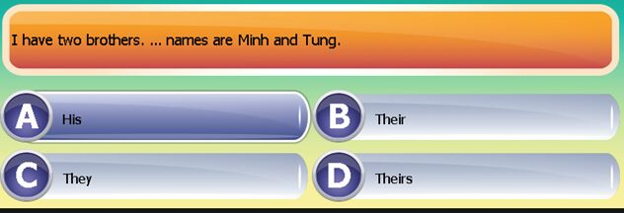
Question 55:
Does Tom p_ _ _ badminton at 4 pm?
Question 56:
The writer of the book you’re reading is _ _ African.
Question 57:
After dinner, my mother checks my homework b_ _ _ _ _ bedtime.
Question 58:
My sister has got some friends from G_ _ _ _ _y.
Question 59:
Fifty- five p_ _ _ twenty-two equals seventy-seven.
Question 60:
What is your k_ _ _ _ _ _ like?
Question 61:
I work _ _ _ _ six o’clock in the morning until three in the afternoon.
Question 62:
.The students played different sports _ _ _ _ as badminton, chess and hide-and-seek.
Question 63:
I am having a birthday party _ _ _ _ my friends.
Question 64:
What is his nationality? – He is A_ _ _ _ _ _ _ _ _(nước Úc).
Question 65:
Where does he live? – He lives _ _ 16 Nguyen Du Street.
Question 66:
My brother is a factory _ _ _ _ _ _. He works in a factory.
Question 67:
There is a small pond b_ _ _ _d the house.
Question 68:
I often write to Jack and tell him _ _ _ _ _ my school.
Question 69:
What d_ _ _ your brother do in the afternoon?
Question 7:
Lena isn’t well today. She is staying at h_ _ _.
Question 71:
What’s the w_ _ _ _ _ _ like in the Summer? - It’s hot.
Question 72:
_ _ _ _ _ does he live? – He lives in Nguyen Du Street.
Question 73:
I live far _ _ _ _ my parents. I phone them everyday.
Question 74:
There is a vi_ _ _ _ fence around my house.
Question 75:
There is a bl_ _ _ fence around my house.
Question 76:
What did your father d_ yesterday evening? - He read newspapers.
Question 77:
I’m not hungry _ _ _ I’m thirsty.
Question 78:
There are many clouds _ _the sky.
Question 79:
Let’s buy a big present _ _ _her birthday party.
Question 80:
_ _ _ _ would you like?-Some soda, please.

- She/comes/Australia./from…………………………………………
- Can you/school/come to/early/tomorrow?
……………………………………………………………………………
- How many/floors/does/your school/ have?
……………………………………………………………………………
- She’s/going to/an English song./sing
……………………………………………………………………………
- She is learning… to use a computer.
A. what B. how C.why D. which
- Last week, I…to a summer camp in NhaTrang.
A .Did B.was C. went D. were
- There aren’t any woman…in the room.
A.on B.at C.in D.from
- Choose the word that has the underlined part pronounced differently
A. late B. place C.take D.dad
- That/great/idea./a/is……………………………………………..
- Her daughter/red shoes/wears/ always /to school.
………………………………………………………………………
- Friend’s/is/name/Mary./Lan’s
………………………………………………………………………..
- Mary’s parent/don’t let /night./out at/her go .................................................................................................................
- to some/tall/is next/The store/trees.
......................................................................................................................
- ... school are you in?-PhamHongThai school
A.which B. What’s C.When D. Where
- Choose the word that has the underlined part pronounced differently:
A. grade B. class C. Late D. Name
- How many...are there in your class ?
A. students B.student C.teacher D .chair
- Choose the word that has the underlined part pronounced differently:
A. how B. know C. brown D. cow
- Choose the word that has the underlined part pronounced differently
A.cheap B.meat C.season D.weather
- Why did’t you... to the cinema yesterday?
A.went B.go C.goes D.going
- The children/summer camp/wonderful/had a/in Vietnam
........................................................................................................
- wants/of English./a teacher/ My younger brother/tobe
...........................................................................................................
- What/going to/you/are/draw,Helen?
.............................................................................................................
- birthday party./cake and sweets/There are/a lot of/in her
..............................................................................................................
- Look/at/on/thatman/mortobike.
……………………………………………………………………….
- your little/son/have English/on Friday/Does/-Yes, he does
……………………………………………………………………………
- Lan good/Is/at/drawing and singing/yes,she does
…………………………………………………………………………….
- Odd one out
A. dog B. cow C. pig D. string
- I like Vietnamese music. - ..........
A. I,too B. So am I C. So do I D. I am, too
- Choose the word that has the underlined part pronounced differently
A. camp B. table C. travel D. match
- There is a br_ _ _ fence around my house.
- _ _ _ _ a lovely song!
- My brother and I often _ _ _ _ _ TV in the living room
- Choose the word that has the underlined part pronounced differently
A. paint B. same C. last D. paper
- We have lots of ...... in the summer.
A. rain B. raining C. rains D. rainy
- the most helpul/He is/all/of/my assistants
………………………………………………………………
- they/playing football/interested/in/are.
………………………………………………………………………….
- why don’t we _ _ to Uncle Tam’s house?
- how often do you la_ _ for school?
- how _ _ you spell your name?-L-I-N-D-A
- How do you feel?-um,I’m…
A.hungry B.doing exercises C.study D.teacher
- They put a big table …middle in the room.
A.in B.on C.of D.by
- sister./Lan’s/older/Mai/is
………………………………………………………………………..
- any/Are there/in your class?/student/German
………………………………………………………………….
- Hello to/of the world./the chilren/all
…………………………………………………………………………
- if I were you, I … done that
A.0 b.never c.had’t d.where
- What is your…of birth-It’s on the eighth of October
A.day B.month C.year D.date
- . Her baby was born ....... 2 o'clock yesterday afternoon.
A. at B. on C. in D. into
- Which sentence is correct?
A. What's your address? B. Where is your address?
C. Where do you live in? D. In where do you live?
- …weather is often cool in Sapa.
A. The B. No C. A D. Some
- Are you free_ _ Sunday morning?
- _ _ _ _ _ are flowers everywhere in the flat.
- They’re rich_ _ they don’t have to work.
- Linda lives _ _ London now.
- All the children around the world … go to school… six every morning
A.can-from. B.must-at C.can’t-in D.must-from
- . ......... a letter here ........ you.
A. It's/on B. It's/for C. There's/for D. It has/ on
- .......... walk on the grass!
A. No B.Not C. Don't D. Doesn't
- …is behind the house-the flower garden is.
A.where B.who C.what D.how
- thirty/September/has/days.
.................................................................................................
- Mum/always/at half past five./gets up
..............................................................................................
- My mother/some stories./tells me/often
……………………………………………………………………..
- miss you/so much,/Mom./I
………………………………………………………………………..
- there’re/months/in the/twelve/year.
……………………………………………………………………………..
- we say:”twelve”and we write”…”
A.11 B.14 C.15 D.12
- Let us ..... to the supermarket.
A. go B. going C. to go D. goes
- Will they go to supermarket tomorrow-yes,they…will.
A. B. tomorrow C.tell D. are
- . What/you/are/doing/now/-they’re/ skipping rose
……………………………………………………………………
- she’s ill_ _she can’t go to school to day
- My uncle/vegetable/to the/market/takes/always
…………………………………………………………
- at twelve o’clock/walks home/his sister/He/and has lunch with
……………………………………………………………………..
- a quarter/to seven/I/at/go to school
……………………………………………………………….......
- Lien/hard/worker/is/a
…………………………………………………………………..
- Mary/noise/always/makes/in the class
…………………………………………………………..
153/ How are you ? – I’m fine, _ _ _ _ _ you.
154/ They are going to stay in Hue _ _ _ a week.
155/ Johnny _ _ from Britain . He speaks English.
156/ What’s the weather _ _ _ _ in the summer ?
157/ What’s the _ _ _ _ _ _ ? I have a fever.
158/ The festival _ _ _ held in the park near uor school.
159/ Sally doesn’t want to eat hamburgers any _ _ _ _ .
160/ _ _ _ _ you at Ha Long Bay last weekend ?
161/ Do you _ _ _ _ many friends ?
162/ I need some stamps. Where is the _ _ _ _ office ?
163/ I can’t go _ _ a trip because we are very busy.
164/ What _ _ _ _ do you get up ? – I get up at 7. am.
165/ Everyday, I clean my room, help my Mom , _ _ _ study English.
166/ My classmates often help each other _ _ _ _ their homework.
167/ My mother is nice _ _ everyone.
168/ _ _ _ _ activities can you do at the festival ?
169/ There are many trees _ _ _ flowers in the park.
170/ Go straight ahead. The park is in f_ _ _ _ of you.
171/ He stays _ _ too late and he is always tired the next morning.
172/ Did Polly enjoy her first day _ _ school ?
173/ _ _ _ do you like informatics. – Because it is interesting.
174/ He plays soccer _ _ _ _ his friends in his free time.
175/ We should go _ _ _ a picnic in autumn because it is very cool.
176/ Why are Science lessons interesting _ _ _ her.
177/ When I _ _ _ a little girl, I liked candies very much.
178/ I’m going to tell you _ _ _ _ _ my new school.
179/ I have a headache. You should _ _ _ _ some aspirins.
180/ _ _ _ - does he do ? He’s a police officer.

