Đề thi Violympic Tiếng Anh – Lớp 3

LỚP 3 - VÒNG 20 – NĂM HỌC 2012 - 2013

Name:………………………………….. Class: ……………
School:………………………Primary School.
________________________________________________________________________

Section 1: SMART MONKEY

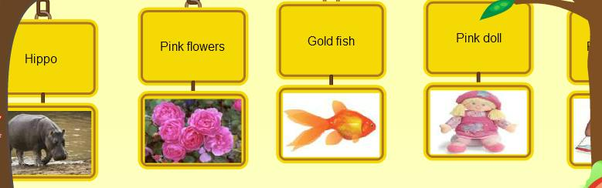

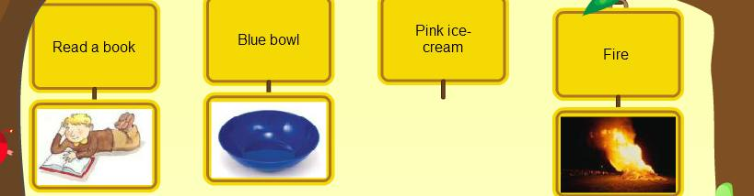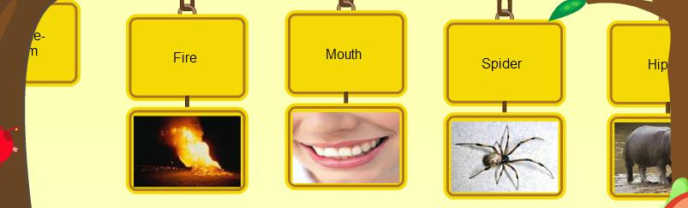
Section 2: WHAT’S THE ORDER?

Question 1:
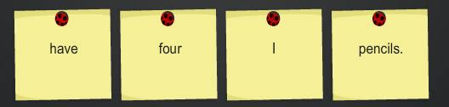

…………………………………………………………………………………………..
Question 2:
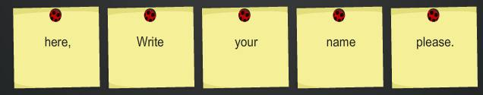

…………………………………………………………………………………………..
Question 3:

…………………………………………………………………………………………..
Question 4:
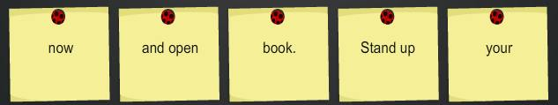

…………………………………………………………………………………………..
Question 5:
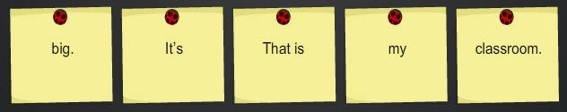

…………………………………………………………………………………………..
Question 6:
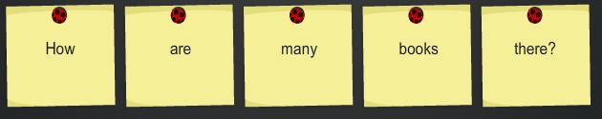

…………………………………………………………………………………………..
Question 7:
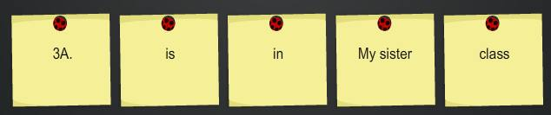

…………………………………………………………………………………………..
Question 8:
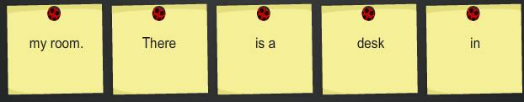

…………………………………………………………………………………………..
Question 9:
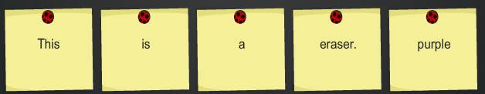

…………………………………………………………………………………………..
Question 10:
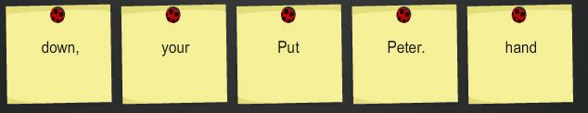

…………………………………………………………………………………………..

Section 3: Find the honey.
