200 CÂU ĐỀ THI IOE LỚP 3 VÒNG 20 (CẤP HUYỆN) NĂM HỌC 2011-2012
Bài thi số 1/Defeat the goalkeeper(thủ môn bắt bóng), khoanh vào chữ đặt trước câu trả lời đúng.
1/Is your …… name Le Kim Dong?-No,it’s Le Kim Dong.
a.middle b.first c.family d.full
2/Linda is calling and Emma is …… the telephone.
a.speaking b.telling c.answering d.saying
3/Odd one out:
a.piano b.guitar c.singer d.violin
4/Red is my….. colour.
a.favourite b.interesting c.beautiful d.like
5/Would you like to play basketball?-……Good idea!
a.I like b.I love it c,I’d love to d.I want
6/Excuse me.Can I sit here?-……….
a.Sure! b.Here you are! c.Yes,I can. d.I’m sure
7/I’d like to send this letter…. China.
a.to b.on c.in d.at
8/Ann and her brother…… at home yesterday
a.didn’t are b.wasn’t c.weren’t d.not were
9/Choose the word that has the underlined part pronounced differently:
a.wet b.chess c.yesterday d.pretty
10/Odd one out:
a.playing b.learning c.writing d.evening
11.Don’t let your brother… the present.
a.to see b.seeing c.see d.sees
12.How…do you study in the school library?-Every afternoon.
a.usually b.never c.sometimes d.often
13.We are…work at the moment.
a.on b.in c.at d.with
14.What is Elena’s date of bith?-…..
a.September 2nd b.September and 2nd c.2nd and September d.September 2
15.Why does Alex go to the….?-Because he has a toothache.
a.teacher b.nurse c.policeman d.dentist
16.I can’t watch TV because I have too….homework.
a.much b.very c.a lot d.many
17.Odd one out:
a.player b.worker c.painter d.teacher
18.The book is open in front….her on the desk.
a.of b.to c.with d.by
19.May I have…sugar?
a.one b.a c.some d.many
20.Choose the word that has the underlined part pronounced differently
a.great b.clean c.teacher d.beans
21.My father has a letter…his friend in Singapore.
a.of b.from c.to d.down
22.What time…the movie start?-At 7 pm.
a.do b.does c.is d.are
23.Is this your…time in Hanoi?-Yes,it is
a.one b.two c.first d.new
24.There are 28…29 days in February.
a.in b.on c.or d.and
25.On the table,there were vegetables,bread and two large…
a.bowl of soup b.bowl of soups c.bowls of soups d.bowls of soup
26.My father never drinks… coffee for breakfast.
a.much b.many c.any d.A&C are correct
27.Which is the third month of the year?-……
a.January b.March c.August d.November
28:….. noodles for dinner last night?
a.Did you eat b.Were you eat c.Did you ate d.Do you ate
29.Odd one out:
a.playing b.learning c.writing d.evening
30/Choose the word that has the underlined part pronounced differently:
a.tired b.fish c.thing d.sick
31/Tommy is 10 years…but he’s very tall.
a.age b.old c.high d.long
Bài thi 2/What’s the order(thứ tự nào đúng)
1/
2/
3/
4/
5/
6/
7/
8/
9/
10/
11/
12/
13/
14/
15/
16/
17/
18/
19/
20/
21/
22/
23/
24/
25/
26/
27/
28/
29/
30/
31/
Bài thi 3/LEAVE ME OUT(LOẠI CHỮ CÁI THỪA)
1.n e a v e r:_______________________
2.b u i l i d i n g;____________________
3.s e a r s o n:______________________
4.f r o n u t:________________________
5.b e h i n a d:______________________
6.t h w i c e:_______________________
7.c h a l e n d a r:___________________
8.o r t a n g e:______________________
9.f i n e l d:________________________
10.m i l d d l e:_____________________
11.s o m i l e:_________________________
12:w i n v i t e:________________________
13.m u s t e u m:_______________________
14.s o r e r y:_________________________
15.c i r c i l e:_________________________
16.h u n i g r y:________________________
17.c a n e d y:_________________________
18.b r o w o n:_________________________
19.s o w e e t:__________________________
20.p u z z a l e:_________________________
21.l a c k e:____________________________
22.r o p u n d:__________________________
23.p i l a c e:___________________________
24.m a t e t e r:__________________________
25.g u i s t a r:___________________________
26.f a s t h e r:___________________________
27.c a l w a y s:___________________________
28.p r e y t t y:____________________________
29.a g r a i n:______________________________
30.m i l d d l e:_____________________________
31.m i r s t a k e:____________________________

LỚP 3 - VÒNG 20 – NĂM HỌC 2012 - 2013
Section 1: SMART MONKEY
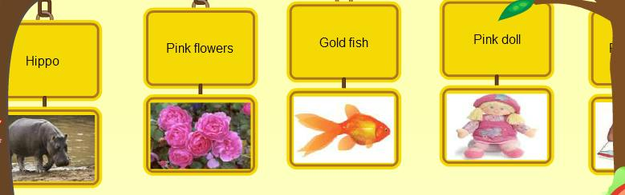
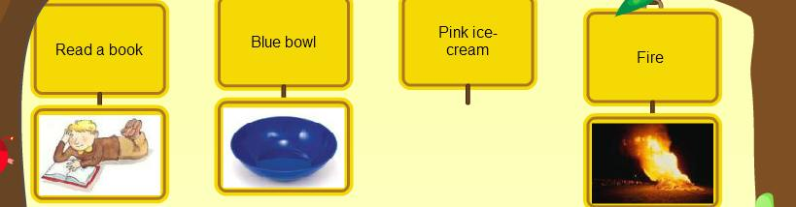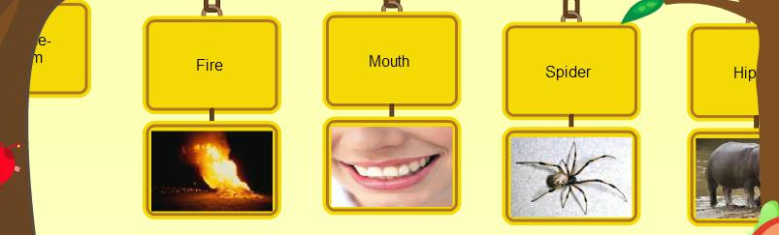
Section 2: WHAT’S THE ORDER?
Question 1:
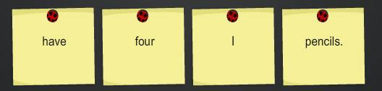
Question 2:
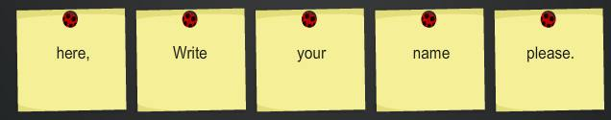………………
Question 3:
………………Question 4:
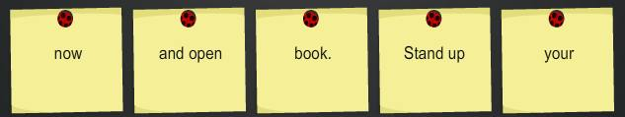………………
Question 5:
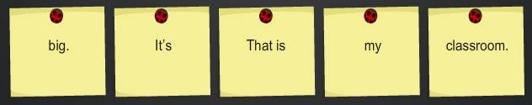………………
Question 6:
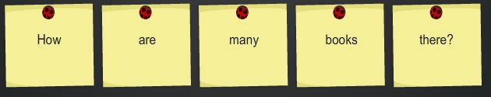………………
Question 7:
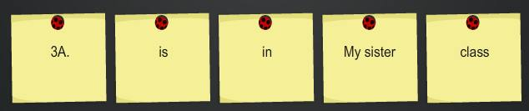………………
Question 8:
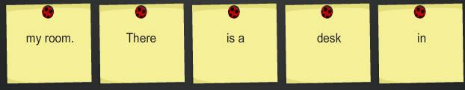………………
Question 9:
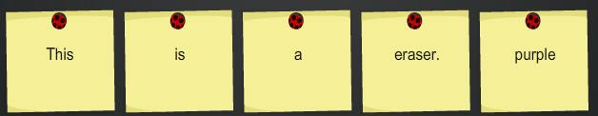………………
Question 10:
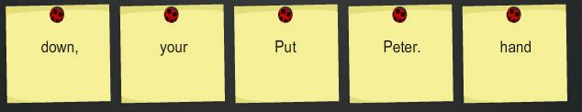

Section 3: Find the honey.
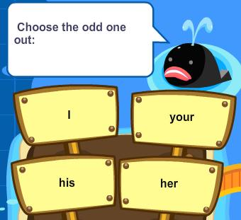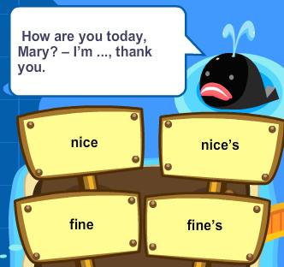
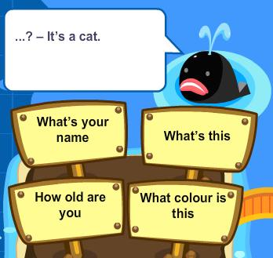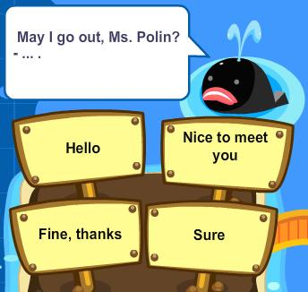

Chúc các em học giỏ i!

IOE LỚP 3 VÒNG HUYỆN NĂM 2012-2013
-----------
1/ friend, /Mary /my /is / too.
………………………………………….
2/ He /Jim /is talking./ sleeping. / isn’t
………………………………………….
3/ How are you? –I’m fine. Thank you._ _ d you?
4/_ _ _ many dogs do you have? I have two dogs.
5/ Point ….. the maps, children.
a.in b.at c.to d.on
6/ This is my aunt……young and pretty.
a.she’s b.she’s is c.He d.He’s
7/ in/ my bag./ two / There are / pencils
……………………………………….……
8/ black board, / at / Look / please. / the
……………………………………………
9/ I have a parrot. How …….ut you?
10/ Hello. I ….Peter. Nice to meet you.
11/ This is my friend, Andy. ……..
a.It’s nice to meet you b. It’s nice too meet you
c.It’is nice to meet you d.She is my friend,too
12/…..you tomorrow, Alice. _Goodbye
a.See b.See’s c.See you d.Bye
13/is / Jack’s sister / doing / What / in the garden?
…………………………………………………
14 /a year?/ months/ are / there in / How many
…………………………………………………
15/ Look …. The blackboard, please.
16/……your books pink? _ Yes, they are.
17/……’s her name? _ Her name’s Kathy Brown.
18/ That’s Alice. ....my new friend.
19/ and an / eraser./ two/ I have/ rulers
…………………………………………………
20/ mother/ the/ My /kitchen./ is in
………………………………………………….
21/ This is my loving m……… I call her “Mummy”
22/ She’s beautiful. And who’s this? _ It’s my elder brother. H…. name Trung
23/….is that? That’s Mary. She is my friend.
a.How b.when c.who d.where
24/ My sister…..got two new dolls.
a.have b.is c.has d.am
25/ red/ crayons./ These /are
……………………………………………..…..
26/ there/ eleven hours/ in /a day?/ Are
…………………………………………
27/ Is the ball …..er the table yours?
28/ How old is jim? He is …years old.
29/ Mary goes to school library to….books.
a.read’s b.reads c.read d.read to
30/ Where are my dolls?_ They are ….. the floor.
a.in b.at c.under d.on
31/ on/ a/ picture / Let’s draw / the wall.
……………………………………………..………
32/ your dad and mum? / these/ Are / photos / of
……………………………………………………..
33/ This is the way I c…… my room.
34/…… is that ? That is my young brother.
35/……is my best friend.
a.My b.He c.Her d.It
36/ Who is she,Peter? ………
a.she Mary b.He’s Tom c.She’s Mary d.My name is Mary
37/ Your brother’s / at / the desk./ ball / is
…………………………………………
38/This / is / my/ father’s / car.
…………………………………..
39/ How ……y cats does Lan have? She has two.
40/Is your school small? ……., it’s big.
41/ ….out your book.
a.Take’s b.Take c.takes d.To take
42/Do you have a…..?
a.doctor b.nurse c.sister d.brother
43/ colour/ What / pens? / those / are
………………………………………….
44 / go to / morning / school / I / every
………………………………………….
45/ S…..you again, students.
46 /Let’s m……. a line, children.
47/ May I go out? …….
a. Hello b.nice to meet you c.Fine, thanks d.sure
48/ What are ……? …….cassettes.
a.they/ There are b.they/ It’s c.this/ It’s d.these/They’re
49/ and fat./ this / is my mother./ She is / young
……………………………………………………
50/ the / words./ down /Copy
………………………………..
51/ How are yoy ?- I’m fine, th……
52/ My brother is a teacher. Oh! My sister is a teacher, t…
53/…..are three bedrooms in my house
a. What b.That c.There d.how
54/ What is Tim’s younger brother doing ? _He……..
a.are skating b.skating c.is skating d.skate
55/ nice / meet / you./ It’s / to
……………………………………..
56/ English in / is learning / little sister / Mary’s / her bed room.
………………………………………………………………
57/ I play hide-and-seek at my breaktime. …..t’s play together.
58/……is she? –She Mr.Wilson. She my English teacher.
59/ Is…….a flower? Yes. That is a flower.
a.that’s b.that c.this d.this is
60/…….., teacher?Sure.
a.Stand up b.Open your book c.who is he d.may I go out
61/ new / are / These / jeans. / my father’s
……………………………………………….
62/ nice to / I’m jane./ see you./ Hi, / it’s
……………………………………………
63/ Do you like pl………g badminton? No, I don’t.
64/ His classroom is b_g. It’s not small.
65/ Read….. me, please
a.on .to c.after d.in
66/ Odd one out:
a.cloudy b.rainy c.sunny d.weather
67/ don’t / I / books./ reading / like
……………………………………………
68/ this / your / box? / Pencil / Is
…………………………………….
69/ -John: This is my sister. – What is …..r name?
70/ How are you to…..y, David? _I’m fine, thank you.
71/ Odd one out:
a.sunny b.rainy c.windy d.cloud
72/ Who’s that ? - ………..
a. That’s my sister b. It’s my family
c. It’s my house d. He is a police
73/ boys./ Let’s/ count/ the
………………………………………………………
74/ that desk./ erasers/ There are/ two/ on
………………………………………………………….
75/ Is …….,… a dog? – No, there is not.
76/ This is my flat. There is a big li___g room.
77/ We need to find the…………..
a. bears b. bees c. boys d.books
78/ Odd one out:
a. its b.his c. she d. her
79/ this / your / pencil /case?/ It
…………………………………………………………….
80/ on/ sleeping/ your dog/ Is/ the flour?
……………………………………………………………..
81/This is Jack, my friend. He is fourteen……...rs old.
82/This is my fa……….er. He is an engineer.
83/What is that? -…………
a.It is my dog b. That is my sister c.They are my dogs d.it is Nam
84/Let’s…….…. a song, children.
a.sing’s b.sings c.sing d.the sing
85/the schoolyard? / they / are / What / doing in
…………………………………………………….
86/apple / sees / a / giant / She
……………………………………..
87/Is this the w…. we go to school?- yes, it is.
88/w….. is that? That’s jenny. She is my friend.
89/How many kites are there? ………
a.One kites b. It’s two kites c. Two kites d.Three kites
90/………is your computer? –It is black.
a.What b.What colour c.How When
91/nice to / It is / meet you, / mrs, hill. too,
…………………………………………..
92/very /beautiful / are / Those / flower./
……………………………………………..
93/What are Tom and his younger sister doing?
–They are lis….. to music together.
94/my bag is …. The table.
95/Can you play the piano/ ……….
a.Yes, I can’t b. No, I can c.Yes, they are d.Yes, we can
96/What are these? ………
a.It’s a bicycle b.They’re bicycles c.They’re bicycle d.It is bicycle
97/colour?/ is / favourite /your / What
………………………………………………
98/ Peter and mary/ the school / gate./ at/ are
…………………………………………………
99/This is my school. It.. name is London Primary School
100/……., I’m Simon. Nice to meet you.
101/Pizza is my favourite…………
a.drink b.food c.apple d.milk
102/Come and play with……
a.to b.my c.I d.me
103/ isn’t / watching / My / TV now./ grandmother
………………………………………………………….
104/ I am / in / school / Nguyen Thi Minh Khai primary / a student
…………………………………………………………………..
105/ There are many things in the ………..oom.(nghe)
106/How many rulers a…… there on the table?
107/Is this an eraser? ……, it is.
a.a b.An c.No d.Yes
108/open your school bag,………………
a.out b.please c.thanks d.too
109/milk / you / Do/ and fish? / want
…………………………………………..
110/crayon / me / the / ,please. /Give
…………………………………………..
111/Lan, this is my new school. – What,s ……….. name?
112/Put your pencils a_ay, please.
113/Goodbye. -……..
a.Bye.See you soon b.Hi. I am Nam
c.Good morning. Sit down,please d.Nice to meet you
114/These are Lan and nga. ….. my friends
a.These b.She’s c.They’re d.It,s
115/ I /borrow /your / May / ruler?
…………………………………….
116/The /red ball / is / the dog. /behind
…………………………………………
117/C…….. here , Peter. Let’s play with us.
118/ There are four teddy bears on the c……….rs.
119/Odd one out:
a.open b.is c.sit d.stand
120/ Is your classroom big? -……, it,s small.
a.Yes b.yes, it isn’t c.No, it is d.No
121/your friend. / “Hello” / say / to / Let’s
………………………………………………
122/my / in / a book case / room. / There’s
……………………………………………….
123/ Nice to meet you, Paul. – Nice to meet you, t……..
124/ Goodbye , Alice. …… you later.
125/There are two mirrors in the ……. (nghe)
a.bedroom b.big room c.bathroom d.living room
126/ How …… cats are there ? two cats.
a. much b.old c. many d.for
127/ the table/ six crayons / There / on / are
………………………………………………
128 / and / see / you / again . / Goodbye
……………………………………………
129/ G…..dbye. See you later.
130/ Thank you. – You are w…...come.
131/Who’s that? _ That’s Miss White. ……... is my teacher.
a.He b.Her c.She d.It
132/ Who is he ?-…….
a.She’s fine b.She’s Mary c.He’s Tom d.I’m fine,thanks
133/ eraser. / Pick up / and / your /ruler
………………………………………….
134/ do / Let / puzzle. /a / us
…………………………………..
135/……e is my English book ? It is on the table
136/Sing wit… me , Jane.
137/ What is this ? -…………
a.This is rulers b. It is a ruler c.It is an ruler d. They are rulers
138/ Odd one out:
a.how b.what c.who d. many
139/do/ How many / dogs / have? / you
……………………………………………
140/your / pencils / children./ away,/ Put
……………………………………………
141/ Wr……. Your name here, please.
142/ What colour is this rose / - It,s p………
143/Who’s …….? It’s ……. Baby suster, Trang.
a.this/ I b.this /Is c.this / my d.this / an
144/ Is this a crayon ? - …….., it isn’t.
a.Not b.No c. Yes d. Yes, it is
145/This / a / red and white/ ruler . / is
…………………………………………..
146/brother’s / that / house? / Linda’s / is
………………………………………….
147/ How ….d is Mary? – She is seven.
148/
149/Odd one out :
a.classroom b.living room c.bedroom d.bathroom
150/I…….. books in the school library.
a. stand b. sit c. write d. read
151/ mess./ a / make / Don’t
………………………………….
152/ you / to music? / like /listening /Do
……………………………………………..
153/That is my caring father . I call …….m “Daddy”
154/……o is that ? –That’s my brother.
155/ Odd one out:
a. repeat b.listen c.read d. am
156/ Odd one out:
a. eraser b.purple c.map d. ruler
157/ aloud/ Red/ and/ sit down. / then
. …………………………………………….
158/ are there/ students/ in/ your classroom?/ How many
……………………………………………………...
159/ That m……over there is Mr Nam.
160/ There are two clock… on the table.
161/ What color…… her pens? - …….. green and red.
a. is/ It’s b. are/They’re c. are/There are d. is/ They’re
162/ Pick …………. Your pen, children.
163/ There are/ tables/ my classroom./ in/ ten
…………………………………………….
164/ the/ answer, / Cride/ children
……………………………………………
165/ What is the……...e of your primary school? – It is Ba Trieu Primary School.
166/ I ca….. my grandfather grandpa.
167/ ……, students.See you later.
a. Good morning b. Good night c. Goodbye d. Nice to meet you.
168/ Do you clean your…………… ? (nghe)
a. bedroom b. art room c. bathroom d. classroom
169/is / brown / a / This / chair.
…………………………………..
170/ talking / about family? /your / Are / friends
……………………………………………………
171/ Let’s make a c………. (nghe)
172/What do you do at break time ? –I often c….. with my friends.
173/……your teeth, John.
a.Read b.Listen c.Stand d.Brush
174/The robot is ….. along the ground.
a.skipping b.sitting c.skating d. chasing
175/ three /long /are / crayons. /There
………………………………………….
176 / There / six days / aren’t / in /a week .
……………………………………………
177/ Is your classroom big? – No, it …n’t.
178/ I like to eat pizza v….y much.
179/ These are pink and white…….
a.a cloud b.clouds c.cloud d.a clouds
180/He ….. to school every morning
a.go b.go’s c.goes d.goes to
181/you /give / Can / that pencil ? / me
…………………………………………
182/ The / flower vase. / the /flowers /are in
………………………………………………
183/Wa….. your hands, please.
184/ Jim and his friend have two hats. T….. are yellow.
185/ How are …., Tom? Fine, thanks. And you?
a.you b.you’re c.your d.he
186/How are you? ……..
a.fine, thanks b.Nice to meet you c.My name’s Sean d.See you later
187/ the table./ There are / books / five / on
…………………………………………..
188/ fine / you? / ,thank you. /And / I’m
………………………………………..
189/Thy are very happy in their small ……..y. (nghe)
190/How m…….. rulers are there ? –Three rulers
191/Nice to meet you. -…………….
a.Goodbye b.See you later c.Nice to meet you,too d.Good morning
192/What’s his name? …………..
a.Fine, thanks b.Nice to meet you, too c.His name is John d.He is my friend
193/ lines, /make / Let’s /please . /two
…………………………………………
194/……is Lan’s grandmother?- She is ninety years old now.
a.What b.How c.How many d.How old
195/……? – She’s my grandmother.
a.Who’s he b.What’s this c.Who’s she d.How are you
196/What’s your name?- ……….
a.Nice to meet you, too b.My name’s John c.I’m fine, thank you d.Goodbye
197/Is your school white? -………..
aYes, it isn’t b. No, it is c.No, is it not d.Yes, it is
198/ Hello.My name is Minh. -………….
a.Fine, thanks b.Hi, Minh. I’m Lan c. I’m ten d.Goodbye
199/What are …..?-……….cassettes.
a. they /There are b.they /It’s c. this/ It’s d.these /They’re
200/ Good morning, Miss white!........
a.Bye, children b.See you again, children
c.Good morning, children d.Fine, thanks. And you
201/.our classroom. / is / This
…………………………………..
202/.bedroom. /my /is /This
…………………………………..
203/.There are /my school bag./ ten /in / pencils
……………………………………………..
204/.a /hat ./ yellow / This /is
…………………………………
205.to / Point /the / teacher.
……………………………………….

Chúc các em học giỏ i!
Wish you good student!

