WHAT’S THE MATTER WITH YOU?
I.Complete the words:
- To__tha__he | - F__v__r | - E__rac__e | - __tom__chac__e | - P__in
- S__re t__roat | - Fl__ | - H__ad__che | - __atte__ | - S__ou__d
- C__rry | - B__cka__he | - D__nt__st | - W__ll | - Do__to__

II.Read and match:
- What’s the matter with you? | - She shouldn’t eat a lot of sweets.
- Nam has a toothache. | - I have a headache.
- Phong has a fever. | - She shouldn’t carry heavy things.
- Mai has a stomach ache | - He should go to the dentist.
- Quan’s grandmother has a backache. | - He should stay in bed.
- Miss Hien has a sore throat. | - She should take a rest.
- My mother has a headache. | - He shouldn’t watch much TV.
- His brother has sore eyes. | - She should take some warm water.
III.Put the words in order to make sentences:
- What’s /your /the /with/ matter/ mother/?
- I/ a /throat/ sore /have/.
- eat /I /speak /can/ not/ or/.
- You /doctor/ should/ to/ the /go/.
- Eat/ You /shouldn’t /ice-cream.
- to /should/ go /the/ He /dentist/.
- Should/ Mr. Tuan/ a/ take /rest/.
- He / heavy /carry /shouldn’t/ things/.
- had /Quan /to /the/ headache/ doctor/ because/ went/ he /a/.

- school / Mai / bad /come/ to /can’t /because/ she/ cold /has/ a/.

- well/ I /feel /don’t/.
- I /get/ you/ will /well /hope/ soon/.
- My /backache /has/ grandfather /a/.
- I’m /health /sorry /to /about/ hear/ very/ your/.
- What’s/ your /the /with /matter /sister/?
IV.Complete the sentences with the following words:
Sore throat – backache – headache – toothache – stomach ache – fever
- Trung had a …................................. last week. He couldn’t speak.
- Nam went to the dentist yesterday because he had a …................................. .
- Quan is in bed and feels very hot. He had a …................................. .
- Phong’s grandpa has a …................................. . He can’t carry heavy things.
- Trung had a …................................. last night because he ate too much at dinner.
V.Make sentences as the examples.
Ex: How/ Son/ feel? (tired) How does Son feel? – He feels tired.
- How/ Lan/ feel? (hot)
...............................................................................................................................................................................................
- How/ Nam and Quan/ feel? (cold)
...............................................................................................................................................................................................
- How/ you/ feel? (thirsty)
...............................................................................................................................................................................................
- How/ they/ feel? (hungry)
...............................................................................................................................................................................................
- How/ workers/ feel? (tired)
...............................................................................................................................................................................................
VI. Find the odd one out:
1.a. cough b. weak c. headache d. sore throat
2.a. sunburn b. toothache c. earache d. unhealthy
3.a. sick b. temperature c. tired d. weak
4.a. flu b. stomachache c. cold d. fat
5.a. sleep b. happy c. live d. smile
6.a. feel b. healthy c. well d. tired
7.a. fat b. big c. matter d. small
8.a. fever b. dentist c. nurse d. doctor
VII.Find and correct the mistake:
- Last week my family move for a new house.
- What’s the matter of you, Lan?
- Don’t stay up so early, it’s bad for your health.
- He has strong white teeth because he brush his teeth regularly.
- She should goes to bed early.
- My father have a sore throat.
- What didn’t Nam go to school yesterday?
- Where are you yesterday?
- We are going to visited our teachers.
- She can’t speak because she has an sore throat.

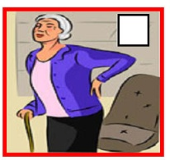
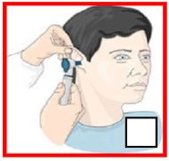
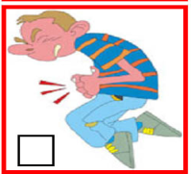
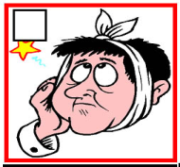
Ex 1: Look and write

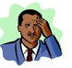
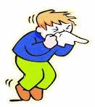
.. ............... …………… ………… ………….. ……………..
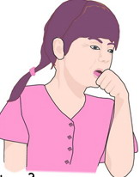
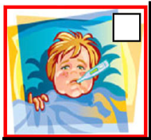
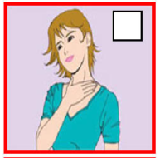

. ………… ……………… …………….. …………… ………………
Ex 2:
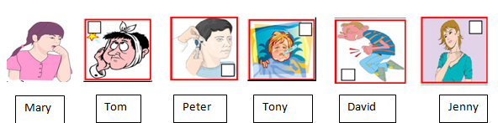
Part 1: Look and answer
- What’s the matter with Mary? ………………………………………………
- What’s the matter with Tom?...........................................................................
- What’s the matter with Peter? …………………………………………………
- What’s the matter with Tony?.............................................................................
- What’s the matter with David?............................................................................
- What’s the matter with Jenny?.............................................................................
Part 2: True or False
- Jenny has a toothache.
- Tom has a runny nose.
- Tony has a fever.
- Mary has a cough.
- Peter has a earache.
- David has a backache.
Ex 3: Read and write
- I have a pain in my teeth. I have a…………….
- Tony has a high temperature. He has a……………….
- Mai has a pain in her throat. She has a………………..
- I have a pain in my back. I have a…………………….
- Thu has a pain in her stomach. She has a…………….
- My father has a pain in his ear. He has a……………..
- He is cold. He has a ……………………………………
- I broke my arm. I have a…………………………..
Ex 4: Read and match
A |  | B
- I have a headache. |  | - You should take a bath in warm water.
- I have a backache. |  | - You should take vitamins.
- I have a toothache . |  | - You should go to the dentist and brush your teeth after meal.
- I have a sore throat. |  | - You should see a doctor and shouldn’t watch too much TV.
- I have a bad cough . |  | - You should take some aspirins
- I have a stomachache. |  | - You shouldn’t drink cold drink.
- I have a fever. |  | - You shouldn’t lift heavy things.
- I have a flu. |  | - You should take cough syrup.
Ex 5: Giving advice by using “ should” or “shouldn’t”
stay up late, drink coffee, do morning exercises regularly, take a hot bath, go to bed early, eat a lot of fruits and vegetables, take some aspirins, see the doctor, drink hot water, brush your teeth twice a day, eat healthy foods, keep your nails short and clean, wash your hands before having meals, see the dentist, eat many candies, drink cold water, eat too much,

 | Should | Shouldn’t
- Tony has a bad toothache.
- Quan has a bad cold.
- Phong has a stomachache.
- Phong has a sore throat.

