What subject do you have today ?
1.Look at the words in the list below and write them under the picturers
- Maths
- Science
- English
- ICT
- Geography
- History

- Physical Education
- Art
- Music
- Design and Technology

2.______________

1.___________________

3.___________________

4._______________

5._______________

6.___________________

7.___________________

8.__________________

2.Read and match the subjects.
1.This subject teaches you how to read and write . | a.maths
2.This subject teaches you the name of rivers and moutains language. | b.Vietnamese
3. This subject teaches you all the things that happened in the past. | c.geography
4. This subject teaches you how to make additions and subtractions. | d.music
5. This subject teaches you do indoor or outdoor. | e.history
6. This subject teaches you how to sing and play instruments. | f. I.T
7. This subject teaches you how to use computers and programmes. | g. P.E
3.Look at the timetable and write about the subjects with a “tick” 
 | 07:15 | 08:00 | 08:45 | 09:30 | 10:15 | 11:00
Monday |  |  |  | 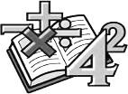 | 
Tuesday |  |  |  | 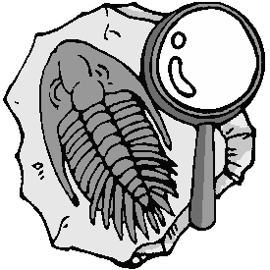 |  | 
Wednesday |  |  |  | 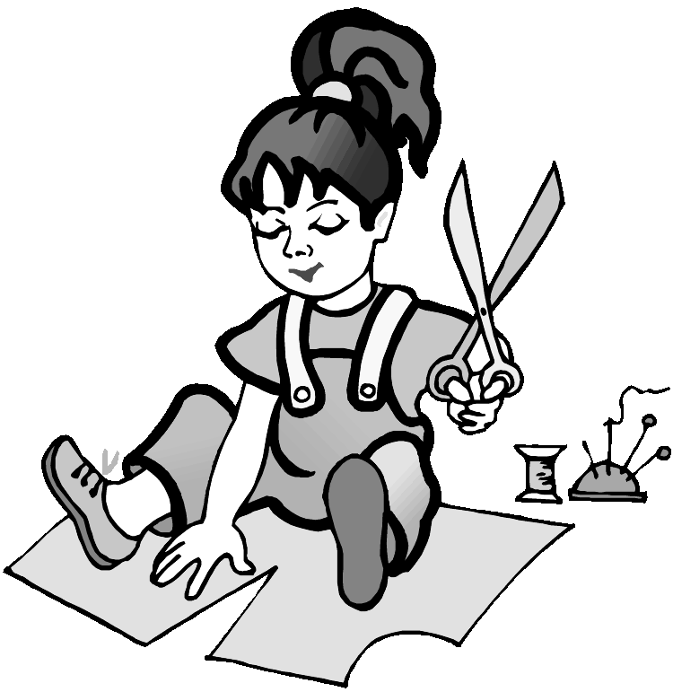 |  | 
Thursday | 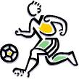 |  |  |  | 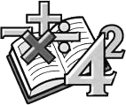
Friday |  |  | 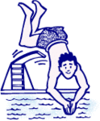 | 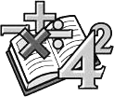
Saturday |  |  | 
Sunday |  |  |  |  | 

On Monday I have ______________________at ____________________.
On Tuesday I have ______________________at ____________________.
On Wednesday I have ____________________at ____________________.
On Thursday I have ______________________at ____________________.
On Friday I have ______________________at ____________________.
On Saturday I have ______________________at ____________________.
On Sunday I have ______________________at ____________________.
4.Odd one out:
1.a. Maths b. IT c. favourite d. Science
2.a. green b. black c. yellow d. colour
3.a. have b. has c. do d. swing
4.a. morning b. swimming c. cooking d. dancing
5.a. Thursday b. Monday c. yesterday d. Sunday
6.a. five b. fifth c. third d. first
7.a. on b. collect c. in d. to
8.a. my b. I c. her d. his
9.a. stamp b. model c. make d. toy
10.a. bike b. kite c. boat d. sail
11.a. two b. three c. nine d. second
12.a. does b. have c. goes d. has
13.a. month b. year c. large d. day
14.a. art b. subject c. Music d. English
15.a. school b. teacher c. mother d. brother
16.a. new b. colour c. big d. old
17.a. timetable b. sing c. collect d. sail
18.a. today b. tomorrow c. yesterday d. Tuesday
5.Fill in the blank with a suitable word:
1.My ____________ subjects are Maths and English.
2.We have IT and PE ____________ Thursday and Friday.
3.I like _______________badminton.
4.What do you like______________? I like __________ stamps.
5.What is your__________? I like swimming and sailing a boat.
6.Taking _____________is my hobby.
7.What do you have today? I ____________ Music, Vietnamese and History.
8.She likes ____________ to music.
9.He goes ___________ school from Monday to Friday.
10.What ___________ do you have on Tuesday? – I have Maths, Science, and Music.
11.She __________Maths and English on Monday.
12.__________you have PE on Thursday ?
13.Do you have music on Saturday ? No , I ___________.
14.What subject _________Alex have today ?
15.He _________Art on Friday.

6.Look at the timetable ,tick the right answer.

 | MONDAY | TUESDAY | WEDNESDAY | THURSDAY | FRIDAY
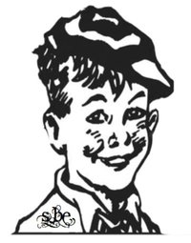  SAM |  | 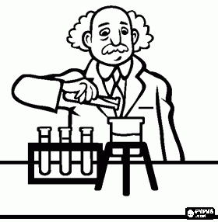 | 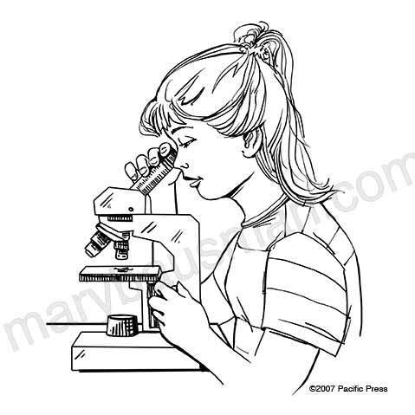 |  | 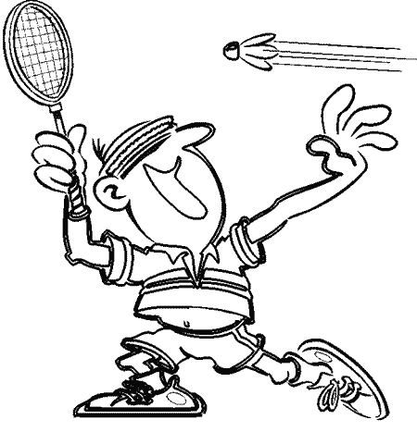
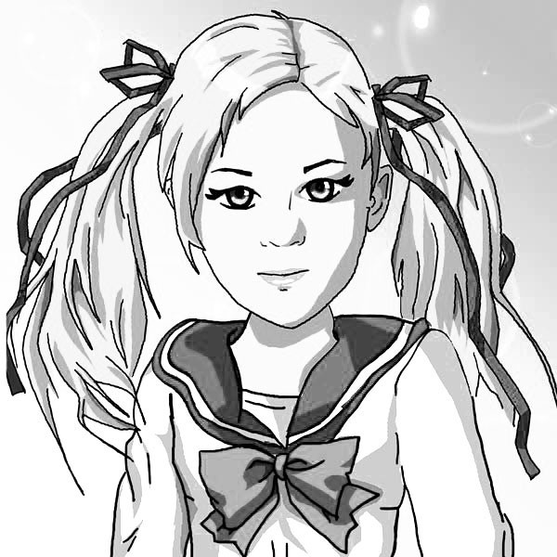  CAROL | 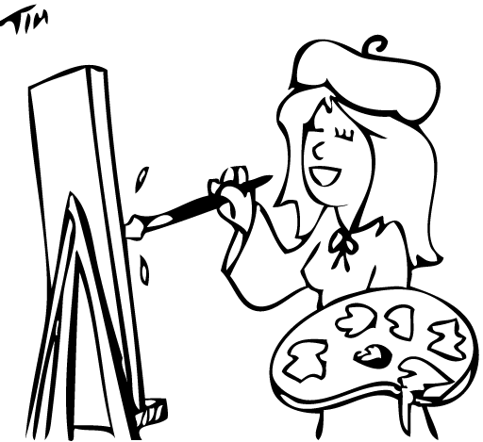 | 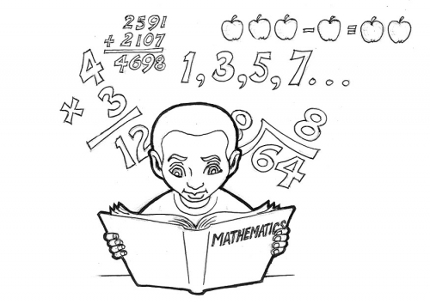 |  |  | 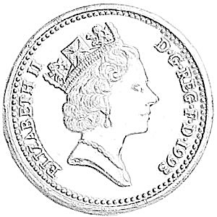
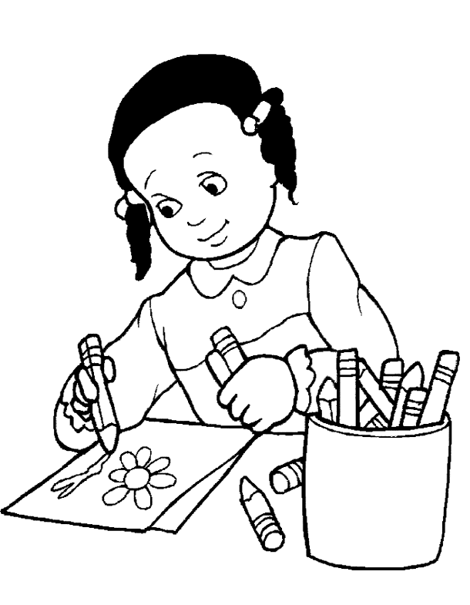
BETTY

☐ true ☐ false
☐ true ☐ false
☐ true ☐ false
☐ true ☐ false
☐ true ☐ false
☐ true ☐ false
☐ true ☐ false
☐ true ☐ false

1.Carol has Music on Wednes
2.Carol and Betty haven’t French on Monday
3.Betty has PE on Tuesday
4.Carol hasn’t French on Friday
5.Sam has technology on Thursday
6.Carol has Maths on Thursday
7.Betty has English on Wednesday
8.Sam has PE on Thursday

7.Find and correct the mistake:
- She have Maths, Art and English.
- I like play chess and table tennis.
- My mother cans cook very well.
- My friends like take photographs very much.
- She doesn’t has Science on Tuesday.
- We’re late to school. Let’s run.
- Music and Art is my favourite subjects.
- IT is physical education.
- When do he have Science? He has it on Monday and Wednesday.
- I am a pupil on Quang Trung Primary School.

