WHAT ARE YOU READING? – Part 1
Test 1
I.Choose the odd one out:
- A. fox B. crow C. lamp D. hare
- A. kind B. gentle C. story D. clever
- A. generous B. hard-working C. brave D. character
- A. reading B. evening C. speaking D. helping
- A. ghost B. generous C.beautiful D. interesting

II.Fill in the stentence

swimming running walking surfing skiing shopping dancing sitting painting sleeping talking climbing
1.I am _____________. 2. I am ________________.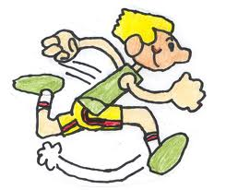
3.I am _____________. 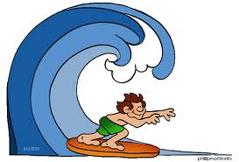4. I am ______________. 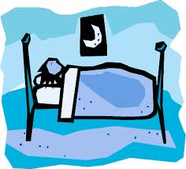
5.I am ______________. 6. I am ______________.
7.I am ______________. 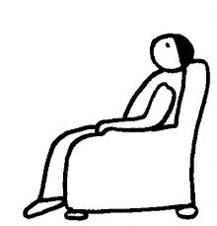8. I am ______________. 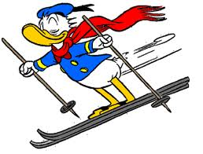
9.I am _______________.10. I am ______________.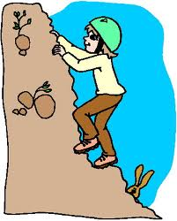
11.I am ________________.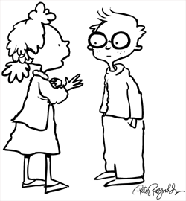12. I am _______________.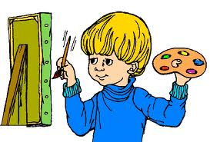

III.Reorder the sentences
1.like/ What/ Seven Dwarfs/ are/ like?
_____________________________________________________________
2.books/ are/ reading/ What/ you/ ?
_____________________________________________________________
3.in/ your/ What/ do/ free/ you/ time/ do/ ?
_____________________________________________________________
4.The/ is/ called/ main/ a schoolboy/ character/ Kudo.
_____________________________________________________________
5.She / and/ is/ The/ reading/ Crow/ Fox.
_____________________________________________________________
6.He/ stays/ and/ home/ comic books/ at/ read/ often.
_____________________________________________________________
7.very/ because/ I/ him/ he/ clever/ like/ much/ is/ and brave.
_____________________________________________________________
8.story/ I/ reading/ am/ Cinderella/ the.
_____________________________________________________________
9.in/ reading/ fairy tales/ her/ She/ time/ likes/ free.
_____________________________________________________________
10.it/ when/ can/ finish/ You/ it/ have/ I
_____________________________________________________________

IV.Fill in each gap in the passage with one suitable word and answer the questions
Today is Sunday . It is fine (1)_____warm . The Pikes (2)_______working in the house now . Mr Pike is cleaning the floor and (3)_________windows . Peter is (4)______him . Mrs Pike and Susan are in the (5)_________. Mrs Pike is (6)_______ the dishes . Susan is helping (7)_______.
The Pikes are (8)_________, but they are happy .
1.Is the weather fine?
_____________________________________________________________
2.What is Mr Pike doing?
_____________________________________________________________
3.Where are Mrs and Susan?
_____________________________________________________________
4.Who is helping Mrs Pike?
_____________________________________________________________
5.Are the Pikes sad?
_____________________________________________________________

