THEY’RE IN PARK
1.Complete with sound
ai
a-e

r_ _ ny | pl_t_ | c_k_
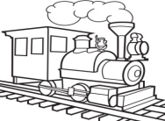  tr_ _n | 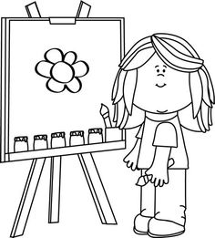  p_ _nt | pl_n_
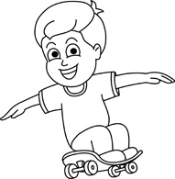  sk_t_ | sn_k_ | 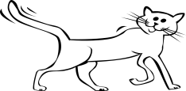  t_ _ l
2.Choose the correct word.
1. . | a.sunny b.rainy c.windy
2. | a.windy b.cloudy c rainy
3 . | a.snowy b.sunny c .rainy
4. 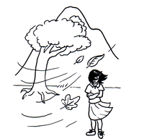 | a.windy b.sunny c rainy
5.. 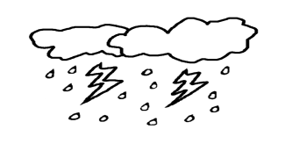 | a.stormy b.cloudy c rainy
6. . | a.snowy b.cloudy c .rainy
3.Look at the pictures and answer the questions.
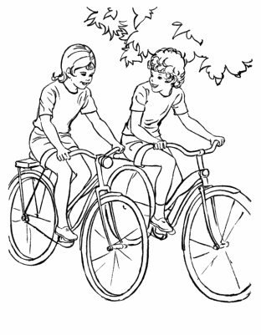  1.What are they doing ?  They're cycling. | 2.What are they doing ?  _______________________________
.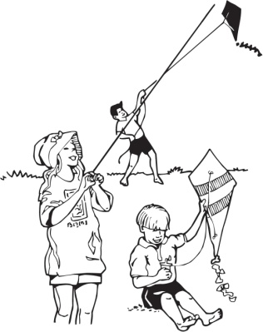  3.What are they doing ?  __________________________ | 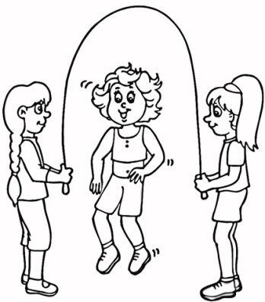  4. What are they doing ?  _________________________
.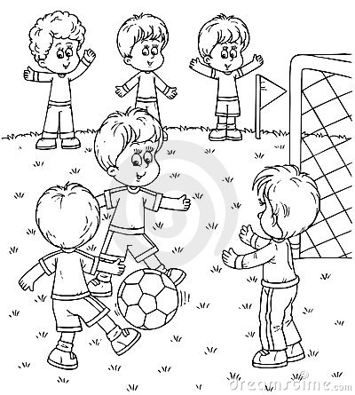  5.What are they doing ?  _____________________________ | 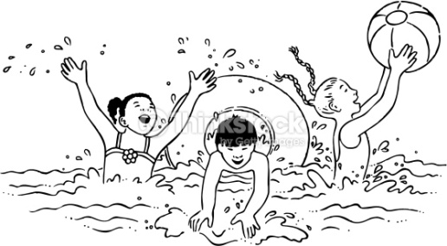  6.What are they doing ?  _________________________

4.Match
- How are you ? | - I am watching TV.
- What is your name ? | - I am good.
- How old are you ? | - I like train and puzzle.
- What is weather like today? | - There are two windows in the room.
- Is it sunny today? | - I like yellow and pink.
- What are you doing ? | - No, it isn’t.
- What toys do you like ? | - It’s sunny.
- What colour is this ? | - I’m seven years old.
- What colour do you like ? | - They are playong football.
- What are they doing ? | - This is green.
- How many windows are there in the room ? | - My name is Nam.
- Where are you cycling ? | - I am cycling in the park.
5.Put the wors in order.
1.What /you/are/doing ________________________________?
/I /playing /football/am/ _______________________________.
2.they/are/What /doing/ ________________________________?
/are/ They / cycling / park/the ___________________________.
4./weather /What / is / the /like /today / _______________________________?
/rainy /It /is / ____________________________________________.
5. is/It/ sunny /Ho Chi Minh / in /city ______________________________________________________________.
6.are /They/ playing /football /
________________________________________________________________.
6.Use the verbs in brackets to say what the person is doing .Correct the sentences.
1.He’s drawing . ( write)
He isn’t drawing .He’s writing.
2.They’re having breakfast .(play)
_________________________________________
3.He’s talking on the phone .(listen to music)
_________________________________________
4.They’re jumping. (swim)
_________________________________________
5.He’s sitting (stand )
_________________________________________
6.She’s walking. (run)
_________________________________________
7.Look at the picture.Read the question .Choose the correct and answer.

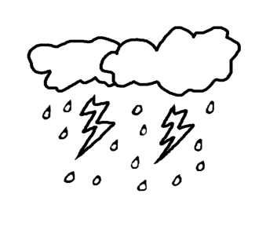  Is it stormy? | What is the wether like ? | Is it rainy ? | What is the wether like ?
Yes it is .  No , it isn’t .  It is stormy. | It’s sunny.  No ,it isn’t.  It’s sunny. | Yes it is .  No , it isn’t .  It is sunny. | It’s snowy.  No ,it isn’t.  It’s sunny

