HELLO
1.Write the missing letters.

N_ ce to m_ et you
Ho__ are you ?
G_ _ d by_
He_ _o

2.Read and match.
1. Hello , I’m Mai a. See you again , Linh.
2. Nice to meet you. b. I am Fine ,thank you.
3.How are you ? c. Nice to meet you too.
4.Goodbye, Mai . d. Hi, Mai . I’m Linh.
3.Complete the sentences.
Lan: Hello. I ______ Lan.
Nam: ______. I am ________
Lan: Nice_______ _______ you.
Nam: _______ to ________ _______, too.
Lan: How ______ you?
Nam: I am _________, Thank _______. And _______?
Lan: I am___________, thank you.
Nam: Goodbye.
Lan: Bye. See _____ ______.
4.Circle the odd one out.
a. hi b. hello c. bye
a. how b .Peter c. Tony
a. pink b. yellow c. ten
a. bye b. goodbye c. hello
a. thanks b. bye c. thank you
a. ten b. one c. apple
a. ant b. bee c. book
a. apple b. banana c. bike
5.Match and write.
__ ye
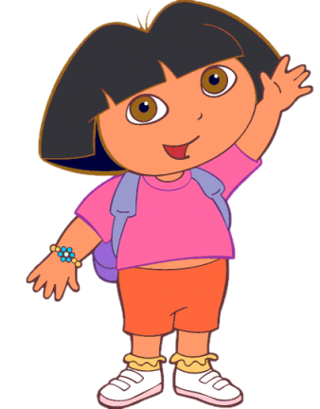
__ello
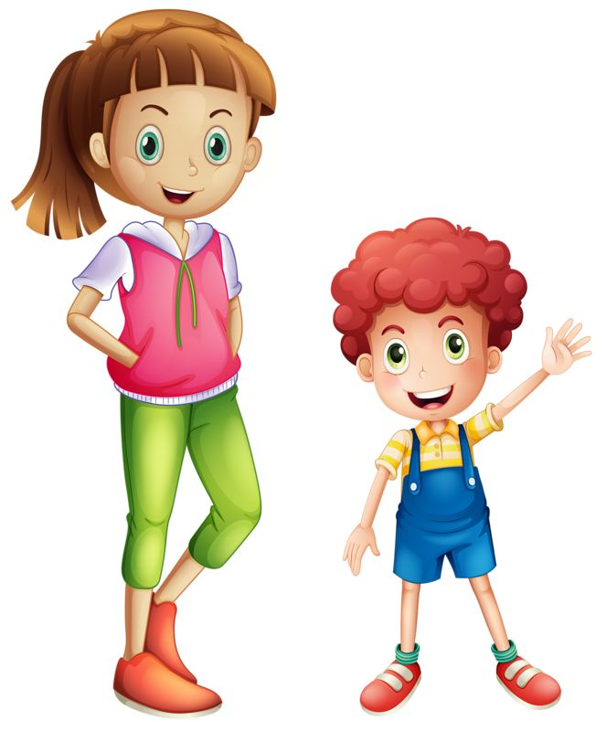
bye

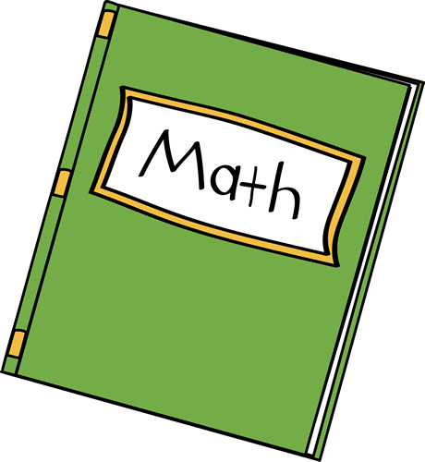
_____ ook
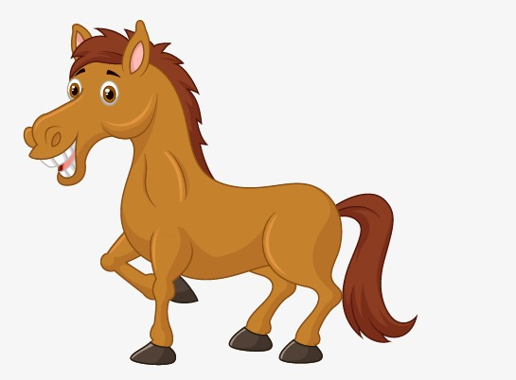
____ orse
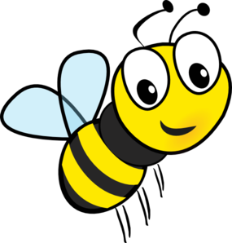
____ ee
h
b

6.Match and colour

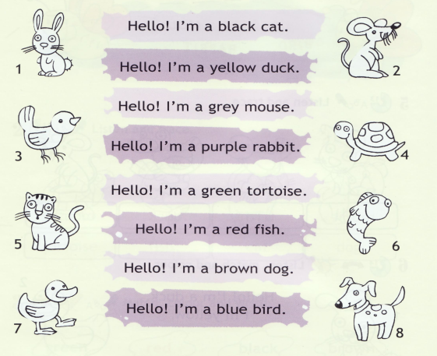
Hello ! I’m a black cat.
Hello ! I’m a yellow duck.
Hello ! I’m a grey mouse.
Hello ! I’m a purple rabbit.
Hello ! I’m a green turtle.
Hello ! I’m a red fish.
Hello ! I’m a brown dog.
Hello ! I am blue bird.

7.Write the alphabet.

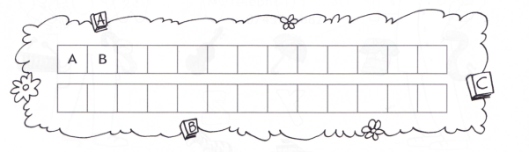

8.Choose and write.
Choose Hello How Vicky I’m (x2) you thank are
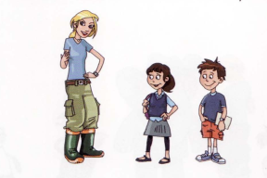
Rob : (1) Hello ! (2)_____________ Rob
Sally :Hello, Robe ! How (3) ___________ you ?
Rob : I’m (4) _______________ , thank you .This is my sister, (5) ________________
Sally: (6)_____________ are (7) _____________ , Vicky ?
Vicky: (8) ______________ fine ,(9) ________ you.
9.Color the correct answer.
a) What is your name?
It is a hat.
My name is Sophie.

b. How are you?
I’m fine, thanks.
Hello!

c. Hi!
Goodbye
Hello!

d. Nice to meet you.
Nice to meet you , too.
I’m Ana.

e) Goodbye.
Hi
Bye

