Where’s my book ?
1.Look and match.
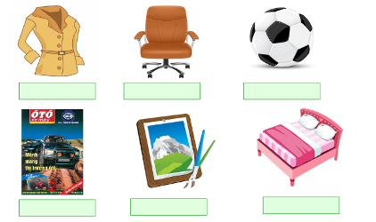
- picture
- bed
- ball
- chair
- coat
- poster

2.Fill in the gap with a suitable letter:
- D__n__ng room | - __ate | - P__ste__ | - Ne__r
- __athroom | - Y__rd | - __ha__r | - __nder
- Ga__d__n | - T__ee | - B__ll | - Be__ind
- F__nc__ | - __itc__en | - __oat | - P__ctur__
3.Put the words in correct order:
- is/ coat/ my/ where/? // - on/ wall/ it/ is/ the/.
________________________________________
- balls/ his/ where/ are/? //– are/ they/ under/ chair/ the/.

___________________________________________
3.is/ of/ in/ there/ a / tree/ house/ my/ front/.
__________________________________________
- is/ fence/ around/ there/ a/ house/ her/.
___________________________________________
- bed/ the/ is/ where/ ?// – is/ in/ it/ bedroom/ the/.

______________________________________________
- is/ gate/ front/ in/ of/ there/ a/ house/ my/.
_______________________________________________

- seventy/ grandfather/ is/ years/ my/ old/.
___________________________________________
4.Match the sentences.
1.Is this your poster ? | a.They’re on the table.
2. Where’s my coat ? | b.Yes ,It is.
3.Are these your books? | c.It’s on the bed.
4. Where are my photo ? | d.No, they aren’t
5.Look and write the answers.
- Where are the coats?
______________________
- Where is the chair ?
___________________
- Where is the poster?
___________________
- Where are the books ?
___________________
- Where are the balls ?
_____________________

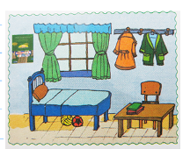

6.Odd one out:
1. a. book b. brother c. pen d. desk
2. a. where b. how c. how old d. old
3. a. father b. grandfather c. brother d. sister
4. a. fourty b. nice c. eight d. nine
5. a. my b. his c. she d. her
6. a. ball b. teacher c. mother d. sister
7. a. poster b. picture c. kitchen d. book
8. a. living room b. bathroom c. bed d. kitchen
7. Read and match:
- Where’s the bed? | - They are on the wall.
- What colour is your coat? | - No.there aren’t. There is a big tree.
- How old is your mother? | - They are in your schoolbag.
- How old are you? | - I’m fine, thanks.
- Where are my books? | - It’s brown.
- Is there a pond in front of your house? | - It’s in the bedroom.
- How are you? | - I’m nine years old.
- Where are his posters? | - She’s thirty eight years old.
2.Look at the picture and complete the sentences with in, on , under or behind.
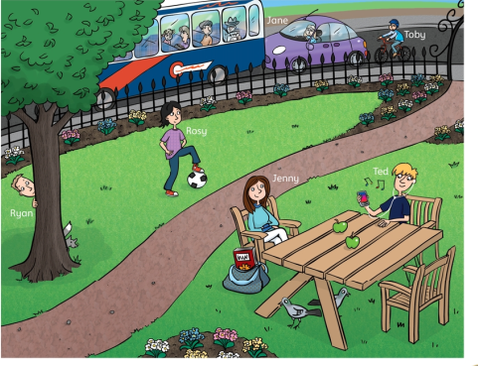
There are four people in the park.
a.There is a ball _______________Rosy’ foot. g. Toby’ bike is _____________Jane’car.
b.There are two apples ____________the table. h.There are four people _______the bus.
c. Ryan is standing _____________the tree. i.There is a tree ____________the park
d.Ted and Jenny are sitting __________the chairs.
e. Jenny has got a book ______________her bag.
f. The birds are __________________the table.
9.Look at the picture , use the words from box to complete the sentences.Then colour.
behind | next to | next to | on
in | on | next to | on

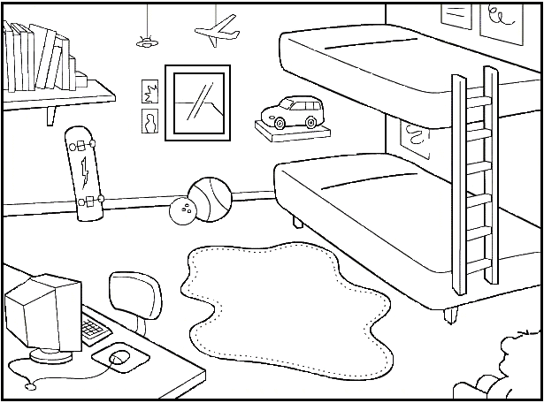
Desk
Bed
Carpet
_{Shelf}
Window
Computer
Skateboard
Balls
Car
Books
There is a red car |  | the bed
There is a blue computer |  | the desk
There are two balls |  | the floor
There is a pink carpet |  | the bed
There is a gray window |  | car
There is a yellow skateboard |  | balls
There are nine brown books |  | the shelf

