**Where were you yesterday ?**

**1.Look at picture and complete the sentences.**





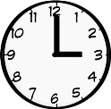

hospital zoo theatre home school

|  |
| --- |
| 1. Where were you in the______________?   I was at ___________________. |
| 1. Where were you in the______________?   I was at ___________________. |
| c. Where were you in the______________?  I was at ___________________. |
| Description: Image result for zoo clipart black and white d . Where were you in the______________?  I was at ___________________. |
| e. Where were you in the______________?  I was at ___________________. |

**2.Use the past simple to complete the sentences**

|  |  |  |
| --- | --- | --- |
| Bobby (swim) _________  at the beach on Saturday  morning. | His brother Sam  (ride) ____ his bicycle . | They (camp) ____in their back yard Saturday  evening. |
| Mrs. Brown (drive) ______  downtown to visit her friend on Sunday morning. | Mr. Brown (go) _________fishing at the lake. | They (have) ___________  lunch together in the  afternoon. |
| On Sunday afternoon, Michael(read) _______ a book about dinosaurs. | His mother (work) _________  in the garden. | They (eat) _____ popcorn  and (watch) _______ TV in  the evening. |
| Tom and Sally (play)  _________together all weekend. | Their cat, Fluffy, (sleep)__________ on the sof all weekend. | Their dog, Spot, (watch)  ______ Fluffy. |

3.**Find and correct the mistakes below.**

* 1. They ~~eat~~ dinner at six o’clock yesterday. **ate**
  2. Did Maria drove to work this morning? ________________________
  3. I not finished my homework last night. ________________________
  4. Did you busy last Monday? ________________________
  5. Was she buy a new car yesterday? ________________________
  6. I wanted to went to Montreal two years ago. ________________________
  7. Was you late for the meeting? ________________________
  8. Who did you talked to? ________________________
  9. Where was you stay in Washington? ________________________
  10. I was read that book last year. ________________________
  11. John flied to Argentina last week.________________________
  12. He weren’t at home last night. ________________________
  13. I not see the movie last weekend? ________________________
  14. What do you did last night? ________________________
  15. Did they has a good time at the party? ________________________
  16. Did you in class yesterday? ________________________

**5.Fill in the sentences with the correct form (past simple) of the appropriate verb, and then match the sentences to the pictures.**

read catch rain watch take do have set

make ~~wash up~~  sit fight dance eat tell

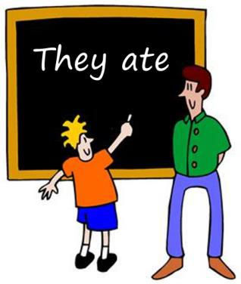

1) Mum _***washed up***_ after lunch.

2) The maid ___________________ the beds in the rooms.

3) It ___________________ a lot yesterday.

4) The boys ___________________ after school.

5) The fortune teller ___________________ me my future.

6) Dave ___________________ a slice of pizza.

7) The couple ___________________ TV last night.

8) Tim ___________________ the table.

9) Dad ___________________ a fairy tale to his children.

10) Dave ___________________ a bath.

11) The ambulance ________________ the injured man to the hospital.

12) Owen ___________________ the homework.

13) Fred ___________________ a cold yesterday.

14) Jane ___________________ in the disco last weekend.

15) The couple ___________________ on the bench in the park.

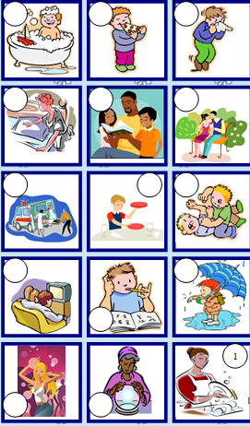

Sit fiht

**6.Complete the sentences with was or were.**

a.I ______ happy.

b.You _________ angry.

c.She _______ in London last week.

d.He ___________ on holiday.

e.It____________ cold.

f.We_______at school.

g.You_________ at the cinema.

h.They_______ at home.

i.The cat _________ on the roof.

**7.Put the verbs into the correct form (simple past).**

a.Last year I (spend) spent my holiday in Ireland.

b.It (be) ________-great.

c.I (travel) _____around by car with two friends and we (visit) lots of interesting places.

d.In the evenings we usually (go) ________to a pub.

e.One night we even (learn)____________some Irish dances.

f.We (be) ______very lucky with the weather.

g.It (not / rain)_____________ a lot.

**8. Choose the correct answer:**

1.They are (paint/ paiting/ paints/ painted) a nice picture in the classroom.

2.What did you (do/ doing/ did/ does) yesterday morning?

3.Was she english? Yes, she (isn’t/ is/ was/ wasn’t)

4.My mother can (plays/ play/ playing/ played) the piano very well.

5.The teacher (is/ was/ are/ am) reading a dictation for the class.

6.Mai and Kien (watch/ are watching/ watches/ watched) a video last night.

7.Mai (gets up/ got up/ getting up/ get up) late this morning.

**9. Read and match:**

|  |  |  |
| --- | --- | --- |
| 1. What nationality is Tom? | 1. They are doing their homework. |  |
| 1. Did they play chess? | 1. It’s the ninth of December. |  |
| 1. Do you like Physical Education? | 1. I’m in the music room. |  |
| 1. Where were you yesterday? | 1. No, they didn’t. |  |
| 1. Where are you Linh? | 1. He’s American. |  |
| 1. What’s the date today? | 1. Yes, I do. |  |
| 1. What subjects do you have today? | 1. I was at home with my parents. |  |
| 1. What are Kien and Nam doing? | 1. English, Vietnamese and Maths. |  |

**10 .Read and answer the questions**

Dear Peter

I’m Minh. Yesterday was fun and relaxing. I got up late. In the morning, I cleaned my room. In the afternoon, I watered the flowers in the garden. Then I did my homework. In the evening, I cooked dinner. After dinner I chatted online with my friend, Hung. We talked about our favourite films. At 10 o’clock I went to bed. What did you do yesterday?

Minh

1.Did Minh get up early yesterday? __________________________.

2.What did he do in the morning? __________________________.

3.What did he do in the afternoon?__________________________.

4.Was he at the zoo yesterday afternoon? __________________________.

5.Did he cook dinner yesterday? __________________________.

6.What did Minh and hung talk about? __________________________.

**11.Complete the text with the past simple form of the verbs.**

Yesterday morning, I 1________ (get) up at 7 and I 2________ (have) a shower at 7.10. Then I 3________ (have) a glass of orange juice and some toast for breakfast. At 7.30 I 4________ (go) to school. After school I 5________ (do) my homework and 6________ (study) English in my bedroom. Later, I 7________ (play) football with my friends until dinner time. After dinner, I 8________ (see) my favourite film: “Finding Nemo”. I 9________ (go) to bed at 10 p.m. It (be) 10___________ a great day!

**12.Complete the story with the words below.**

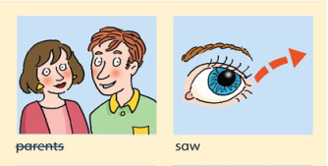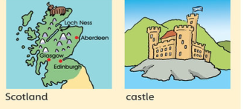

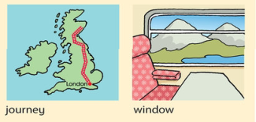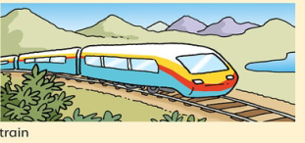

Last week , John went on holiday with his parents .They travelled by _____________. It was a long ______________. They got on the train in London and went to sleep .The next morning , they wake up in ______________! John looked out of the ___________.He ___________moutains and big _________________.Scotland was an exciting place.