When’s your birthday ?
1.Look and match
1.the eleventh of September  2.the twelfth of January  3.the thirteenth of August  4.the fourteenth of October  5.the fifteenth of April  6.the sixteenth of December | 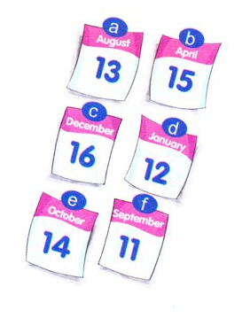
2.Read and write
January - February - March - April - May - June - July - August - September - October – November -December

1.First month of the year | January
2.Last month of the year.
3.Month after June
4.Month before September
5.Second month of the year
6.Tenth month of year
7.Third month of the year
8.Month between March and May
8.Fifth month of the year
9.Month before October
10.Month before December

3.Read and match

- What day is it today? |  | - We’re fine, thank you.
- Where is Linda from? |  | - I visit my grandparents.
- What nationality is Tom? |  | - It’s on Wednesday.
- What is the date today? |  | - We have English.
- When is the next English class? |  | - He's American.
- What do you do on Sunday morning? |  | - It’s the sixteenth of August.
- What do we have on Fridays? |  | - She’s from England.
- How are you? |  | - It’s Sunday.
4.Choose the best answer:
1.When’s _____ birthday?
A.you B. his C. I D. it
2. It’s the thirty-first ____ October.
A.in B. to C. of D. on
3.Her _______ is on the seventeenth of May.
A.day B. birthday C. date D. birth
4._____ is the date today?
A.What B. When C. Where D. How
5.My birthday is on the _____ of August.
A.four B. fourteen C. fourteenth D. twenty-four
6.His birthday is ____ the thirtieth of October.
A.on B. in C. of D. to
7.It’s on the ______ of December.
A.twenty B. twentieth C. twentyth D. twenth
8.When’s your birthday? - ________________.
A.It’s Wednesday B. It’s the first of June
C.It’s on the ninth of March D. Happy birthday.

5.Match the months with the numbers!
January is the | 10th month of the year.
February is the | 7th month of the year.
March is the | 9th month of the year.
April is the | 1st month of the year.
May is the | 4th month of the year.
June is the | 8th month of the year.
July is the | 5th month of the year.
August is the | 11th month of the year.
September is the | 12th month of the year.
October is the | 3rd month of the year.
November is the | 2nd month of the year.
December is the | 6th month of the year.

6.Look and answer the questions as in the model:
How ald is Jim ?  He is 4 years old.  When is his birthday ?  It’s on the 4th of May | 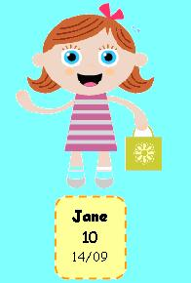  How old is Jane?  ____________________  When is her birthday?  ____________________ | How old is Fred ?  _________________  When is his birthday?  _________________
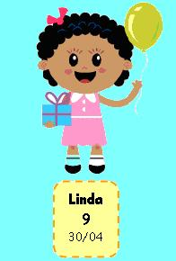  How old is Linda?  ____________________  When is her birthday?  ____________________ | 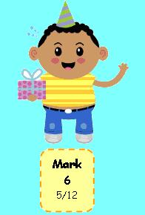  How old is Mark ?  _________________  When is his birthday?  _________________ | 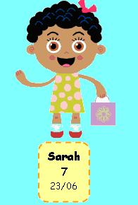  How old is Sarah?  ____________________  When is her birthday  ___________________

