What’s your name ?
1.Answer the questions
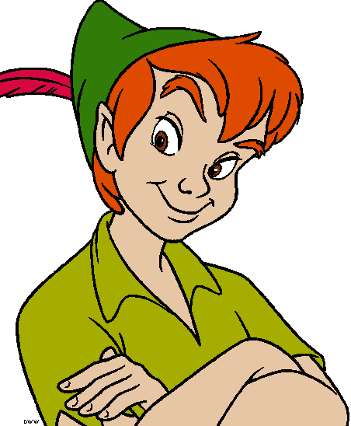 (Peter)  What’s your name ?  My name is Peter. | 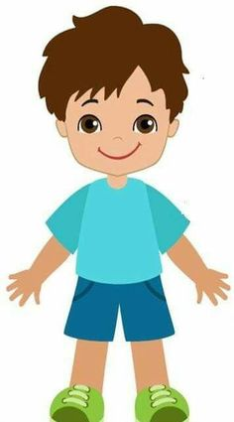(Tony)  What’s your name ?  ____________________
(John)  What’s your name ?  ____________________ | (Lisa)  What’s your name ?  ____________________
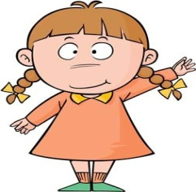(Mary)  What’s your name ?  ____________________ | 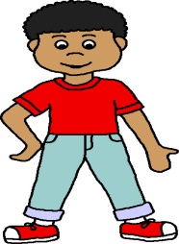 (Ben)  What’s your name ?  ____________________
2.Write am is are
1.Hello .I ___________Nam . I _______a boy.
2.How _____________you , Miss Hien .
3.I ________fine, thanks.
4. What __________your name ?
5.My name ___________ Linda .I __________a girl.
6. She ___________Lily.

3.Match
1.Hello . My name’s ____________ | a. ___________you today , Miss Hien ?
2. What’s ___________________ | b.___________ you spell your name ?
3.How are ___________________ | c. __________to meet you , Nam.
4.Nice ______________________ | d. ___________Linda.
5.How do ___________________ | e.____________ your name ?
4.Put the words in the right order.
a.name /your /What /is
______________________________
b.is /name /Peter/ My/.
______________________________
c.name /is/My/ Lisa /.
______________________________
d.spell /How /do/ your/ name / you/?
______________________________
e.to /you/ Nice/meet/.
______________________________
f.My /is /Lily./ name /
______________________________
g.Lisa. / Her /name / is /
______________________________
5.Look at the pictures and fill in the blanks.

What’s your name?
My name is _____.
How old are you?
I’m 13 years old.

What’s your name?
My name is _____ .
How old are you?
I’m 12 years old.

What’s your name?
My name is _____ .
How old are you?
I’m 18 years old.
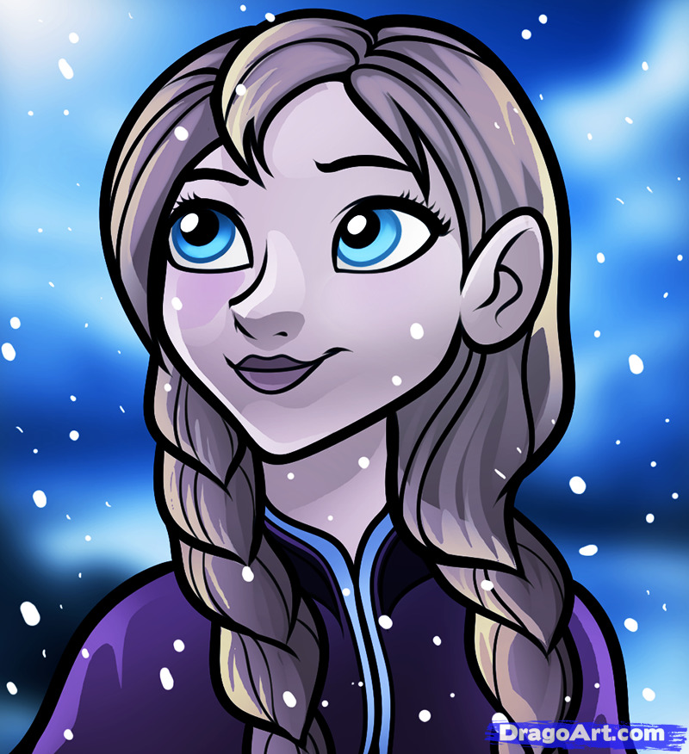
What’s your name?
My name is _____ .
How old are you?
I’m 11 years old.
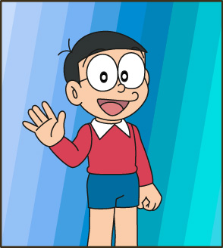

5. Circle the odd one out
6.Circle the odd one out
- a. hi b .bye c. hello
- a. how b. Peter c. Linda
- a. bye b. goodbye c.name
- a. what b. how c. hi
- a. yellow b. pink c. Linda
- a. Tony b. Peter c. fine

7.Complete
