What toys do you like?
1.Choose the correct words from the list below and write them under the correct pictures
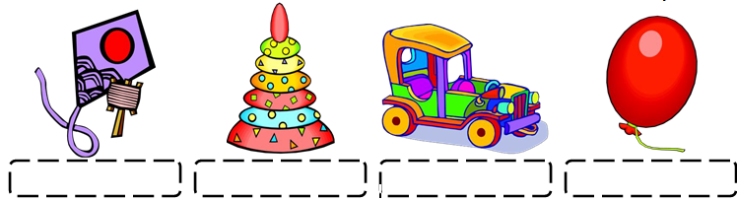
• car rattle
• doll balloon
• blocks robot
• plane bike
• puppet puzzle
• train
• ball
• kite
• boat
• truck
• pyramid

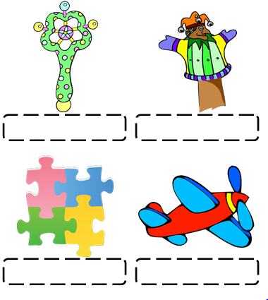
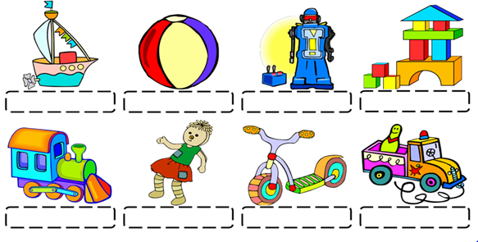
2.Look , draw and write.
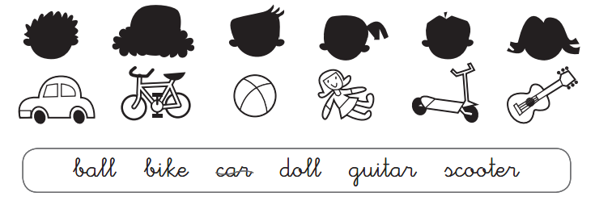
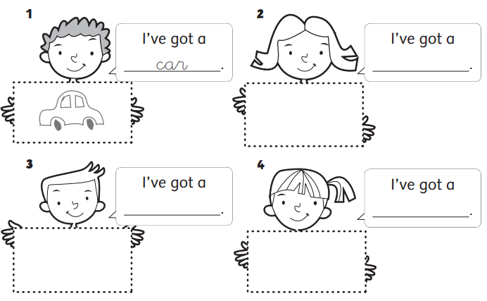
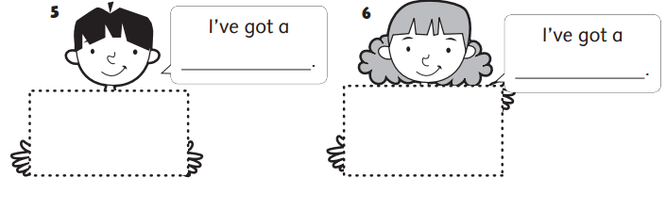

3.Write like or likes.
- I _________trucks.
- He ________ ships.
- He ________cars.
- She _______ kites.
- Peter ___________planes.
- Mary ___________dolls.
- I _________________balls.
- Tony ____________puzzles.
- I _____________trains.
- She __________robots.

4.Write Yes , I do ()or No , I don’t (×)
a.Do you have any goldfish ?() ___________________.
e.Do you have any birds?() ___________________.
e.Do you have any rabbits?(×) ___________________.
d.Do you have any parrots?() ___________________.
c.Do you have any dogs?() ___________________.
b.Do you have any cats?(×) ___________________.

5.Match
1.How many cats do you have? | a. Yes, I do. | 1-
2. What toys do you like? | b. He likes ball and robots. | 2-
3. What toys does he like? | c. I have two cats. | 3-
4. What toys does she like? | d. I like dolls. | 4-
5.Do you like kites ? | e. She like puzzles. | 5-
6.Cirle the odd the out.
1. puzzle kite car bread
2. cat dog rabbit kite
3. forty study twenty fifty
4. purple puzzle brown orange
5. TV doll ball kite
7.Read and circle a , b ,c
Peter , Mary , Linda are Mai friends. They have lovely pets. Peter has a big dog .Its name is Lola .Mary has a small cat .Its name Pipi.Linda has two rabbits.Their name are Bell and Ball .Mai has five goldfish.They do noy have names.Their pets are cute.

1.Peter , Linda , Mary and Mai are ___________________.
a. classmates b.friends c.brothers and sisters
2.Peter has _______________________.
a. a small dog b. a big dog c . a big rabbit.
3. Mary __________________________.
a.a small cat b.a small rabbit c. a small dog
4.The names of rabbits are _________________.
a. Lola and Pipi b.Lola and Bell c.Ball and Bell
5.Their rabbits are _________________.
a. small b.big c.cute.
8.Look at the pictures and answer the questions.
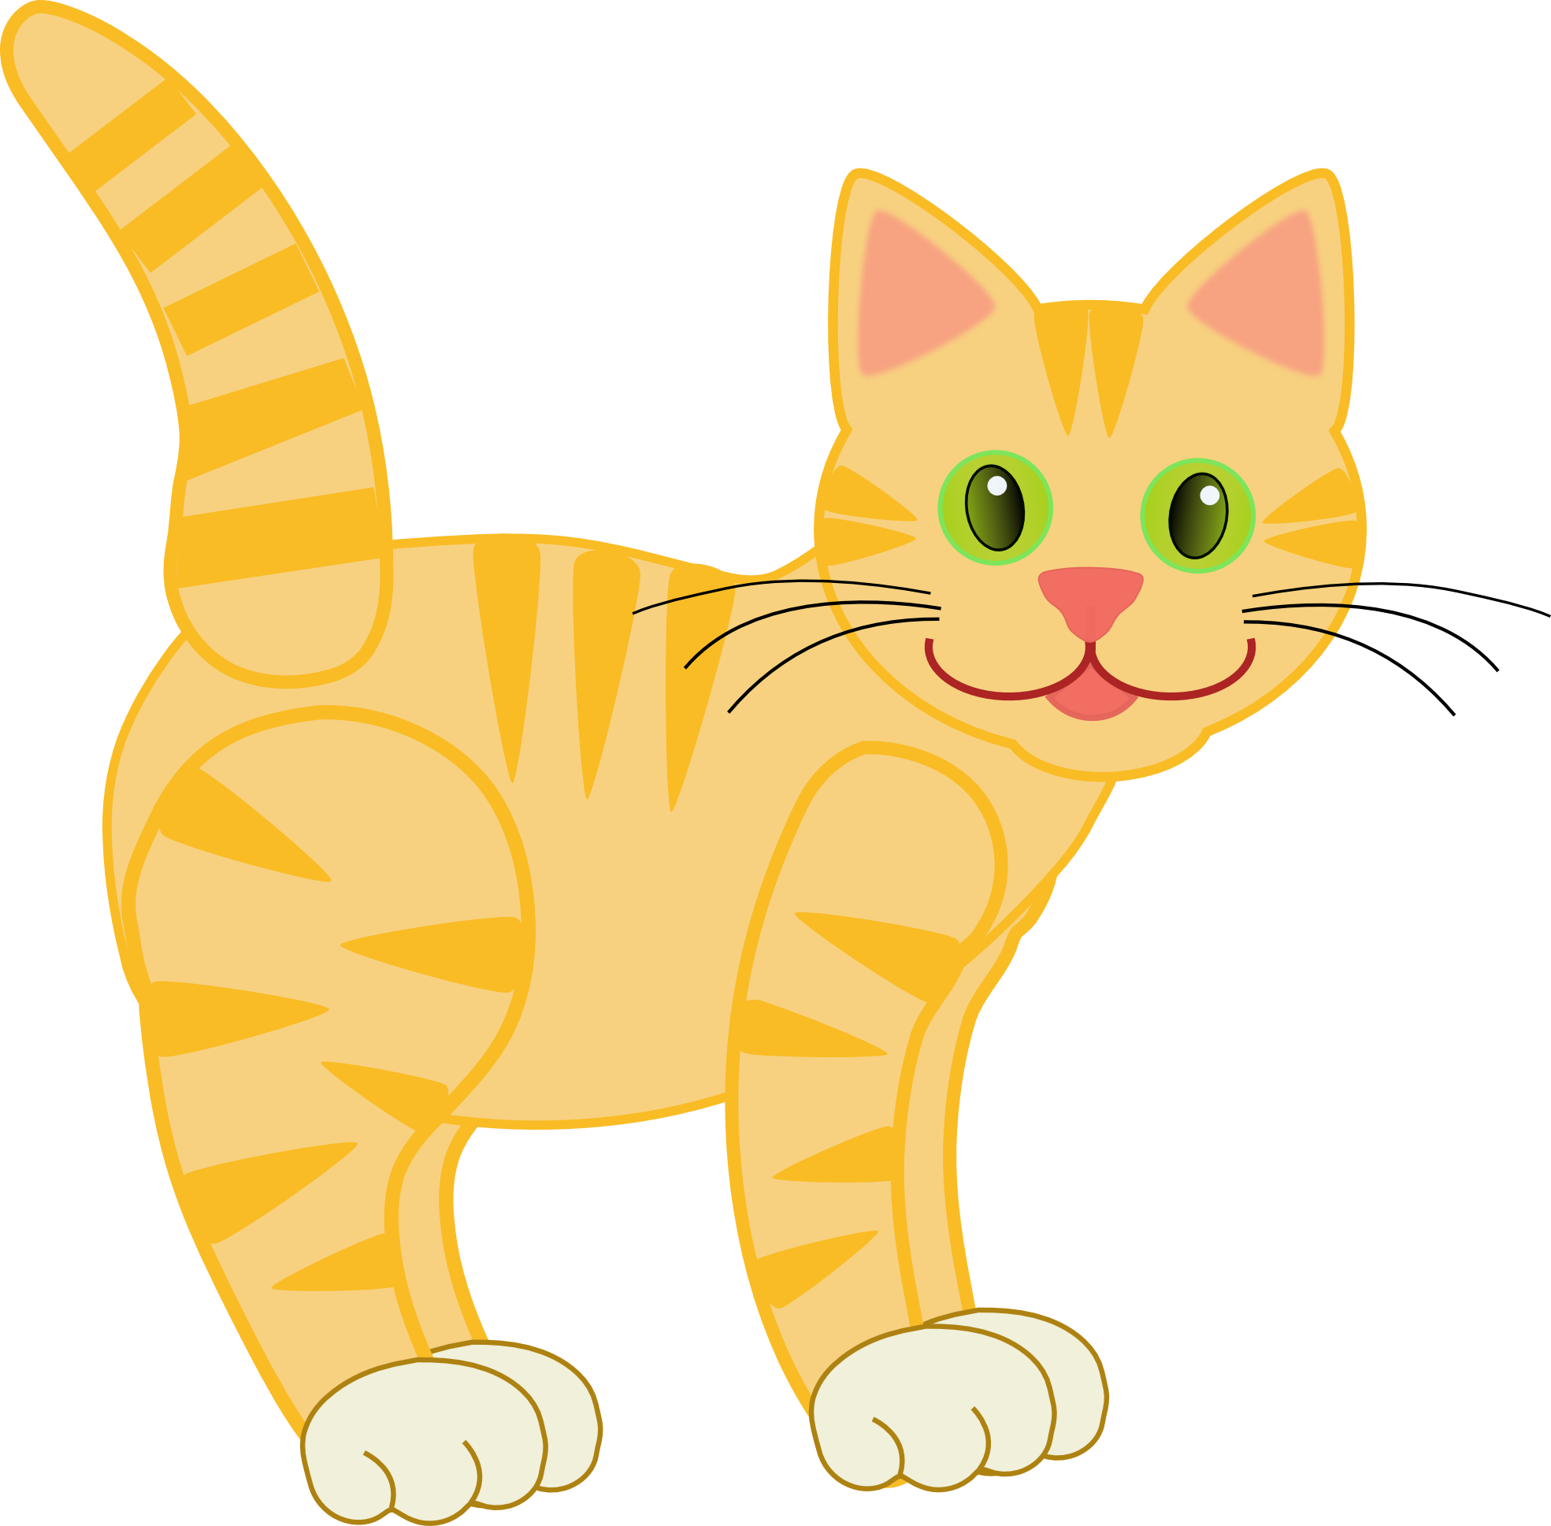How many cats do you have ? I have two cats.

How many dogs do you have ? _____________________.

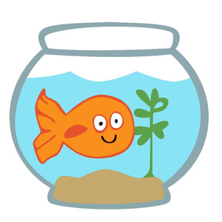How many goldfish does she have ? __________________________.

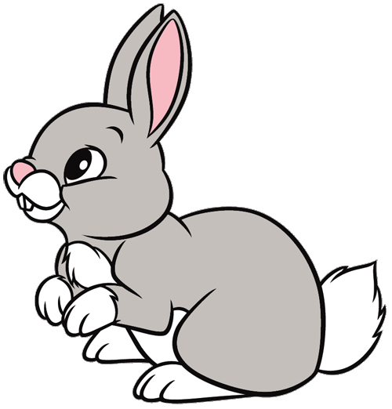
How many rabbits does he have ? __________________________.

9.Write have / has.
- I _______________five birds.
- She ____________a cat.
- John ___________two dogs.
- Mike ___________a goldfish.
5. I ______________three parrots.

