**What time is it ?**

**1.Read and draw .**

|  |
| --- |
| three o’clock quarter past four seven minutes to nine half past ten twenty to six |

**2.What time is it ? Write**

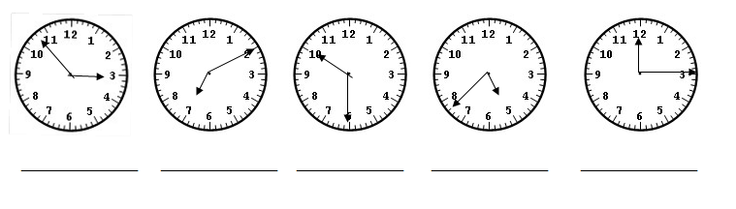

**3.Write about you**

a.What time do you get up ? _____________________________.

b.What time do you have breakfast ? _____________________________.

c.What time go to school ? _____________________________.

d.What time do you have lunch? _____________________________.

e.What time do go home school ? _____________________________.

f.What time do you have dinner ? _____________________________.

g.What time go to bed ? _____________________________.

**4.Look at the picture , read and match.**

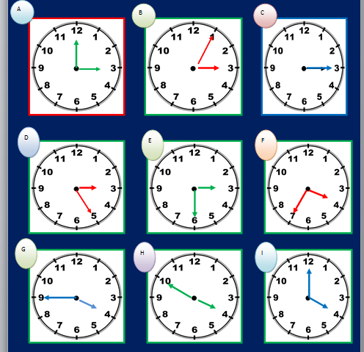

1.It’s four o’clock.

2.It’s twenty five to four.

3.It’s twenty five past three.

4. It’s three o’clock.

5.It’s half past three.

6.It’s ten to four.

7.It’s a quarter to four.

8.It’s five past three.

9.It’s quarter past three.

1 ______ 4 ______ 7 ______

2 ______ 5 ______ 8 ______

3 ______ 6 ______ 9 ______

**5.Look at the pictures , read and complete the sentences.**

|  |  |  |
| --- | --- | --- |
| eat breakfast | get up | go to bed |
| go to school | go home | take a shower |

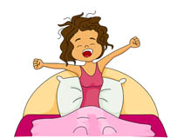



1. What time do you ____________?

I ____________ at __________ o’ clock.

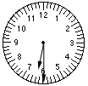

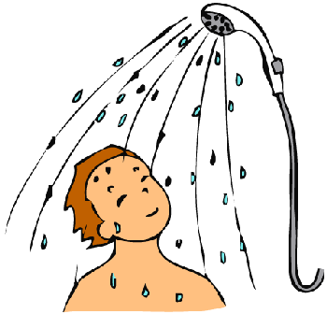

2. What time do you ______________?

I ___________at half past ________.

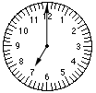

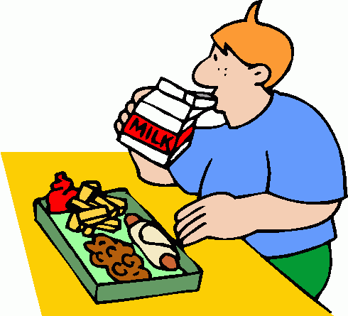

3. What time do you _____________?

I ____________ at ____________.

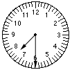



4.What time do you ___________?

I _____________at __________.

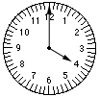

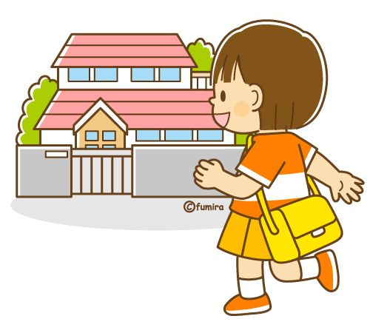

5. What time do you __________?

I_____________at __________.

6. . What time do you ____________?

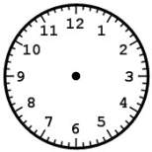

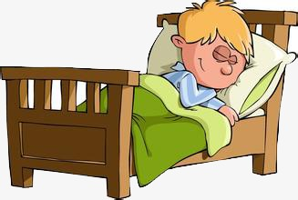

I _____________at nine o’clock.

**6.Order the words into sentences. Connect the sentences to the clocks and the pictures .Draw lines**

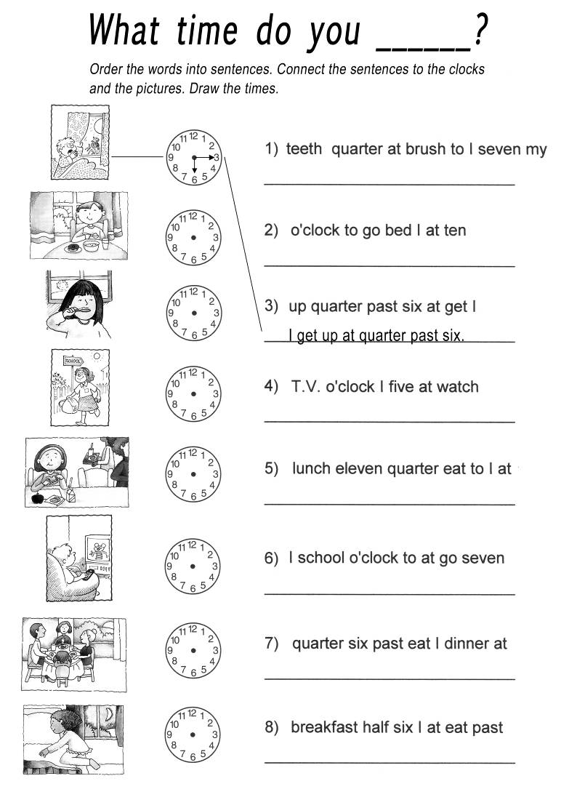

What time do you _____________?

**7.Matching**

|  |  |
| --- | --- |
| **A** | **B** |
| 1. Hi Nam, How are you? | a. Yes, I do. |
| 2. I’m fine, thanks. What are you doing? | b. I go to school at seven o’clock. |
| 3. Do you like English? | c. I’m well. And you? |
| 4. What time do you go to school? | d. I have lunch at 12 o’clock. |
| 5. What time do you have lunch? | e. I’m learning English. |
| **A** | **B** |
| 0. What’s your name? | a. My name’s Hung |
| 1. Where is Alan from? | b. Yes, she does. |
| 2. I’m sorry. I’m late. | c. I like Music and science. |
| 3. What subjects do you like? | d. Yes, I can. |
| 4. Can you play football? | e. Not at all. |
| 5. Does she like English? | f. There are twelve books. |
| 6. How many books are there on the shelf? | g. He is from Singapore |

**8. Complete the sentence:**

1. What time _________it? - It ___________ 9 o’clock.
2. What ________is it? - It_________Ten twelve.
3. What time______you get up? - I get up ________six o’clock.
4. ________ do you go to school? - I go ___________at six thirty.
5. What________do you have lunch? - I have lunch _________twelve o’clock.
6. What time ______ she/ he get up? - He/ She ______up at six o’clock.

**9.Write down the correct sentences.**

a.five to seven/gets up/Billy/at.

.....................................................................

b.You /breakfast/have/ at / o’clock / seven.

.....................................................................

c.Peter / to /goes/at / thirty /seven

.....................................................................

d.in the/do/afternoon./my homework/I

.....................................................................

e.She / home /goes/ at/ quarter /three/ past

.....................................................................

e.My/ goes /to /bed / at /ten/ o’clock.

.....................................................................

f.Bobby /up/gets / quarter /at/to eight

.....................................................................

**10.Sophia’s daily routine.**

Sophie is eleven years old and she lives in Brighton, England.

She usually gets up at a quarter to eight, she has a shower, gets dressed and then she brushes her teeth. After that, she goes downstairs and has breakfast. For breakfast she usually has milk, toast and orange juice. Then she brushes her teeth again because she likes them white and healthy!

Then she grabs her school bag and goes to the bus stop to catch the school bus. Classes start at half past eight and finish at half past four. She usually has lunch at the school canteen with her schoolmates at about 12 o’clock. Her best friend is Amy and Sophie always sits next to her at lunch.

After school she returns home and does her homework. She is a very hard-working pupil and she never misses a school task! After homework, she usually listens to music and watches television a bit.

At half past seven it is time for dinner. Then she usually reads a book or chats with her parents for a while.

Finally, she goes to bed at about ten o’clock, but before that she brushes her teeth. Sophie is a happy little girl!

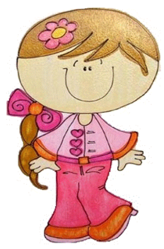

**a.Answer the questions about the text.**

1. What time does Sophie get up?

---------------------------------------------

2. Does she usually have a shower?

---------------------------------------------

3. What does she eat for breakfast?

---------------------------------------------

4. What does she drink for breakfast?

---------------------------------------------

5. What does she do after breakfast?

--------------------------------------------

6. Does she go to school on foot?

---------------------------------------------

7. What time does school start?

---------------------------------------------

8. What time does it finish?

-----------------------------------------

9. Where does Sophie usually have lunch?

-----------------------------------------

10. Who is Sophie’s best friend?

------------------------------------

**b.Order Sophie’s daily routine.**

|  |  |
| --- | --- |
| She goes to bed at about ten o’clock.  She gets dressed.  She catches the bus to school.  She has lunch at the school canteen.  She listens to music.  She gets up.  She does her homework.  She has a shower.  She has dinner. |  |
|  |
|  |
|  |
|  |
|  |
|  |
|  |
|  |