What do you like doing ?
1. Open the brackets and match the sentences with the pictures.
 |  | 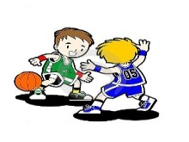
- They __________________ (like/play) leapfrog.
- She ___________________ (like/paint).
- He _________________ (like/take) photos.
- They ________________ (like/play) basketball.
- Children ______________ (like/play) tennis.
- He ___________________ (like/watch) TV.
- He ___________________(like/fish).
- She ____________________(like/sing).
- They ___________________(like/cook) food.
- They _________________(like/play) chess.
- She _________________(like/skateboard).
- They ________________(like/watch) TV.
- He ___________________(like/listen) to music.
- He ____________________(like/read) comics.
- They __________________(like/play) hide-and-seek.
- He __________________(like/cook) food.
- They _______________ (like/listen) to stories.
- She __________________(like/play) basketball.
- They __________________(like/play) volleyball.
- She __________________ (like/do) gymnastics.

 |  |  | 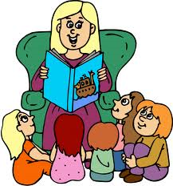
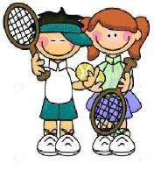 |  |  | 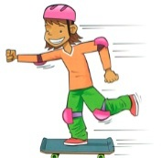
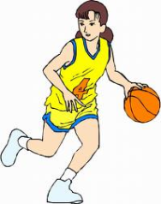 |  |  | 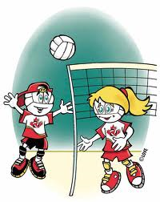
 |  |  | 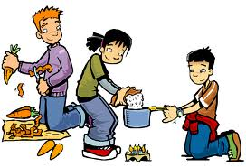
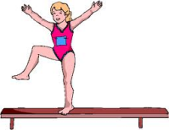
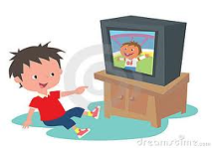 | 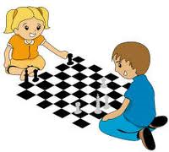 | 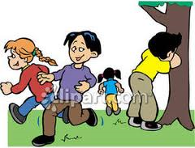 | 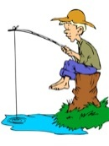
2.Read , follow the lines and circle True or False
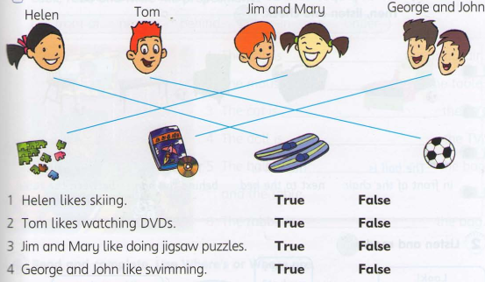

3.Read and write .Use like and the verb in the brackets.
a.He likes cooking.
b.They ________________( swim)
c.He ___________________(take) photographs | 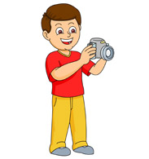
d.Alex ______________(collect) stamps.

4.Complete the table. Write about yourself:
I like | I don’t like
5.Put the words in order
1, school / this / go / we / the / to / way / is
→_______________________________________.
2, in / is / my / Hoan Kiem / District / school
→__________________________________________________ .
3, you / like / songs / to / listening / do / English
→________________________________________. ?
4, class / you / what / in / are
→ ________________________________________. ?
5, my / football / brother / playing / likes / much / very
→________________________________________.
6, she / reading / does / like / book
→________________________________________. ?
7, I / school / Tony / same / in / and / the / study
→ _______________________________________ .
8, taking / they / not / photos / like / do
→ _______________________________________ .
9, Mary / guitar / does / like / the / not / playing
→ ______________________________________ .
10, ping pong / her / hobby / is / brother’s / playing
→_______________________________________.

6.Read and circle the correct words.
1.Sky _______________________ reading books. () (likes/doesn’t like)
2.Peter _______________________ climbing trees. (×) (likes/doesn’t like)
3.Amy _______________________ riding her bicycle. (likes/doesn’t like)
4.LiLy _______________________ shopping. (×) (likes/doesn’t like)
5.John_______________________ playing video games. (×) (likes/doesn’t like)
6.I _______________________ swimming.(×) (like/don’t like)
7.I _______________________ playing badminton. () (like/don’t like)
8.Sarah and Mar_____________ drawing pictures. (x) (like/don’t like)
7.Kick is writing a letter. Read Kick’s letter with the correct form of the given words.
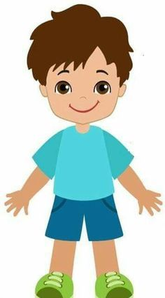 | Dear Sir,  I like to (1) ____________ (make) friends. I would like to join the Pen-pal Club. Here is something about me.  My name is Kick. I am eight years old. I live in Palermo. I go to San Juan Bosco School. I like many sports. I like (2) ____________ (swim) and (3) ____________ (play) badminton after school. I like (4) ____________ (write) letters. I like (5) ____________ (read) books too.  Please let me join your club. Thank you.  Yours truly,  Kick.

8.One of the two sentences is right. Decide which one.

a) I like go to the cinema.

I like going to the cinema.
b) Do you like play videogames?
Do you like playing videogames?
c) He likes singing.
He like singing.
d) Do Tom like reading?
Does Tom like reading?
e) Why do you like learning in the library?
Why you like learning in the library?
f) She likes playing volleyball?
Does she like playing volleyball?
g) Do Sarah and Peter like swimming?
Does Sarah and Peter like swimming?
9.Complete the sentences with "like" or a verb in gerund.
a) She really ________ going to the gym. 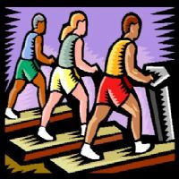
b) I don't like ___________football. 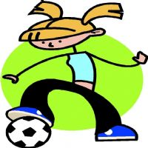
c) Do you like ________?
d) My sister doesn't __________getting up early. 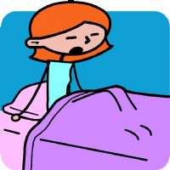

10.Make sentences using the words bellow, adding -ing to the verb and the auxiliary do/does when necessary. In negative sentences use the short negative form don't/doesn't.
a)I / not like / go / to the cinema. ______________________________
b)You / like / cook? __________________________________________
c)He / like / play / with his friends. ______________________________
d)She / like / shop? ___________________________________________
e)My parents / not / like / watch TV. ______________________________
f)Peter / not / like / go / to the beach. ______________________________
g)You / like / ski? ______________________________________________
h)Ana and Josh / really / like / relax / in the park. _______________________
k)Why / you / like / skateboard?____________________________________
11.Make sentences.
like | love | not like | hate

I + + She + + He + +
I love singing.
I + + 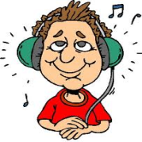 She + + He + + 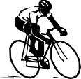

I + + 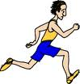 He + + I + +

