What do you do at break time ?
1.Odd one out:
- a. break time b. book c. notebook d. pencil case
- a. basketball b. play c. badminton d. table tennis
- a. football b. stand c. sit d. ask
- a. like b. come c. play d. chess
- a. blind man’s bluff b. hide-and-seek c. pencil sharpener d. skipping
- a. classroom b. class c. open d. gym
- a. yes b. hello c. hi d. good morning
- a. fine b. five c. nine d. eight
- a. how old b. what c. who d. are
- a. skating b. skipping c. morning d. chess
- a. orange b. bookcase c. brown d. blue
- a. rubber b. black c. white d. violet
- a. pencil case b. pencil c. pen d. school
- a. small b. old c. new d. eleven
- a. I b. my c. he d. she
- a. ruler b. rubber c. yellow d. school bag
- a. colour b. open c. close d. come
- a. desks b. notebook c. books d. rubbers
- a. break time b. chess c. football d. skating
- a. play b. skipping c. do d. like
2.Put the words in correct order to make meaningful sentences:
- I /table tennis/ play/ break/ at/ time/________________________________
- Those/ pens/ pencils/ are/ and/ my/.________________________________
- colour/ are/ your/ what/ notebooks/?________________________________
- library/ and/ nice/ big/ the/ is/________________________________
- is/ computer/ old/ large/ but/ the/ room/_______________________________
- like/ you/ blind man’s bluff/ do/?________________________________
- Phong/ and/ like/ Quan/ football/.________________________________
- do/ you/ what/ break time/ do/ at/?________________________________
- are/ they/ orange/ red/ and/________________________________
- she/ old/ eight/ years/ is/.________________________________
- Lan/ and /Quan/ do/ badminton/ like/?________________________________
- Tuan/ at/ break time/ play/ Hung/ and/ basketball/________________________
3.Put the words in the right columns.
Football, gym, desk, white, orange, rubber, badminton, skipping, skating, library, classroom, pencil, pencil case, basketball, computer room, black, blue, green
Games | School thing | School facility | Colour
4.Fill in the blanks
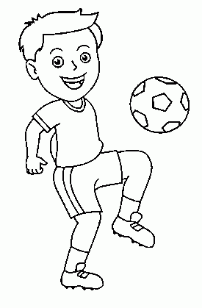  I _________at breaktime. | 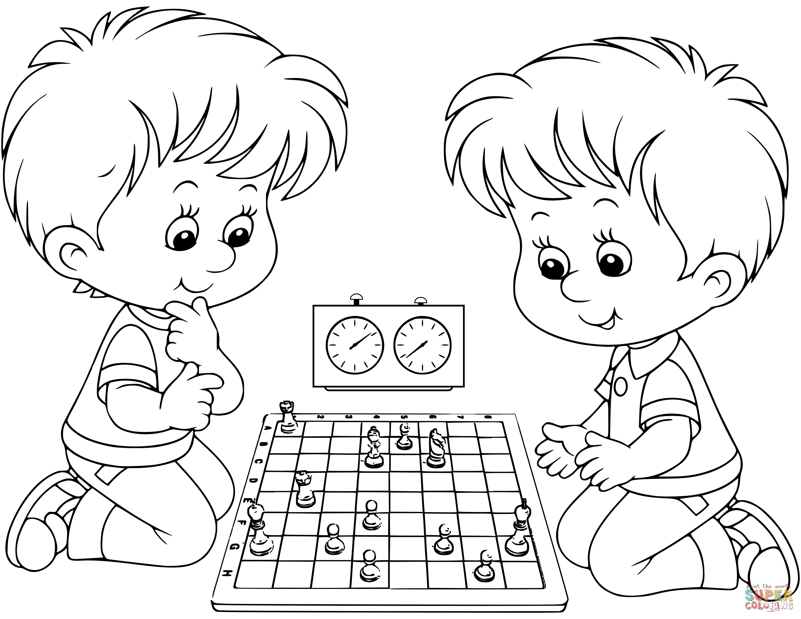  They_________at breaktime. | 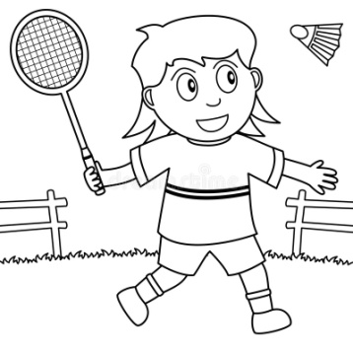  I ______________  at breaktime
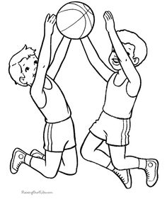  We_________at breaktime. | 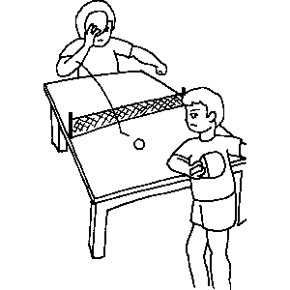  We  at breaktime. | 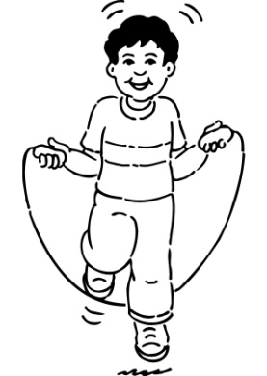  I _________  at breaktime

5.Write Y es , I do () or No , I don’t (×)
a.Do you like badminton? ()
__________________________
b. Do you like hide-and-seek?(×)
______________________________
c. Do you like skipping?()
______________________________
d. Do you like blind man's bluff?(×)
______________________________
e. Do you like skating?(×)
______________________________
f) Do you like playing football ?(×)
_______________________________
6.Answer questions about you:
- What’s your name? ____________________________________
- How do you spell your name? __________________________________
- How are you? ____________________________________
- How old are you? ____________________________________
- Is your school big? ____________________________________
- What colour is your school bag? ______________________________
- What colour is your book?__________________________________
- Are your pens and pencils red? _________________________________
- What do you do at break time? __________________________________
- Do you like skipping? _______________________________________
7.Match
1.What is your name ?  2.How are you ?  3.How old are you ?  4.What colour is it ?  5.Are they your friends ?  6.What do you do at breaktime ?  7.Do you like skipping ?  8. Is it yellow ?  9.May I com in ?  10.Who is this ? | a.It is pink.  b.No , I don’t.  c. I play chess at breaktime.  d.My name is Linda.  e. I am fine.  f. I am eight years old.  g. This is Amy.  h. Yes, they are.  i) Yes, you can .Come in , please !  j.No,it isn’t. | 1_  2_  3_  4_  5_  6_  7_  8_  9_  10_
8.Circle the correct answers.
- This is my________________, Lan
a.Book b. pen c. bag d. friend
- This is my____________, Mr Nam
a.Teacher b. desk c. table d. board
- Is____________ your friend ? Yes, it is.
a.This b.these c. the d.they
- This is____________ ruler.
a.I b. my c. the d. you
- What’s this? ____________
a.It’s a desk b. this is my friend c. it’s red d. this is my teacher.
- ___________ is this? It’s my friend, Minh.
a.What b. who c.how d. what’s
- Is this___________ friend, Mai? yes, she is
a.My b. I c. you d. your
- ________that Linh? Yes, it is
a.Is b. am c. are d.who
- ________this his friend? No it isn’t.
a.Am b. are c. is d. what
- Are they your friends? ___________________
a.Yes, it is b. yes they are c. yes it isn’t d. no, it is

