**What day is it today ?**

**1.Write**

|  |  |  |
| --- | --- | --- |
| Yesterday | Today | Tomorrow |
| Tuesday | Wednesday | Thursday |
|  | Monday |  |
|  | Thursday |  |
|  | Tuesday |  |
|  | Sunday |  |
|  | Saturday |  |
|  | Friday |  |

**2.Read and answer the questions**

1. What day is before Saturday? ______________
2. What day is after Wednesday?______________
3. What day is after Sunday? ________________
4. What day is before Tuesday? ________________
5. What day is two days after Thursday?__________
6. What day is before Monday? _______________
7. What day is after Monday? _________________
8. What day is before Thursday? ________________
9. What is the first day of the week? ____________
10. What day does school begin? ___________________

**Sunday Monday Tuesday**

**Wednesday Thursday Friday**

**Saturday**

**3.Read and complete the table.**

In the morning, I go to school from Monday to Saturday. On Thursdays afternoon, I have an English class. I play volleyball with my friends on Tuesday and Wednesday. On Saturdays, I go swimming. On Sundays, I help my parents at home in the morning and in the afternoon, I visit my grandparents.

|  |  |  |  |  |  |  |  |
| --- | --- | --- | --- | --- | --- | --- | --- |
|  | Monday | Tuesday | Wednesday | Thursday | Friday | Saturday | Sunday |
| In the morning |  |  |  |  |  |  |  |
| In the afternoon |  |  |  |  |  |  |  |

**4.Complete the dialogue:**

|  |
| --- |
| Tuesday weekend Sunday today |

Amy: What day is it (1) _____________, Peter ?

Peter : It’s (2) _________________. I go to school

Amy : What do you do on (3) _______________?

Peter : I play football with my friends in the afternoon

Amy : Do you go school at the (4) ______________?

Peter : No, I don’t go to school.

**5.Odd one out:**

1. Evening morning going swimming
2. Tuesday today Monday Wednesday
3. Afternoon morning late evening
4. Zoo school book home
5. Has do listen help
6. Linda Peter Hakim Nam
7. Weekend Saturday today Sunday
8. Class teacher kite pupil
9. Fish plane parrot turtle
10. Does has help likes

**6.Which day comes next ? Write**

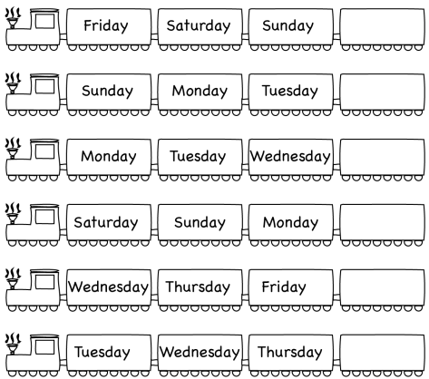

**7 .Complete these sentences.**

1. What ______ _________ it _________, Nam?
2. _________ Friday
3. She __________ the piano __________ Saturday
4. ______ he go ______ school _______ Sunday?
5. Is _________ ________ first __________ June?
6. ______ the morning, I __________ to school
7. ______ Saturday, _________ helps her parents at ________ ___
8. I _______ go to __________ at the weekend
9. What _________ you _____ on Tuesday?
10. How _________ in __________ afternoon?
11. ___________ day ________ it tomorrow?

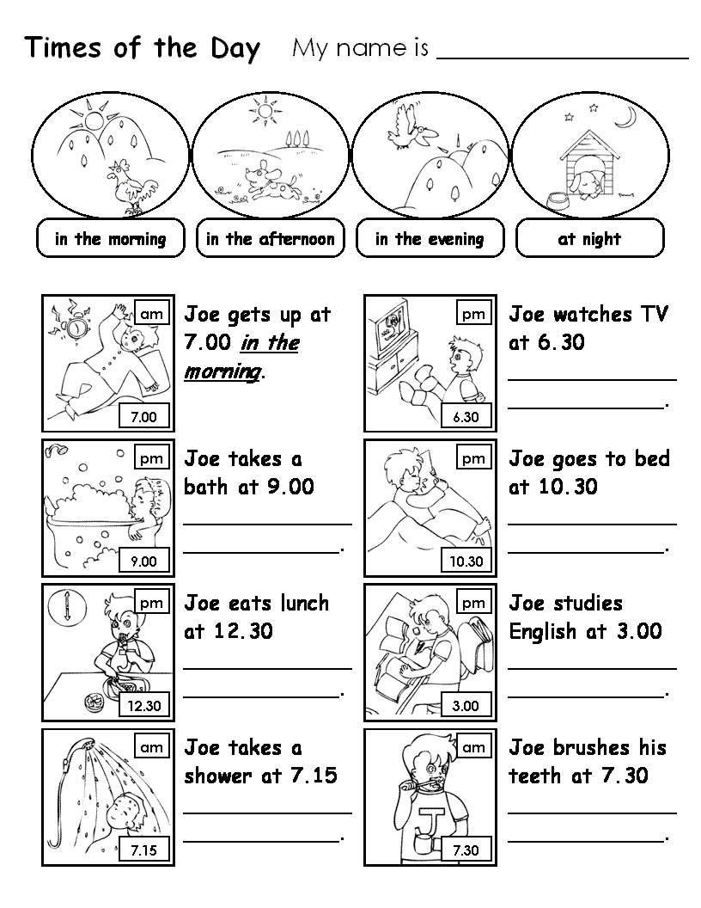**8.Look at the pictures and write.**

p.m



a.m

Tom has breakfast at 7. 00

__________________

Tom reads the newspaper at 7.00

__________________



p.m

a.m



Tom takes a shower at 6.00 ____________

____________________

Tom goes to bed at 11.00 __________________

p.m



a.m



Tom eats lunch at 1.00 ______________

Tom takes tne bus at 8.00 ___________

Tom goes to the office at 9.00 __________________

p.m

a.m



Tom wakes up at 5.00 ______________



**9. Write and order**

Wednesday Saturday  ~~Monday~~ Thursday

Sunday Tuesday Sunday

