What colour is it ?
1.Read and colour
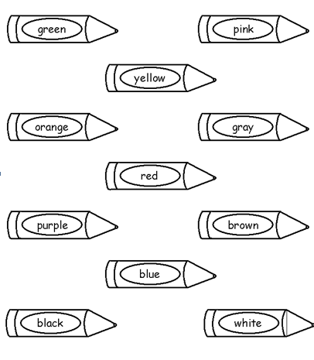

2.Order the words to make the sentences
a.Is/ It/pink/ _______________________________________
b.My/pen/ green/ is/ ______________________________________
c.Your /bag /is /red/school/ _________________________________
d.What /is/colour /it?/ ____________________________________
e.Colour/ are/ they? / What/ ______________________________
g.They/brown/ are/ ______________________________________
h.What/ colour/your/ is pencil?/ ______________________________
f.My /are /yellow/rubbers/ __________________________________
3.Write one word in each blank.
a.This ________my school bag.
b.Those __________my pens.
c.What ___________is your book ? It is yellow.
d.What colour __________your pens ? They are green and blue.
e.Is that your sharpener ? _____________,it is.
g.Is this your notebook ? _____________, it isn’t.
h.Are these your pens ? Yes , they ____________.
f.Are those your books ? No , __________________
4.Read and cirlce T (True )and F (false)
Hi . I am Nam .Those are my new school things . Look at my school bag . It’s yellow .That is my book .It is red.That is my pen .It is brown.Those are my rulers.They are orange and blue. Those are my rubbers. They are black and purple. I like my new school things . I want to keep them clean.
a.Nam has new school things. T F
b.The school bag is blue. T F
c.The book is pink. T F
f.d.The rulers are orange and blue. T F
The rubbers are white and purple. T F
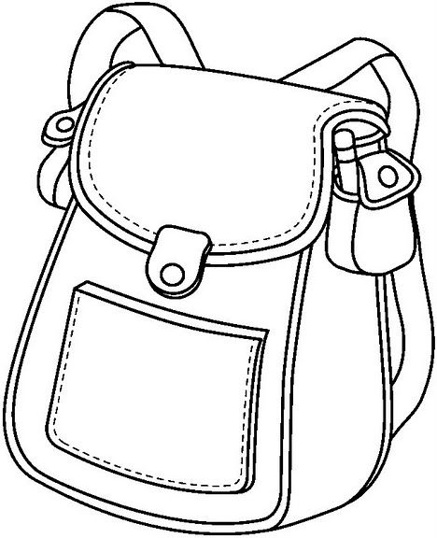
5.Match and write
1.I am s _x years old.
4.That is a b ___x.
3.The school bag is wh_te
2.Sit down ,please !
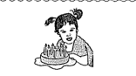
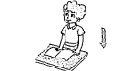
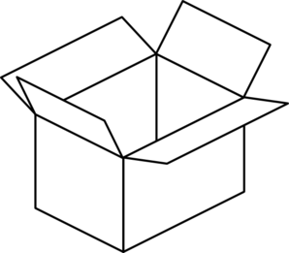
o
i

4.Read anh colour.
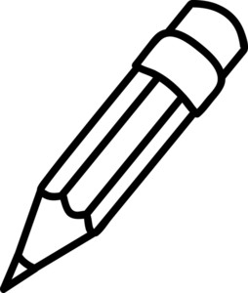  a) My pencil is green. | 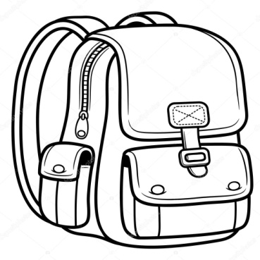  b) My school bag is pink.
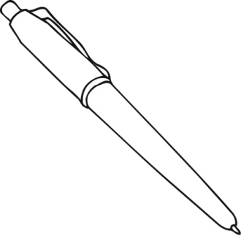  c) My pen is blue. | 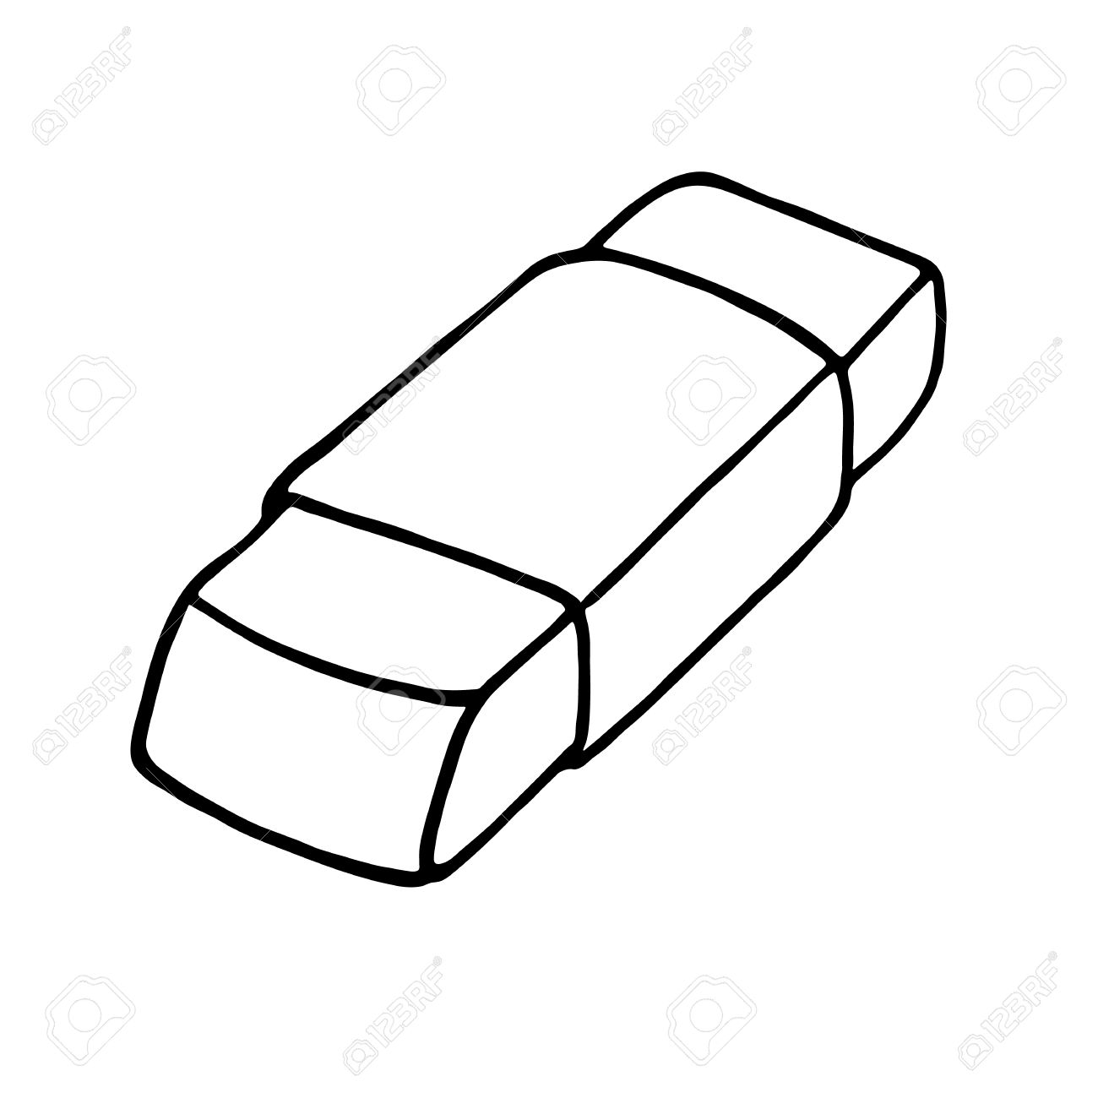  d) Your rubbers are red.
5.Match the questions with the responses.
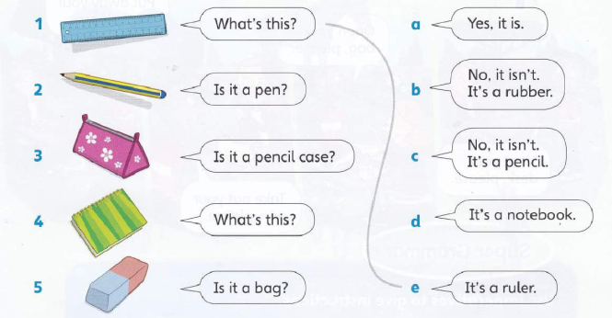

6. Write the questions and answers
1. this/ What’s / ?
a/ It’s/ book/.
_________________________________________________________________
2. rubber /it /Is /a / ?

is/Yes, /it/.
_________________________________________________________________
3. it/notebook /Is /a/ ?

isn’t /it/No,/.
_________________________________________________________________
4. this / What’s/ ?

a/ It’s/ bag/green/.
_________________________________________________________________
5.your /pens /What/ colour /are/?
_________________________________________________________________
are /They/yellow/
_________________________________________________________________
6. What / your /book/is /?
_________________________________________________________________
is/blue/It
_________________________________________________________________

