What are you doing ?
1. Choose the word from the box and write
sing ,clean ,drive ,cook , read ,watch

1.What is she doing ? 2.What is she doing ? 3.What is he doing ? _______________ ___________the kicthen. _________________
4.What is he doing ? 5.What is she doing ? 6.What is she doing _______________ ____________a book. _______________TV.

2. Read and complete
watching cooking is in doing

My name is Peter. Today, my family (1)__________at home. We are (2)______________ the living room. My father is (3)______________ TV. My mother is (4)_______________ the dinner. My sister is (5)__________________ her homework and I am playing computer game.
1.Where’s Peter family? ________________________________________
2.What is his father doing? ________________________________________
3.What is his mother doing? ________________________________________
4- What is his sister doing ? ________________________________________
3. Choose the best answer
1- My mother is _______________ (cook/cooker/cooking)
2- She’s ______________ the kitchen (on/in/there)
3- What is she _____________? (doing/does/do)
4- I am _________________ a book (listening/reading/watching)
5- He’s _________________ football with his friends (doing/plays/playing)
4. Put the words in order
1- I/music/am/listening/to ________________________________________________________________
2- friend/My/is/homework/her/doing ____________________________________________________________
3- you/are/parents/What/doing/? ______________________________________________________________
4-now/you/Where/are?
____________________________________________
5- in/kitchen/She/the ________________________________________________________________
6- mother/My/cooking/is/dinner ______________________________________________________________
5.Read and write the missing words
1- Linda is in the kitchen. She is ____________________ a big meal
2- Tony is in his ___________ He doing his homework
3- Where is Mary? She is in the schoolyard. She is ________________ badminton
4- My family is in the ________________ room. We are __________________ TV

6.Complete the questions with the verbs in the brackets ,then look at picture and writethe answers.
Is she doing her homework ? (she/do)
Yes,she is.
1.________________football ( they/play)
___________________
2.___________________film( he/watch)
___________________
3.______________on the beach.(Julia/sit)
___________________
4._________________dinner(Mum and Dad/make)
____________________
5.__________________(it/rain)
____________________.

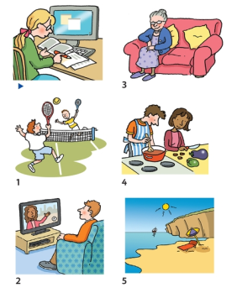

7.Circle the correct option.
- She isn’t/ aren’t playing tennis.
- You isn’t/ aren’t going to the beach.
- He isn’t / aren’t doing his homework.
- I’m not/ I’s not watching TV.
- They isn’t / aren’t wearing shoes.
- The dog isn’t / aren’t drinking water.
8.Look at the pictures and read Isabel’s blog .Complete the text with present continuous forms of the verbs .Use short forms.
drink eat have listen play rain read sit talk write

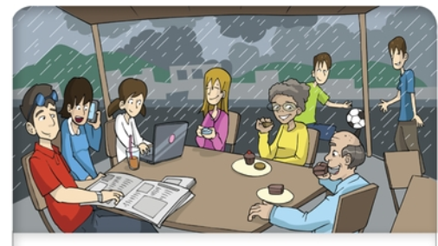

Hi everyone. We’re on holiday in Germany but the weather is bad today.
It’s raining. We __________in a cafe’.I’ve got a computer and I _____________
my blog.My sister ___________to music.My brothers aren’t in a cafe’.They _________
football in the rain.My mum _____________her friend on the phone.And my dad? He _____________the newspaper.Oh yes,and my grandparents are here too.They ____________cakes.I haven’t got a cake. But I _____________fruit juice.I like it!
We ________________a good time.
See you soon.

