**What are they doing ?**

**1.Complete the sentences with the correct form of the verbs in brackets.**

|  |  |  |
| --- | --- | --- |
| 1.I’m drinking | 2.They(not/sleep)  ___________________ | 3.You (not/study)  ____________________ |
| 4. We (swim)  __________________ | 5.He (not/dance) _____________ | 6.It (rain)  ____________________ |

**2.Use the verbs in brackets to say what the person is doing . Correct the sentences.**

* **He’s drawing .( write)**

1. He isn’t drawing . He’s writing.____________________________.
2. She’s eating .(drink) ____________________________.
3. They’ra having breakfast ( play) ____________________________.
4. He’s talking on the phone.( listen to music) __________________________.
5. They’re jumping. (swim) ____________________________.
6. He’s sitting (stand) ____________________________.
7. She’s walking (run) ____________________________.

**3.Look at the picture, read and write the right name.**

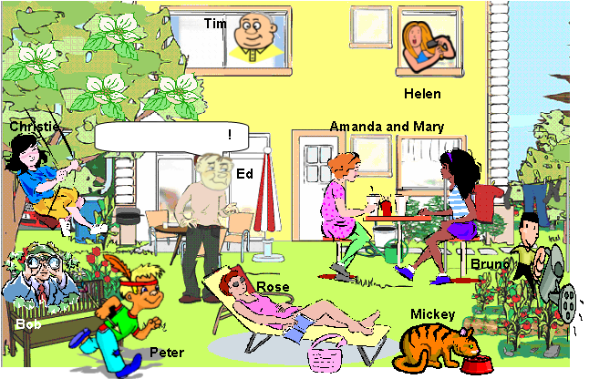

1. She is relaxing____________________.
2. She is swinging.___________________.
3. It is eating________________________.
4. He is bird watching_________________.
5. They are having a drink_____________ .
6. He is watering the flowers____________.
7. He is looking out of the window________.
8. He is playing______________________.
9. He is talking_______________________.

j.She is combing her hair______________.

**4.Choose the word that pronoun different from the others**

1.A. cake B. black C. bat D. rabbit

2.A. eat B. peach C. bread D. read

3.A. question B. pretty C. umbrella D. yellow

4.A. fish B. spider C. piano D. milk

5.A. rainy B. hungry C. windy D. fly

6.A. frog B. long C. color D. hop

7.A. ruler B. under C. puddle D. jump

8.A. where B. what C. who D. white

9.A. thin B. weather C. thirsty D. throw

10.A. pour B. round C. cloud D. house

5.**Put the verbs in brackets into Present Continuous.**

1. Mr. Clarks is in the garden. He _ _ _ _ _ _ _ _ _ (weed).
2. Look! Jane and Phil _ _ _ _ _ _ _ _ _ (dance).
3. Where _ _ _ _ _ _ _ _ _ (your cousins/sleep) today?
4. Pam and I _ _ _ _ _ _ _ _ _ (solve/not) a puzzle.
5. Why _ _ _ _ _ _ _ _ _ (you/sit) on the floor?
6. The kids are sad. They _ _ _ _ _ _ _ _ _ (smile/not).
7. Listen! The birds _ _ _ _ _ _ _ _ _ (tweet) nicely.
8. Nigel _ _ _ _ _ _ _ _ _ (type) his literature essay.
9. My dog _ _ _ _ _ _ _ _ _ _ (lie/not) on the sofa now.
10. I _ _ _ _ _ _ _ _ _ (study) really hard these days.

**6.Read and match.**

|  |  |
| --- | --- |
| 1.Are you listening to music ? | a.No , she isn’t. |
| 2.Are they visiting friends ? | b.Yes, it is. |
| 3.Is she doing homework? | c.Yes, I am. |
| 4.Is it sleeping ? | d.No,you aren’t. |
| 5.Are we eating ? | e.No , they aren’t. |

**7.Look and answer**

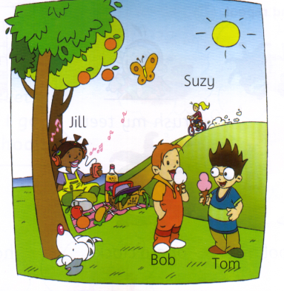

1.Is the dog sleeping? _______________________.

2.Is jill listening to music?

_______________________.

3.Is Suzy reading?

_______________________.

4.Are Tom and Bod playing football ?

_______________________.

8.**Correct the grammar mistakes below. The first one is done for you. There are 12 more.**





|  |
| --- |
| Today is Saturday and my family and I relaxing at home. My father usually washes his car on weekdays but he not washing the car now. Now, he is read a book about cars.  My mother usually bakes cookies on weekdays, but she not  baking now. Now, she watching a cooking show on TV. My |
| older sister usually does her homework on weekdays but she isn’t do her homework now. Now, she paint some pictures. My little brother usually helps my father wash the car but he not helping my father now. Now, he plays with his toys. And me? Usually I clean the yard but I not clean the yard now. Now, I tell you about my family! How about you? What you doing now?  **13.Describing a picture. •Use the ‘ing’ form of the verbs.** |

In the picture, there is a young girl in a park. She (stand) _________on a skateboard and she (smile) _____________and (look)___________ at a picnic basket full of food. Next to the basket there is a cat. It (sleep)________ on a bench, and behind the bench there is a bird. It (walk) _____________on the ground. There is another bird, as well, but it (fly) ___________. There is also a butterfly, and it (fly) _______, too. In the background there is a man. He (walk) _______his dog. He should be careful because there is a man (drive)_______a car very fast on the road behind him.

**14.Fill in the blanks with “**is**” or “**are**”.**

1) Kate _____ cooking a turkey for dinner.

2) Mom _____ setting the table.

3) John ______ making coffee.

4) The boys _____ watching TV.

5) It ____ snowing outside.

6) The baby ____ laughing.

7) The girls _____ painting Easter eggs.

8) We_______ eating turkey.

9) The dog ____ barking.

10) They _____ celebrating Easter.

**15.Write the correct “ing” verb in the blank.**

1.Kate is ______________ dinner (prepare).

2.They are _________ for Easter eggs (hunt).

3.We are ______________ turkey (eat).

4.The Easter Bunny is ___________ (come).

5.I am ____________ Easter eggs (make).

6.The children are ____________ candy (eat).

7.You are ______________ a nice song (sing).

8.The dog is _____________ the cat (chase).

9.The cat is ________________ (run).

10.He is _______________ coffee (drink).

**16.Make a question. /Fill in the blank with “be” and “ing” verb**

1._______ I _____________ dinner? (coo 7. ____ the dog________________ ?(bark)

2. _______ Jack ______________ pie? (bake) 8._____ she _____________?(talk)

3._______ the girls ______________? (eat) 9.______he ______________?(laugh)

4.___ it_______________? (rain) 10. 10_____Kate and John _______?(sleep)

5. ____they___________Easter eggs? (make)

6.______ you ____________ ? (coming)