This is my pen
1.Draw , look and write
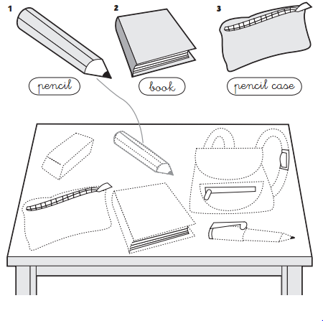
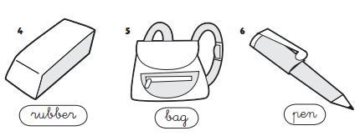
2.Fill in the blanks.
1.It is a ______________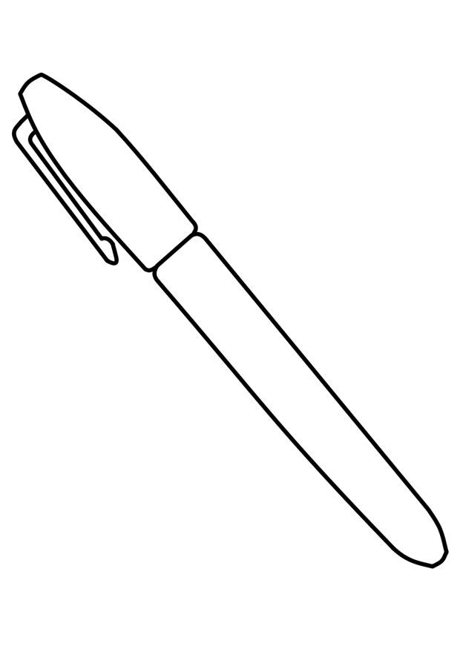 2. It is a ________________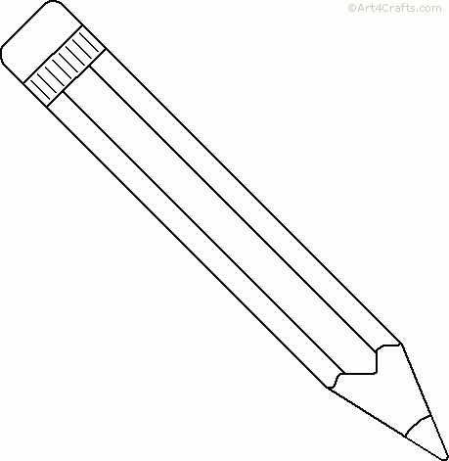
3.It is a _____________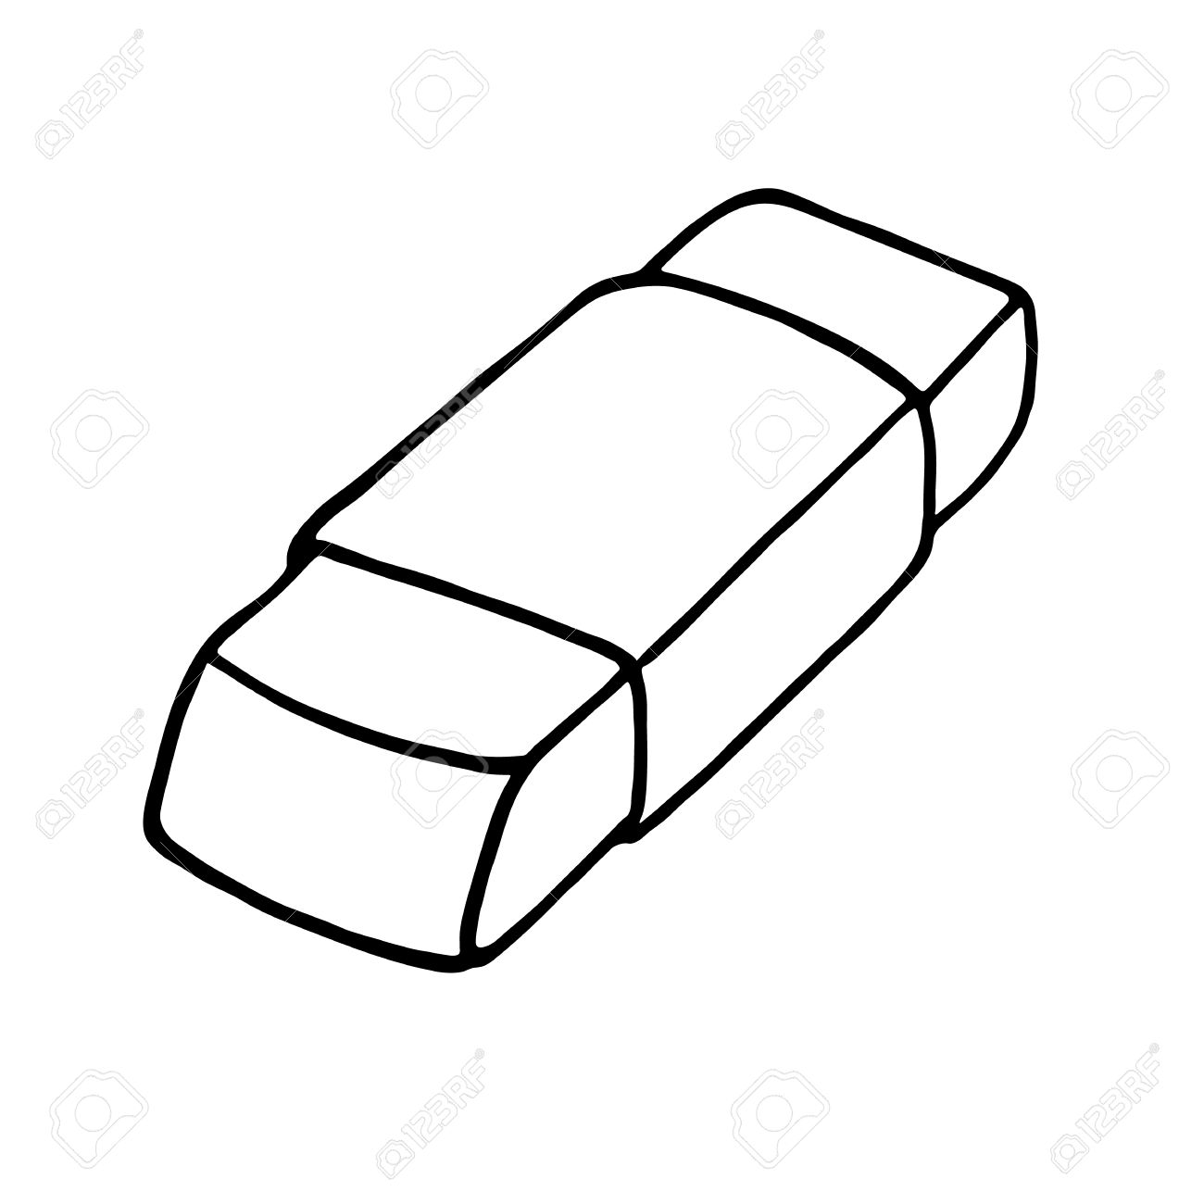 4. It is a ________________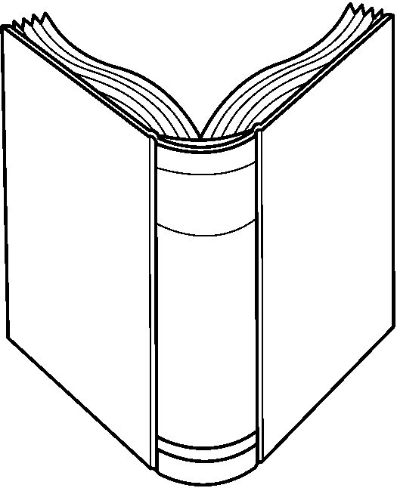
5.It is a ____________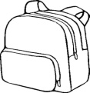 6. It is a ________________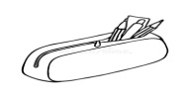
6.It is a ____________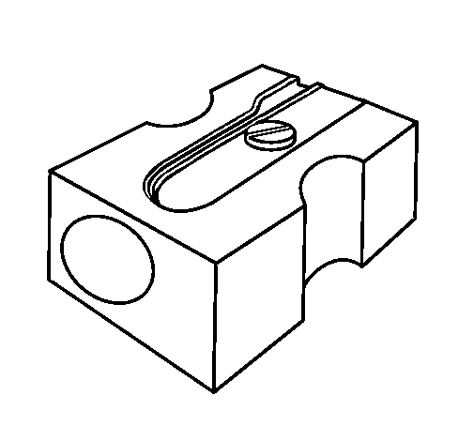7. It is a ___________________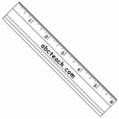
3.Color the that corresponds with the picture.

a. 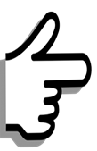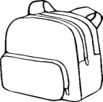 | This is my bag.  That is my bag.
b. | This is my rubber .  That is my rubber.
c. | These are my pens.  Those are my pens.
d. | This is a book.  That is a book.
e. | These are my rulers..  Those are my rulers.
f. | This is my pencil.  That is my penicl.
g. | This is my pencil sharpener.  That is my penicl sharpener.

4.Circle the correct and write.
1.This /These is my school bag.
2. ____________(This /These ) are Mr Loc and Miss Hien.
3.That is my ________________(pen/pens).
4.Those are my _______________(ruler/rulers)
5. That is my classroom . ________________( It is /They are ) large.
7.Those are my rubbers. __________________(It is / They are ) small.
5.Complete the sentences with this or that .

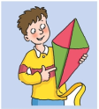  ________is a kite. | 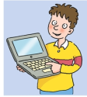  ______is a computer. | 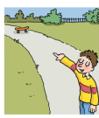  _______is a skateboard. | 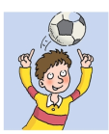  _________is a ball.
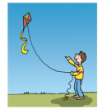  __________is a kite. | 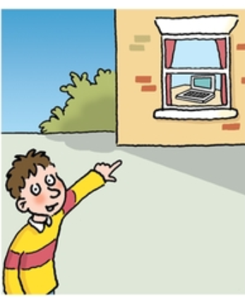  ______is a computer. | 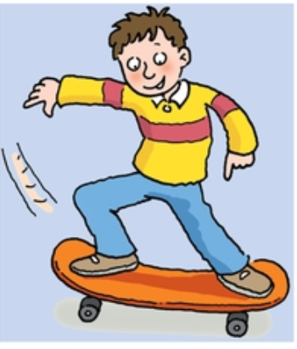  _______is a skateboard. | 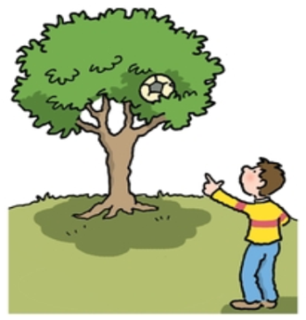  _________is a ball.

6.Order words to make sentences

is / This / my /pen _____________________________________
- is/ rubber / That / my _____________________________________
- books/ These / are / my _____________________________________
- pencil case /is / This/my_____________________________________
- bag / is /This /my _____________________________________
- my/ Those / penicls / are_____________________________________
- These/ pens/ are/my _____________________________________
- my/ cat / That / is _____________________________________
- That /dog/is / my _____________________________________
7. Write
- Is this your school bag ? Yes , _____________.
- Is that your penicl case ? No , ______________.
- Are these your pens ? No , _____________.
- Are those your rulers ? Yes ,____________.
- Is this your pencil ? Yes , ____________.
- Is these your notebooks ? No , _____________.

