**This is my house**

**1.Read and match**

1. There's a living room
2. There's a kitchen
3. There's a bathroom.
4. There's a bedroom.
5. There's a dining room.
6. There's a garden.



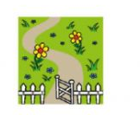







**2.Read and tick (✔)**

Hi! My name is Mary This is my house. It is big. There is a garden in front of the house. There are trees in the garden. There is not a garage. The living room is large ,but the kitchen small. There are four bedrooms, two bathrooms in my house. There is a pond behind the house. Around the pond, there are many trees and flowers. They are very beautiful.

|  |  |  |
| --- | --- | --- |
|  | **Yes** | **No** |
| 1. Mary’s house is small. |  |  |
| 1. The garden is behind the house. |  |  |
| 1. The living room is large. |  |  |
| 1. There are many rooms in Mary's house. |  |  |
| 1. There is a pond in front of her house. |  |  |

**3. Read and match**

|  |  |
| --- | --- |
| 1.There is my | a.over there |
| 2.There’s a garden | b.garage ? |
| 3.The living room | c.house |
| 4.Is there a | d. is large |

**4.Match the sentences.**

|  |  |
| --- | --- |
| 1.Is there a pond in front of the house ? | a. Wow ! It’s beautiful! |
| 2.Is that your house ? | b.Yes, there is . |
| 3.That is my room. | c.No , it isn’t. It’s old. |
| 4.Is the house new ? | d.Yes, it is my house. |

**5. Circle the odd one out:**

1. A. mother B. father C. uncle D. brother
2. A. grandfather B. brother C. grandmother D. teacher
3. A. sister B. brother C. friend D. mother
4. A. family B. mummy C. baby D. Daddy
5. A. daughter B. uncle C. son D. baby
6. A. house B. bedroom C. garage D. kitchen
7. A. bathroom B. school C. bedroom D. dining room
8. A. kitchen B. dining room C. library D. living room
9. A. class room B. bathroom C. living room D. bedroom
10. A. table B. chair C. garden D. desk

**6. Reorder these words to make meaningful sentences:**

1. small/ is/ this/ house/ a/.___________________________________________
2. a/ living/ large/ room/ is/ this. _______________________________________
3. There/ is/ in/ house/ the/ bedroom/ a/ ? _______________________________
4. pond/ in/ garden/ the/ is/ a/ there/___________________________________
5. kitchen/ the/ old/ is/. ____________________________________________
6. room/ living/ the/ large/ is/.________________________________________
7. bath/ the/ room/ big/ is/. __________________________________________
8. That/ a/ is/ pond/.________________________________________________
9. over/ there/ the/ is/ garden/. ______________________________________

10.my/ is/ this/ house/. / is/ it/ beautiful ________________________________

**7.Look at the pictures and answer the questions.**

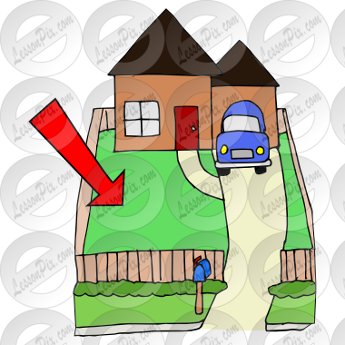

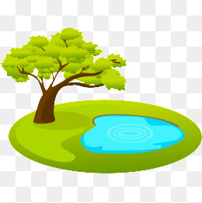



Is there a yard ?

_________________

Is there a pond?

_________________

Is there a garage?

__________________

8.**.Fill in the blanks with sound** ch **or** th

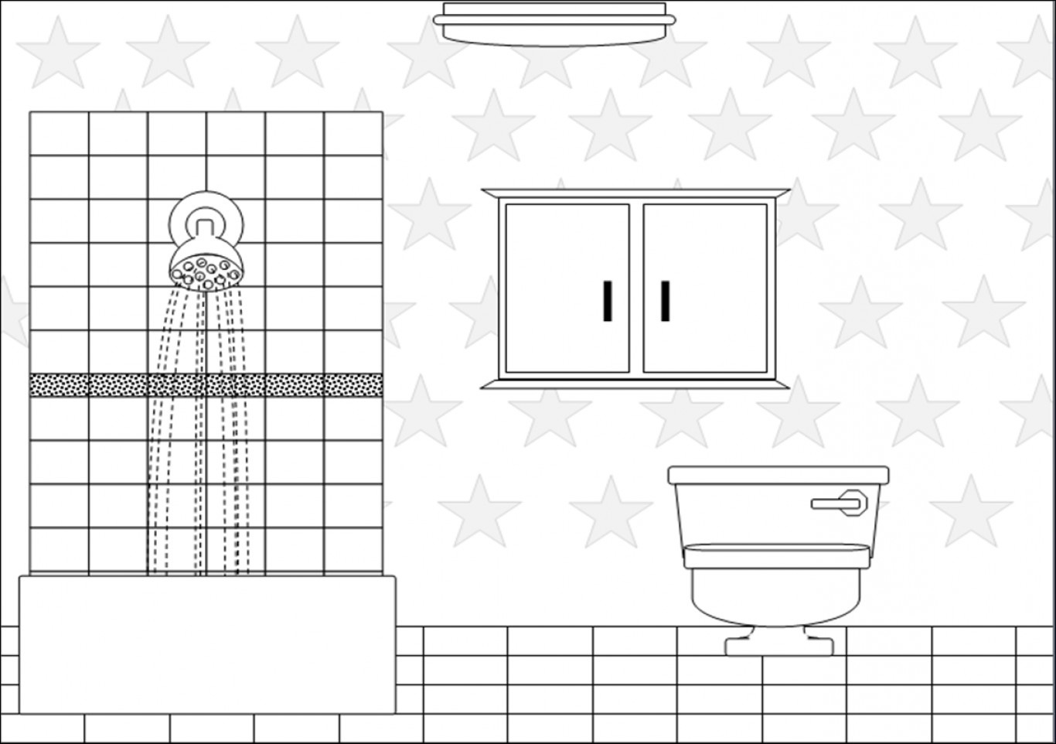

ba___room

___

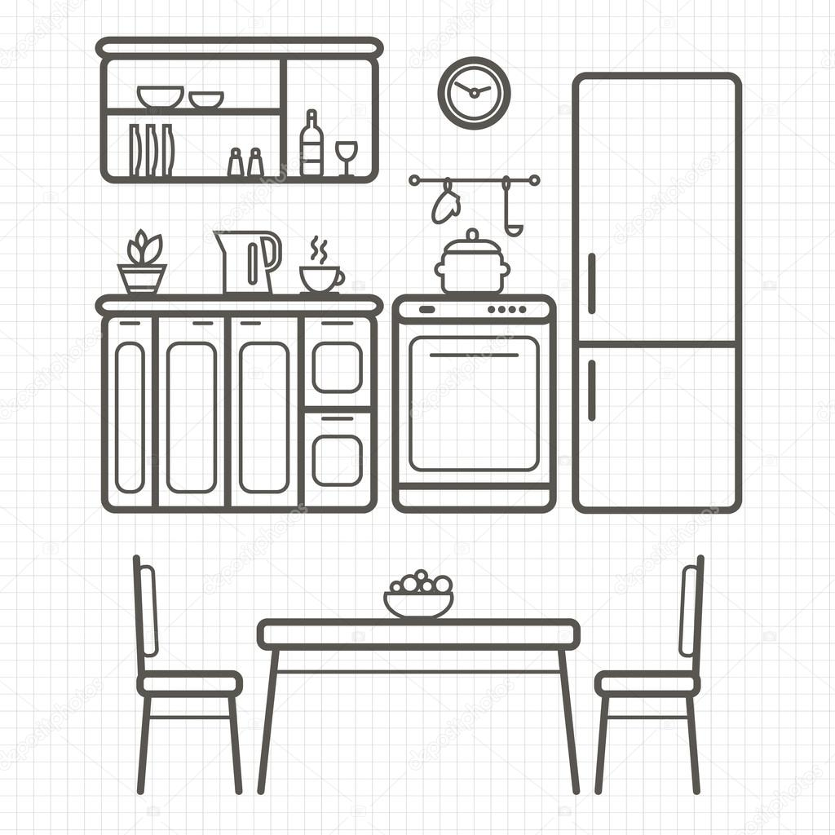

kit___en

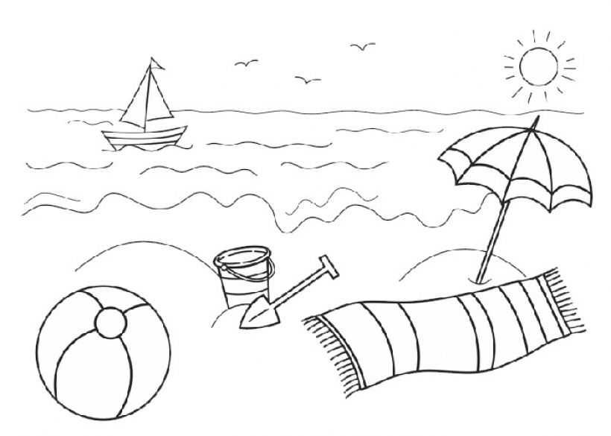

bea__



___air



___ocolate

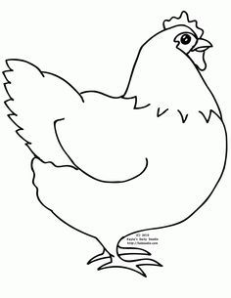

___icken



___ree



fa___er

**9.Look at the picture , write and colour.**

garage , bathroom , hall , kitchen , living room ,bedroom

