This is my family
1.Look at the each family member picture and fill in the missing letters.
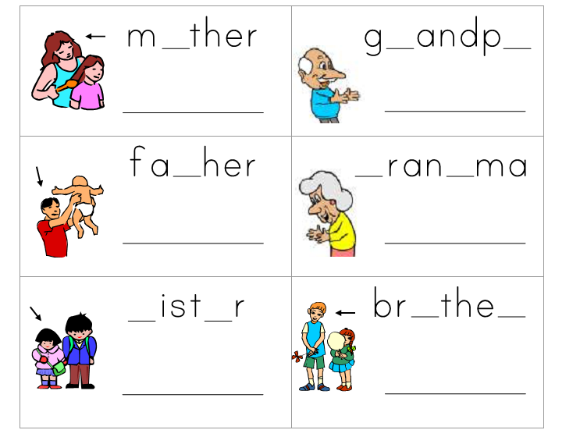

2.Look at the letters on the picture . Write a letter next to its correct sentence below
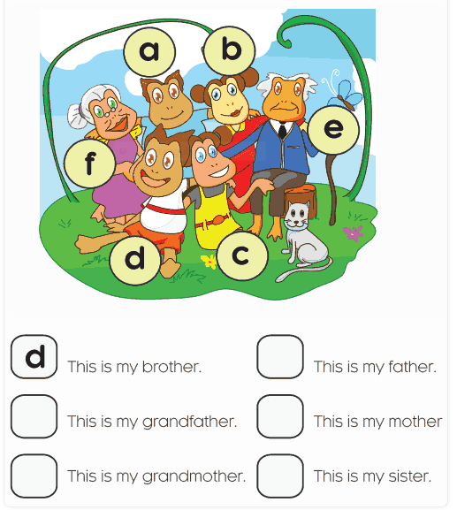

3. Match the question to the answer.
Sally | John
- What is your name? | - This is my mother.
- How old are you? | - It is a book.
- What is this? | - My name is John.
- Is it a red pen? | - No, it isn’t.
- Who is that | - That is my grandmother.
- Who is this? | - I am five years old.
4.Rearrange the given words.
- I / Peter / am. =))________________________
- five / years / old / I/ am. =))________________________
- is / This / family / my. =))________________________
- This / my / father/ is. =))________________________
- mother / This /is / my. =))________________________
- is / This / sister / my. =))_______________________
- my/ family / I / love. =))_______________________
8. that's/ grandfather/my =))_______________________
5.Odd one out:
- a. father b. mother c. rubber d. sister
- a. ruler b. grandfather c. grandmother d. brother
- a. black b. brown c. blue d. brother
- a. small b. school bag c. young d. little
- a. photo b. stand c. it d. ask
- a. how old b. nice c. what d. who
- a. am b. hello c. is d. are
- a. my b. her c. his d. he
- a. your b. bookcase c. desk d. pencil shapener
- a. classroom b. computeroom c. new d. gym
6.Write the number below in English:
1: one | 9: nine | 17: seventeen | 70: seventy
2: two | 10: ten | 18: eighteen | 80: eighty
3: three | 11: eleven | 19: nineteen | 90: ninety
4: four | 12: twelve | 20: twenty | 100: one hundred
5: five | 13: thirteen | 30: thirty | NUMBER
6: six | 14: fourteen | 40: forty
7: seven | 15: fifteen | 50: fifty
8: eight | 16: sixteen | 60: sixty

15 |  | 63
21 |  | 67
25 |  | 78
34 |  | 88
36 |  | 93
42 |  | 94
49 |  | 95
55 |  | 99

7. Answer questions about you:
- What’s your name?____________________________________________
- How are you? ____________________________________________
- How old are you? ____________________________________________
- What colour is your school bag? _________________________________________
- What colour is your pen? ____________________________________________
- How old is your father? ____________________________________________
- How old is your mother? ____________________________________________
8.How old is your brother/ sister? __________________________________________
8.Put the words in the right columns.
swimming sixty-five brother tennis grandfather forty-one basketball mother thirteen football father sixty-eight volleyball sister forty -nine

Sport | Family member | Number
9.Read and complete.
teacher old sister am name

Hi , My (1)_____is Amy.This is the picture of my family.
This is my mother.She is a teacher.She is thirty years(2) __________.That is my father.He is a (3)_________too.He is thirty-three years old.That is my younger(4)____________She is four years old.I am a pupil.I(5) ____________seven years old. We are a happy family .

