This is Tony

1.Look and write
this that

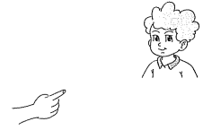
- _______is Peter.
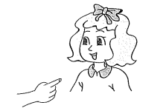
- _______is Linda.
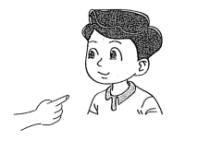
- _______is Nam.
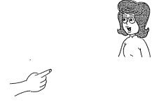
- _____Mss Hien.

2.Circle a or b
1._____________is Lisa . a.This b. What
2.That ____________Miss Hien. a. is b. are
3.Is that Tony ? ___________,he is . a. yes b . No
4.Is that Peter ? No , __________ a. It is b. It isn’t.
5.How __________you ? a. is b. are
6.What __________your name ? a. are b. is
My name is Tony.
7.How ___________you spell your name ? a. do b. are

3.Write
what how who

- A : _____________is your name ?
B : My name is Linda.
- A : _____________is that ?
B : It is Peter.
- A : ____________do you spell your name ?
B : M-A-I
- A: ____________are you today ?
B:I am Ok .Thanks.

4.Circle the odd one out.
1. a.Mary b. what c. who
2. a.this b.that c. yes
3. a.you b. I c.name
4. a.no b.Tony c.Peter
5. a. hi b.hello c.bye

5.Write the answers.
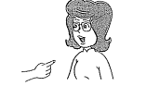
3. Is this Mss Hien ?
________________
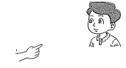
2.Is that Nam?
___________________
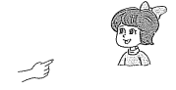
1.Is that Linda ?
__________________

6.Write
Down
2. t ____________3
3. f ____________5
4. o ____________1
5.s ____________6
6.n ____________9
7. t ___________2
Across
1.e ____________8
3.f ____________4
5.s ____________7
7.t ____________10
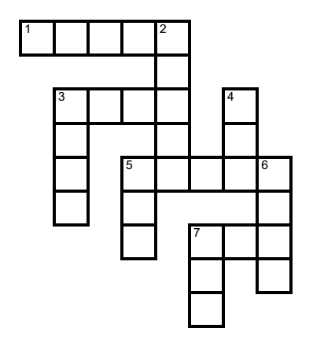

7.Color the that corresponds with the picture.
a. 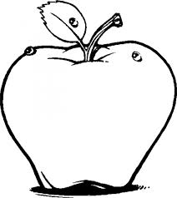 | This is an apple  That is an apple
b. 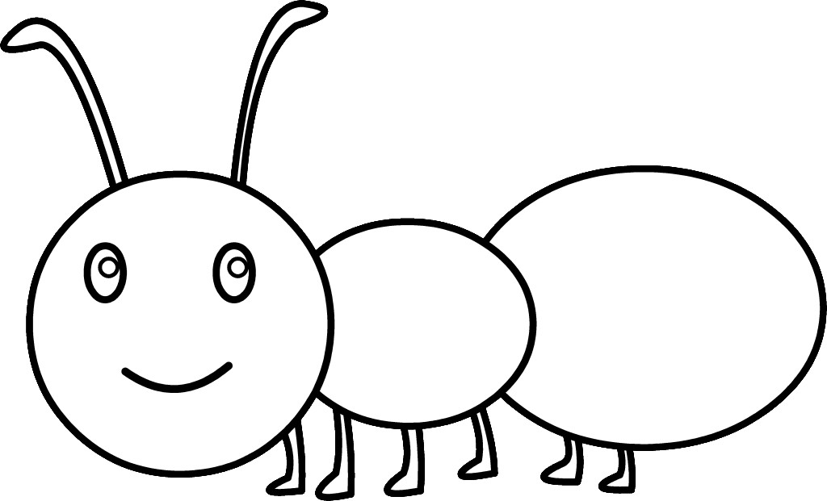 | This is an ant .  That is an ant.
c. 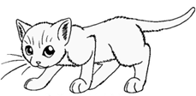 | This is a cat.  That is a cat.
d. 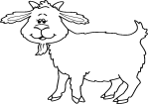 | This is a goat.  That is a book.

8.Complete the sentences with this or that .
________is a kite. | ______is a computer. | 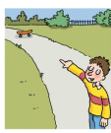  _______is a skateboard. | 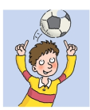  _________is a ball.
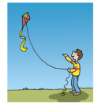  __________is a kite. | 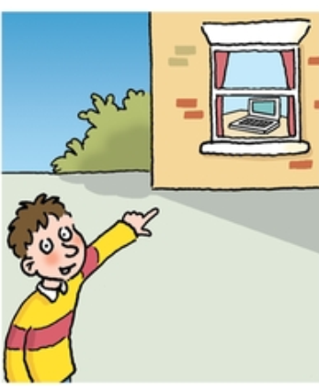  ______is a computer. | 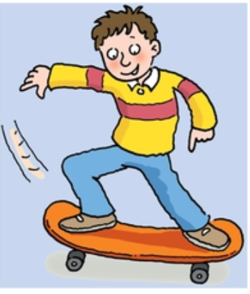  _______is a skateboard. | 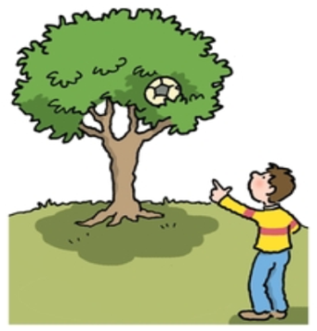  _________is a ball.
9.Color by number.
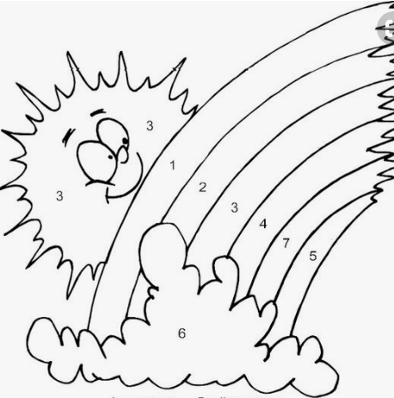
one= blue
two = yellow
three = red
four = green
five = purple
six= gray
seven = pink

