That is my school
1.Look and write
That is the school ; That is the gym ; That is the computer room ;
That is the classroom ; That is the playground , That is the library

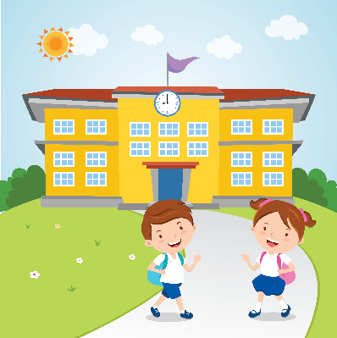  That is the school. | _____________________ | 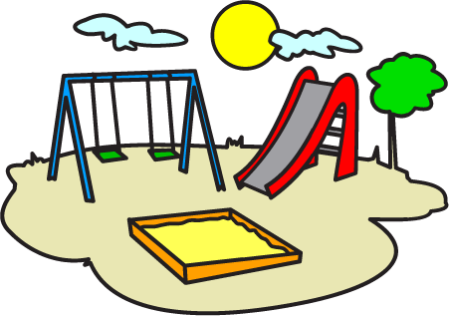  ______________________
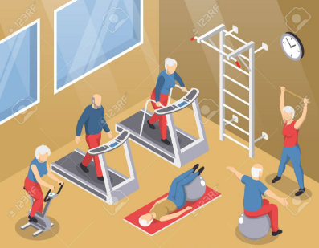  ____________________ | ______________________ | 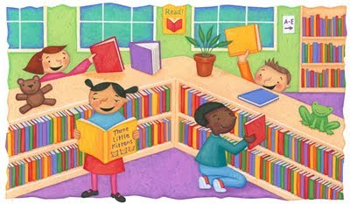  ________________________
2.Circle a , b or c.
1.Is that your school ? Yes, ______________. A) it is B) it isn’t C) I am
2.This is our library . __________new. A) it is B) she is C) he is
3._________the computer room big ? A) Is B) Are C)This
No , it isn’t . It’s small.
4.Is the playground large ? No , It isn’t . It’s _______A) big B) small C) old
5.Is the school new ? Y es , _________ A) it is B) it isn’t C) he is
6.Is the library old? No,________. It's new A) it isn’t B) it is C) he is
7.Is the gym big? No, it isn't. It's __________ A) big B) small C) new
3.Read and circle a, b or c
This is our school . It is Rose Primary . It is big and new . Th is is our school playground . It is large. It is n ext to the computer room. These are our classrooms .They are big and bright.

1.The name of the school is ______________________.
a.Queen Primary School b. Rose Primary School c. King Primary School
2. The school is ____________________.
a.big and new b. big and old c. old and bright
3. The school playground is __________________.
a.large b. old c. small
4.The library is n ext to the __________________________
a.classroom b.gym c. computer room
5.The classroom are ________________________.
a.small and old b.small and new c.big and bright
4. Circle the odd one out.
1.a) small b) big c) large d) sit down
2.a) classroom b) computer room c) library d) house
3.a) am b)he c)are d)is
4. a) hi b)he c)she d) I
5. a.)Tony b)Peter c)Amy d)Hi

5.Write

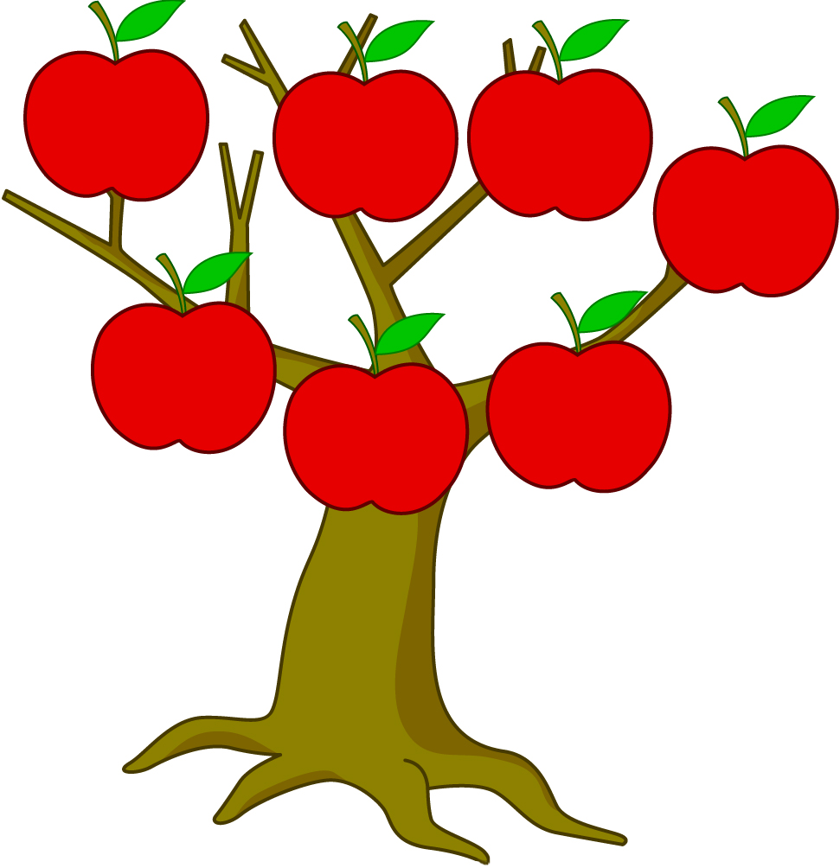
1.rooclassm
___________

4.cmoupertmoom
___________

3.anctnee
____________

6.braliry
_________

Pl___gro_nd
Ca___ee__
Cl___sr___m
L_br_r_
S___ool
T____et
C_m___te_ r____
5.groplayund
_____________

2. ettiol
___________

7.chsloo
________

6.Write
school
library
classroom
computer room
computer room
gym
playground
playground
gym

