Nice to see you again
1.Match the greetings with the pictures.
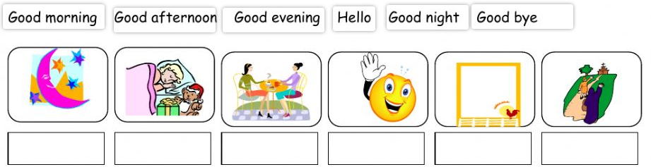

2.Draw a line to macth the greetings and sentences.

1.It’s 7 am . I’m having breakfast. | a.good moring
2.It’s 10 pm . I’m going to sleep. | b.good afternoon
3.It’s 8 pm . I’m meeting Mr Green. | c.good evening
4.It’s 4 pm . I’m leaving Miss Bell’s classroom. | d.hello
5.It’s 9 am . I am meeting my friend Martin. | e.good night
6.It’s 2 pm . I’m entering the library. | f.good bye

3.Match and write.
I go to bed at ________________________ | night
I go to school in the ___________________ | evening
I play in the _________________________ | afternoon
I watch televison in the _________________ | morning
Find and circle
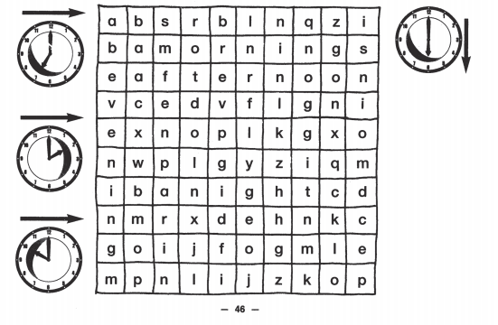

4.Read and match
1. Good morning, class.  2. How are you, Mai?  3. Goodbye, Miss Hien.  4. Nice to see you again  5. Good night | A. Nice to see you, too.  B. Bye, Hoa. See you tomorrow.  C. Good night.  D. Good morning, Miss Hien.  E. I'm very well, thank you.
5.Read the questions . Write the answers.
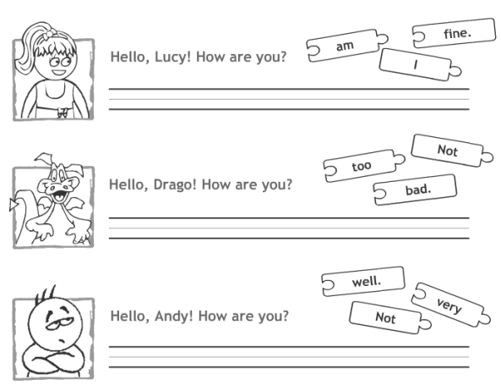

6.Reorder these words to make a complete setence.

- to/ you/ see/ nice/ again ______________________________
- morning/ good/ teacher ______________________________
- you/tomorrow/see ______________________________
- later/ see/ you ______________________________
- am/ Vietnam/ I/ from ______________________________
- mai/are/you/how/? ______________________________
- to/too/nice/you/see ______________________________
- am/well/I/very ______________________________

7.Read and circle:
Today I go school from 7:30 to 11:30 in the morning. My classroom is very big. My friends are lovely. We usually say “Hello” every morning. When my teacher comes into classroom, everybody stands up and say “Good morning, teacher”. She is a beautiful woman. When our lessons finish, she says “Goodbye, class”.
- I go to school ____________ in the morning
A. From 6.30 to 10.30 B. from 7.30 to 11.30
- My classroom is very ____________
A. Big B. small
- When my teacher comes into the classroom, everybody stands up and say “_______________”
A. Good morning teacher B. hello teacher
- My teacher is _______
A. a lovely woman B. a beautiful woman
- When our lessons finish, our teacher says “______________”
A. Goodbye class B. good night mum
8.Complete the dialogue:

1. Mai: Hello, my __________ is Mai
Lan: ___________, Mai. I’m ___________. How _______you?
Mai: I ________ fine, thanks. And _________?
Lan: ____________, thanks

2. Mai: Good afternoon, Miss Trang
Miss Trang: _____________Mai, _________________________?
Mai: I’m fine, thank you. How ________________?
Miss Trang: ______________, thanks. Goodbye

9.Unscramble the words below.

