I’m from Japan
1.Look at the picture and write
England – English the U.S.A. – American Malaysia - Malaysian Japan – Japanese
Viet Nam –Vietnames Australia - Australian

I’m ______________________________  I’m from __________________________ | 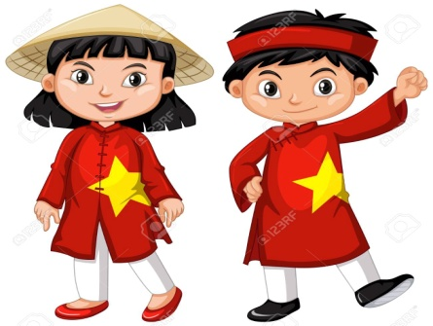  We’re__________________________  We’re from____________________
I’m ______________________________  I’m from __________________________ | 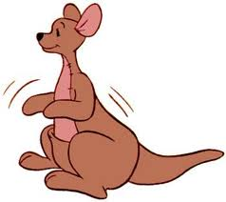  I’m ___________________________  I’m from ______________________
I’m ______________________________  I’m from __________________________ | 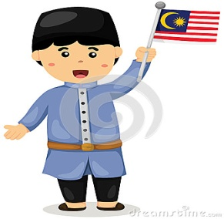  I’m _______________________  I’m from ___________________

2.Write the nationality of the countries under the flags

3.Fill in am, is, are, not isn´t or aren´t
a.She isn’t from England. She _______from US.
b.You ___________ American .You are Italian.
c.My favorite sport is tennis. It______ football.
d.I am Australian . I ______ Japanese.
e.We aren’t musicians. We ___________ students.
f.I ________ a musician. I’m not a teacher.
g.Tony is sixteen years old. He_______sixty years old.
h.They aren’t from Egypt. They_______ From Brazil.
4.Choose the odd one out .

a) England b) American c) Japanese d) Vietnamese
a) Good morning b) Goodbye c) Good evening d) Good afternoon
a) First b) Second c) Four d) Ninth
a) January b) October c) December d) Thursday
a) Tenth b) Tuesday c) Wednesday d) Sunday

5.Fill in the chart with the following words and then complete the text below
Rome Spain Paris U.K. Germany
Canberra Japan American Berlin
Tokio Russian U.S.A France Madrid
Brazilia English Italian Australian
Italy German London Japanese Washington D.C
French Spanish Australia Brazil Brazilian Moscow Russia

COUNTRY | NATIONALITY | CAPITAL
My name is ______________and I come from____________( your country)
I’m ______________(your nationality).I like my home country!
My flag is_________________ (write the colours of your flag)

Draw your flag !

6.Read and answer:

Name: Nguyen Thi Lan  Hometown: Ho Chi Minh City, Viet Nam  School: Nguyen Hue Primary School  Class: 4a5 | Name: John Smith  Hometown: London, England  School: International Primary School  Class: 4a1
- What is the girl’s name?__________________________________
- Where is she from? __________________________________
- What is her school’s name? __________________________________
- What nationality is she? __________________________________
- What is the boy’s name? __________________________________
- Where is he from? __________________________________
- What is the name of his school? _________________________________
8. What nationality is he? __________________________________
7.Read and match:
- Where are you from? |  | - Nice to meet you, too.
- How are you, Mai? |  | - Bye Hoa, see you tomorrow.
- What nationality are you? |  | - She is Vietnamese.
- What’s your name, please? |  | - Yes, come in.
- Goodbye, Miss Hien. |  | - I’m very well, thank you. And you ?
- Hi, Hoa. It’s nice to meet you. |  | - I’m Peter.
- Sorry, I’m late. |  | - I’m from France.
- What nationality is your mother? |  | - I’m English.

