How old are you ?
1.Match the numbers
How old are you ?
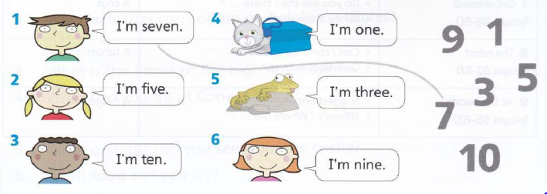

2.Look at the picturers and answer the questions.
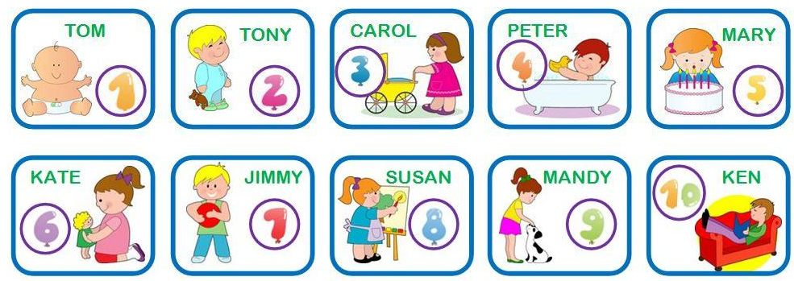

How old is Jimmy?  He is seven years old | How old is Susan?  ______________________ | How old is Peter?  ______________________
How old is Mary?  _____________________ | How old is Tom ?  ______________________ | How old is Ken?  ______________________
How old is Kate?  ____________________ | How old is Carol?  ______________________ | How old is Mandy?  ______________________

3.Complete the sentences.
- How old are you? I ___________seven years old.
- Is your friend seven ___________old ? ___________, he isn't. He six years old.
- How old _______ your mother? She is 35 years ________.
- ________you seven years old ? __________, I am.
- Is Sally four years old? Yes, _________is.
- _______ old is Brian? __________is ten years old.
- How old___________ Mark and Lucy?
- Mark _________twelve years old.
- Lucy __________ten years old.
- I ___________thirteen years old.
4.Read and write
he is nine years name

Hello .My (1) __________is Trang . I am eight(2) _________________old.This (3)________
Tony .He is seven years old. That is Phan. (4) _____________is ten years old. And that is Mia .She is (5) _________________years old. We are good friends.
5.Circle the odd one out
a) tiger elephant bear eight
b) ten seventeen yellow nine
c) Mary Tony Peter bye
d) hello he she I
e) cat dog hippo pen
6.Write is or are
For example: How old is your aunt?
1. How old _____ your father? 5. How old _____ her mom´s cat?
2. How old_____ your mother´s sisters?
3. How old ______your sister´s dogs?.
4. How old _____his brothers?
7.Complete the sentences. 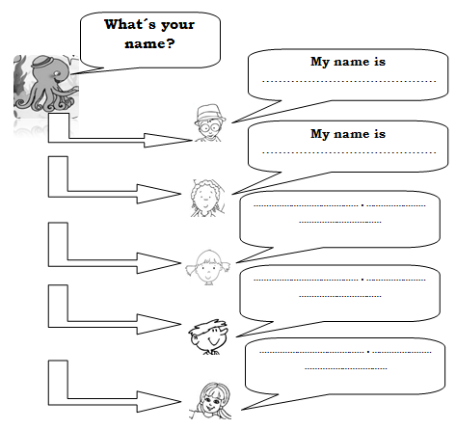
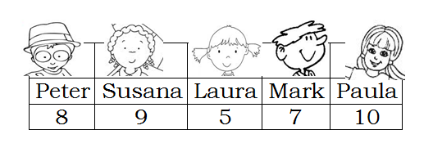
8.Write is or are .
For example: How old is your aunt?
1. How old _____ your father?
2. How old_____ your mother´s sisters?
3. How old ______ your sister´s dogs?.
4. How old _____ his brothers?
5. How old _____ her mom´s cat?
9.Choose the correct answer.

1.How old is ________?
a.you b. your brother c. they
2.I am 22 ________.
a.years old b. year old c. year olds
3.How old are____?
a.he b. you c. your nephew
4.How _______ his brother in law?
a.old is b. old are c. he old
5.He _____ 15 years old
a.are b. has c. is
6.She _____ 65. She is young
a. isn´t b. doesn´t have c. aren´t
7.They _____ 5 and 6 years old
a.have b. are c. is

