**Do you have any toys ?**

**1.Look and write.**

|  |  |  |
| --- | --- | --- |
| Description: Kết quả hình ảnh cho ball  There is a\_\_\_\_\_\_\_\_ | Description: Kết quả hình ảnh cho teddy bear  \_\_\_\_\_\_\_\_\_\_\_\_\_\_\_\_\_\_\_\_\_\_ | il_570xN  \_\_\_\_\_\_\_\_\_\_\_\_\_\_\_\_\_\_\_\_\_\_\_\_ |
| Káº¿t quáº£ hÃ¬nh áº£nh cho doll clipart  \_\_\_\_\_\_\_\_\_\_\_\_\_\_\_\_\_\_\_\_ | Káº¿t quáº£ hÃ¬nh áº£nh cho boat clipart  \_\_\_\_\_\_\_\_\_\_\_\_\_\_\_\_\_\_\_\_\_\_ | Description: Hình ảnh có liên quan  \_\_\_\_\_\_\_\_\_\_\_\_\_\_\_\_\_\_\_\_\_\_ |

**2.Odd one out:**

1. a. ship b. house c. room d. class
2. a. plane b. kite c. teddy bear d. ruler
3. a. kitchen b. living room c. garage d. robot
4. a. ball b. ship c. garden d. doll
5. a. tree b. garden c. pond d. yo-yo
6. a. doll b. robot c. bear d. puzzle
7. a. kite b. plane c. car d. school
8. a. gate b. ball c. yard d. pond
9. a. room b. yo-yo c. ship d. plane

**10**. a. teddy bear b. puzzle c. doll d. fan

**3.Put the words in correct order:**

1. my/ it/ puzzle/ is \_\_\_\_\_\_\_\_\_\_\_\_\_\_\_\_\_\_\_\_\_\_\_\_\_\_\_\_\_\_\_\_
2. doll/ the/ is/ the/ table/ on \_\_\_\_\_\_\_\_\_\_\_\_\_\_\_\_\_\_\_\_\_\_\_\_\_
3. are/ there/ balls/ two/ the/ bed/ near\_\_\_\_\_\_\_\_\_\_\_\_\_\_\_\_\_\_\_\_\_\_\_\_\_
4. you/ teddy/ have/ bear/ a/ do/ ? \_\_\_\_\_\_\_\_\_\_\_\_\_\_\_\_\_\_\_\_\_\_\_\_\_
5. car / I/ a/ have / little\_\_\_\_\_\_\_\_\_\_\_\_\_\_\_\_\_\_\_\_\_\_\_\_\_
6. sister/ doll/ a/ does/ your/ have/ ? \_\_\_\_\_\_\_\_\_\_\_\_\_\_\_\_\_\_\_\_\_\_\_\_\_
7. have /Linda/ a/ doesn’t / robot\_\_\_\_\_\_\_\_\_\_\_\_\_\_\_\_\_\_\_\_\_\_\_\_\_

**4.Fill in the blank with is, are, have or has:**  
1. There \_\_\_\_\_\_\_\_\_\_\_\_a poster on the wall.  
2.\_\_\_\_\_\_\_\_ they your friends?  
3. Where \_\_\_\_\_\_\_\_\_\_\_\_\_\_- my toys?  
4. I \_\_\_\_\_\_\_\_\_\_\_ a ship and two robots.  
5. She \_\_\_\_\_\_\_\_\_ many pretty dolls.

6. Are there any cars on the shelf ? – No, there \_\_\_\_\_\_\_\_\_\_\_\_not.  
7. Does she \_\_\_\_\_\_\_\_\_ any toys? – No, she doesn’t.  
8. There\_\_\_\_\_\_\_\_\_\_a ball under the bed.

**5. Write** I have got a / I haven’t got a  **for each picture.**

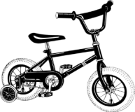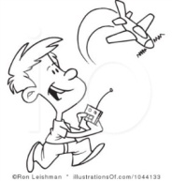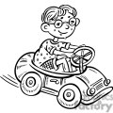

plane carbike

yes

no

yes

train 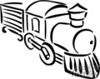 robot 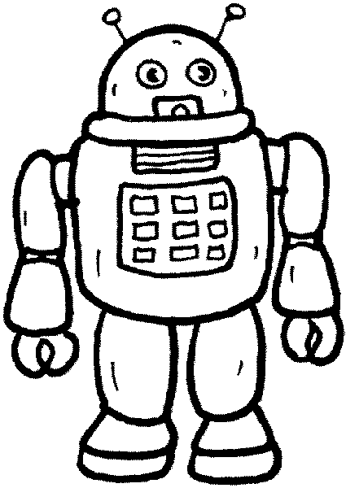 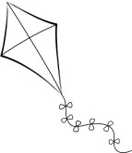kite

yes

no

no

1. I have got a \_\_\_\_\_\_\_\_\_\_\_\_\_\_\_\_\_\_.

2. I haven’ t got a \_\_\_\_\_\_\_\_\_\_\_\_\_\_\_\_\_.

3. \_\_\_\_\_\_\_\_\_\_\_\_\_\_\_\_\_\_\_\_\_\_\_\_\_\_\_\_\_\_\_\_\_\_\_.

4. \_\_\_\_\_\_\_\_\_\_\_\_\_\_\_\_\_\_\_\_\_\_\_\_\_\_\_\_\_\_\_\_\_\_\_\_.

5. \_\_\_\_\_\_\_\_\_\_\_\_\_\_\_\_\_\_\_\_\_\_\_\_\_\_\_\_\_\_\_\_\_\_\_\_.

6. \_\_\_\_\_\_\_\_\_\_\_\_\_\_\_\_\_\_\_\_\_\_\_\_\_\_\_\_\_\_\_\_\_\_\_\_\_.

**6.Circle the correct answers.**

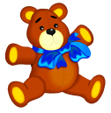 Is it a teddy? Yes, it is\ No, It isn’t.

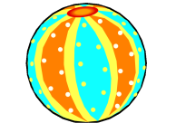

Is it a car? Yes, it is\ No, It isn’t.

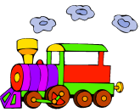

Is it a train? Yes, it is\ No, It isn’t.

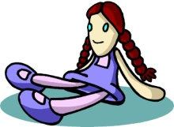

Is it a ball? Yes, it is\ No, It isn’t.

http://www.esljunction.com/esl-efl-flashcards/toys-flashcards/images/kite.jpg Is it a kite? Yes, it is\ No, It isn’t.

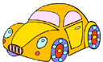

Is it a puzzle? Yes, it is\ No, It isn’t.

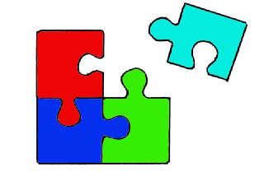

Is it a doll? Yes, it is\ No, It isn’t.

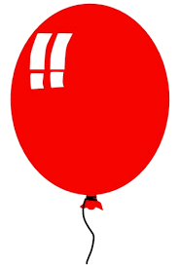

Is it a balloon? Yes, it is\ No, It isn’t.

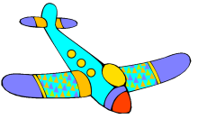

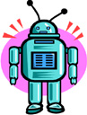 Is it a plane? Yes, it is\ No, It isn’t.

Is it a robot? Yes, it is\ No, It isn’t.



Is it a drum? Yes, it is\No, it isn’t.

**7.Fill in the blank with suitable word:**

shelf – window – chairs – table – bed – many

Look at my bedroom. It is large and nice. There are many things in my bedroom. Here is my (1) \_\_\_\_\_\_\_\_The bed is big. There are (2) \_\_\_\_\_\_\_\_\_ball under the bed. Next to the bed is a big (3) \_\_\_\_\_\_\_\_My school things are on this table. There are two small (4) .\_\_\_\_\_\_\_\_\_\_\_ behind the table. There is a (5) \_\_\_\_\_\_\_\_near my bed. My planes and robots are on this shelf. There is a beautiful picture above the (6) \_\_\_\_\_\_\_\_\_\_.

**8.Make sentences using “Do/ Does…have…? - …have/ has…”**

* She/ doll? –2 🡪 Does she have any dolls? – She has two dolls.
* You/ cup?- 6 🡪 Do you have any cups? – I have six cups.

1. You/ teddy bear? – 3

1. Your mother/ coat? – 4

1. He/ ball? – 1

1. Lan and Hoa/ doll? – 5

1. Nam/ car? – 7

1. Your brother/ robot? – 2

1. Your father/ map? – 3

1. You/ toy? – 8

..........................................................................................................................................