**Do you have any pets?**

**1.Write have / has**

1. She __________three dogs. 7. Amy _________three cats.
2. He __________two parrots. 8. I ________a dog.
3. They ________five cats. 9. We _______two birds.
4. He _________four goldfish. 10.They _______a parrot.
5. I ___________five dogs.
6. Linda _____________a rabbit.

**2.Write**

No, I don’t

Yes, I do

|  |
| --- |
| 1. Do you have any cats? ______________________ 2. Do you have any parrots? ______________________ 3. Do you have any monkeys? ______________________ 4. Do you have any mouses? ______________________ 5. Do you have any dogs? ______________________ 6. Do you have any pets? ______________________ |

**3.Write**

No, he doesn’t.

No, she doesn’t.

Yes, he does.

Yes,she does.

1. Does Linda have any cats ?  _____________________.
2. Does he have any dogs ?  _______________________.
3. Does she have any rabbits ?  __________________.
4. Does he have any monkeys ? ______________________

**4.Read and answer the questions.**

I am Mary. I have four pets. They are a dog , a bird and two goldfish.The dog is in the garden.It is black and white. The bird is in the cage. It is blue and brown. The two goldfish are in the tank.They are black and orange .I love my pets very much.

1.What pets does Mary have ?

______________________________________

2.Where is the dog ?

______________________________________

3.Where are the two goldfish ?

________________________________________

4.What colour is the bird ?

___________________________________________

5.What colour are the two goldfish ?

_____________________________________________

**5.Make questions using the following cues:**

1. Where/ cats? – they/ in front of/ the TV.

________________________________________

________________________________________

1. Where/ dog? – it/ under/ the table.

__________________________________________________

________________________________________

3.Where/ parrot? – it/ in/ the cage.

________________________________________

________________________________________

4.Where / gold fish? – it/ in / the fish tank

________________________________________

_________________________________________

**6.Look at the pictures and answer the questions.**

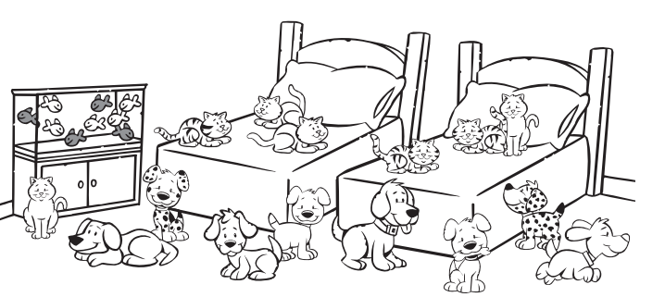

How many pets can you count ? Use there is / or there are to answer

_______________________________

_______________________________

_______________________________

_______________________________

_______________________________

_______________________________









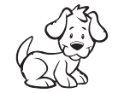

 _______________________________

**7. Complete with ‘in’, ‘on’, ‘under’!**

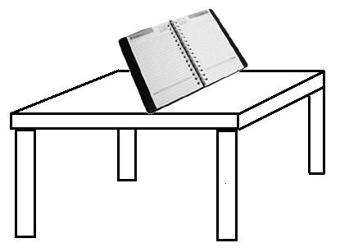1.

The book is _____ the table.

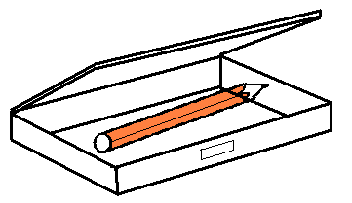

2.

The pencil is _____ the pencil case.

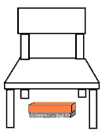

3.

The duster is ____________ the chair.



4. The book is _______ the chair



5. The globe is ______ the chair

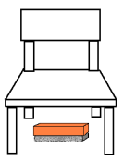

6. The duster is _____ the ________

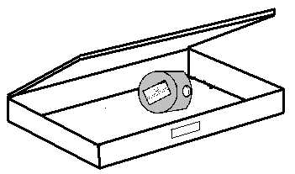

7. The sharpener is __________________________