Can you swim ?
1.Choose the word from the box and write
swim ; skate ; dance; ride a bike ; skip ; cook
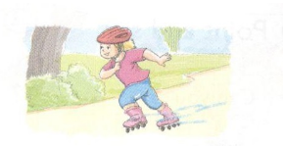  She can ____________ | 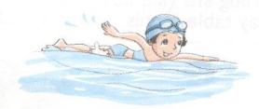  He can ____________ | 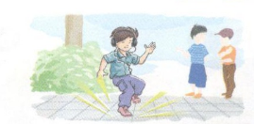  I can ____________
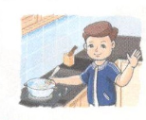  I can ____________ | 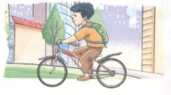  I can ____________ | 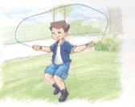  I can ____________

2.Write Yes, I can ; No, I can’t
Can you play table tennis ? Can you play volleyball ?
____________________ ____________________
Can you play the piano ? Can you play guitar ?
____________________ ____________________
Can you swim ? Can you skip ?
____________________ ____________________
3.Look and read . Choose yes or no
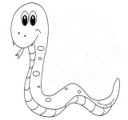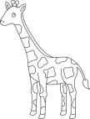  1  2  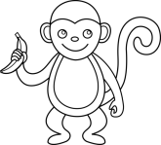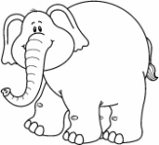  3  4  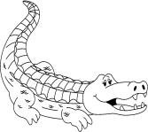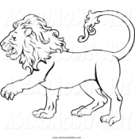  6  5 | Yes No  1. Can a snake run ?  2. Can a giraffe fly ?  3.Can a monkey climb?  4.Can an elephant walk ?  5.Can an alligator swim?  6.Can a lion fly ?

4.Look at the pictures and complete the sentences with can/can’t and a verb.
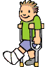  1 | 2 | 3 | 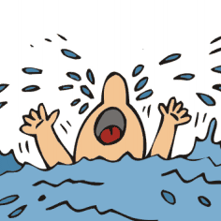  4
5 | 6 | 7 | 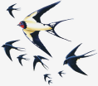  8
1.He can’t run. 5. They ___________________
2.It _______________________ 6. She __________________
3.She ______________________ 7. He __________________
4.He _______________________ 8. They ____________________
5.Odd one out:
- a. table tennis b. football c. guitar d. volleyball
- a. dog b. cat c. fish d. pig
- a. swim b. book c. cook d. skate
- a. father b. teacher c. mother d. sister
- a. have b. goes c. swim d. sing
- a. play b. kites c. guitar d. piano
- a. June b. Sunday c. July d. September
- a. what b. when c. who d. Wednesday
- a. your b. you c. he d. she
- a. Vietnamese b. England c. Japan d. America
- a. badminton b. football c. sing d. basketball
- a. song b. chess c. piano d. guitar
- a. name b. sing c. nationality d. day
14.a. nice b. big c. read d. small

15.a. old b. young c. beautiful d. cannot
6.Choose the best answer:
1.Odd one out:
A.cook B. skip C. can D. swim
2.I can _____ a cat. A. swim B. skate C. draw D. dance
3.What _____ you do? A. are B. can C. about D. is
4.I can’t dance, ____ I can sing. A. but B. and C. can D. x
5.Can you play _______? A. table B. the guitar C. a cat D. a bike
6.Phong can _____ a bike. A. skate B. play C. cook D. ride
7.Can you swim? _________________.
A.Yes, I can’t B. No, I can’t C. Yes, you can D. No, she can’t
8.What can you do? ___________________.
A.I can’t skip B. She can cook C. I can play chess D. Yes, he can.
7.Circle “Yes” or “No”
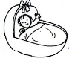 a.She can write . | Yes | No
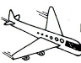b. It can fly. | Yes | No
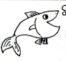 c.It can swim. | Yes | No
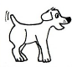 d.It can sing. | Yes | No
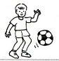 e.He can play football. | Yes | No

8.Match
1.What can you do ? | - Yes,it can.
2.Can you swim ? | - She can sing and dance.
3.Can he cook ? | - Yes,I can.
4.What can he do ? | - No, she can’t.
5.Can she sing ? | - Yes, he can .
6.What can she do ? | - He can draw.
7.Can it run ? | - I can cook.
9.Reorder the words to make sentences
1.Can/ sing ?/you / ____________________________________________________
2.Yes. / can/I//______________________________________________________
3.he/Can /dance ?/_____________________________________________________
4.he/can’t/No./________________________________________________________
5.sing./She /can’t/______________________________________________________
6.John /swim. /can /_____________________________________________________
7.she /Can /run ?/______________________________________________________
8.can /she /Yes./ _______________________________________________________
9.Alex/ draw/ can/______________________________________________________
10.Look at the pictures and answer the questions
Can they cook ?  ___________ | Can she sing ?  ___________ | 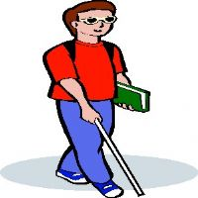  Can he see ?  ___________ | 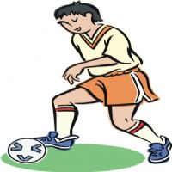  Can he play football ?  _______________ | Can she draw?  ___________

