Are they your friends ?
1.Cirlce a , b or c.
1.This is Tony . ____________is my friend. a.He b.She c. It
2.That is Miss Hien .
____________is our teacher . . a.He b.She c. They
3.This is Mai and this is Nam.
_________________are my friends . a. She b.They c.He
4.Are Quan and Phng your friends ?
Yes, _____________. a.they are b.they aren’t c. It is
5._________________are they ?
They are my friends . a. What b.How c. Who
am is are
2.Read and write
1.Hello . My name is Mary . I ________a girl.
2.How old ___________you ?
3.This is Mr Loc. He __________my teacher.
4.That is Mia. She ____________my friend.
5.This is my cat. It ____________two years old.
6.We ____________pupils.
7.This is Miss Hien and that is Mr Loc.They _________my teachers.
3.Order the words to make the sentences.
a.My /is /name /Peter./ __________________________
b.I / ten/am old ./years/ __________________________
c.is/This / Tony./ _______________________________
d.friends./They/are/my/ _________________________
e.to/Nice/meet/you./ ____________________________
f.Sally/That /is / ____________________________
g.you/How /do/name?/ spell / your/ ____________________________
4. Write the pronouns
I you he she it it they they

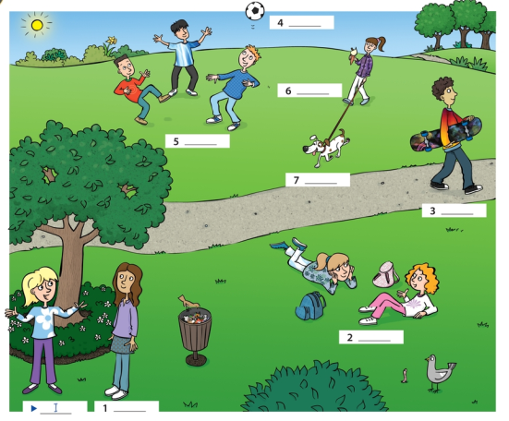

5.Put the words in the right columns
Mary ten hi who Peter what how old hello
Seven Tony eight how six bye Linda Goodbye
Name | Number | Questions | Greeting/  Saying Goobye
Mary | ten | who | hi

