Are there any posters in the room?
1.Make sentences using the words given. Example:
• There/ three/ book/ on/ table. → There are three books on the table
• There/ a/ chair/ near/ desk. → There is a chair near the desk.
1.There/ two/ map/ wall. ___________________________________
2.There/ a/ television/ on/ table. __________________________________
3.There/ three/ bedroom/ in/ my house. _____________________________
4.There/ a/ lamp/ on/ table. ______________________________________
5.There/ five/ pencil/ in/ pencil box. ________________________________
6.There/ five/ room/ in/ my house. _________________________________
7.There/ twenty/ student/ in/ my class. _____________________________
2.Make and answer the questions.Example:
there/ book/ in/ schoolbag/ ? / Yes
Are there any books in the schoolbag?
Yes, there are.
there / sofa/ in/ living room/ ? / No
Are there any sofas in the living room?
No, there aren’t.
1.There/ wardrobe/ in/ bedroom/ ? / No
___________________________________________________
2.There/ cupboard/ in/ dining room/ ? / No
___________________________________________________
3.There/ picture/ in/ bedroom/ ? / Yes
___________________________________________________
4.There/ lamp/ on/ table/ ? / Yes
___________________________________________________
5.There/ bed/ in/ kitchen/ ? / No
___________________________________________________
3.Make and answer the questions:
Example:
• cupboard/ in/ kitchen/ ? / 1 =) How many cupboards are there in the kitchen? There is one.
• student/ in/ class/ ?/ 30 =) How many students are there in the class?
There are thirty.
- coat/ in/ wardrobe/ ? / - 15
-------------------------------------------------------
-------------------------------------------------------
2. picture/ on/ wall/ ? / - 4
-------------------------------------------------------
-------------------------------------------------------
3. fan/ in/ living room/ ? / - 3
-------------------------------------------------------
-------------------------------------------------------
4. window/ in/ bedroom/ ? / - 2
-------------------------------------------------------
-------------------------------------------------------
5. chair/ in/ living room/ ? / - 6
-------------------------------------------------------
-------------------------------------------------------
4.Read and answer the questions:
This is my living room. There are many things in the room. There are three windows and one door. There is a sofa, a desk, six chairs. There is two lamps on the desk and a TV on the cupboard. There are five pictures and one fan on the wall.
- How many windows are there? ________________________________________
- How many chairs are there? _________________________________________
- How many pictures are there?______________________________________
- How many fans are there? _________________________________________

5.Look the picture and answer the questions
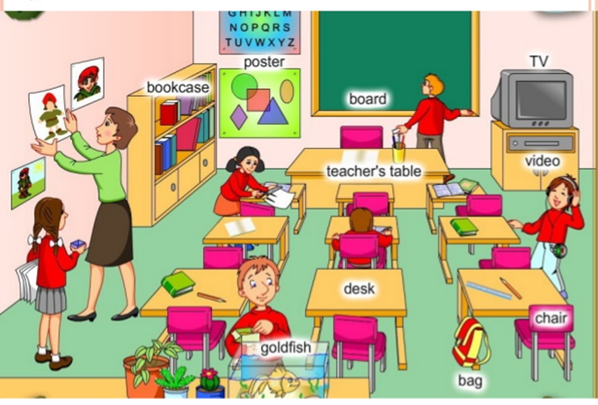

1.How many teachers are there in the classroom ? There is a teacher in the classroom.
2.How many boys are there in the classroom ?
_____________________________________
3.How many girls are there in the classroom ?
_____________________________________
4.How many bookcases are there in the classroom ?
_______________________________________
5.How many chairs are there in the classroom ?
_______________________________________
6.How many televisons are there in the classroom ?
_______________________________________
8.How many desks are there in the classroom ?
____________________________________________
9.How many pictures are there on the wall ?
___________________________________________
6.Match the words with right images , by writing the correct number inside the circle.
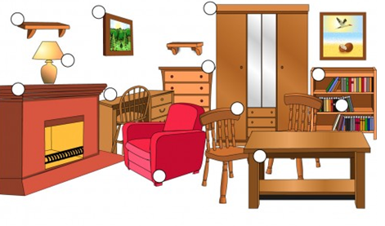
1.armchair
2.table
3.shelf
4.painting
5.lamp
6.drawers
7.wardrobe
8.desk
9.bookcase
11 .books
12 fireplace
12 chair

Write the sentences with “there is “/ “there are” using the words above.
- There is an armchair in the room.
- There ______________________________________________________
- There ______________________________________________________
- There ______________________________________________________
- There ______________________________________________________
- There ______________________________________________________
- There ______________________________________________________
- There ______________________________________________________
- There ______________________________________________________
- There ______________________________________________________
- There ______________________________________________________
- There _____________________________________________________
7.Look at the pictures and circle the options.
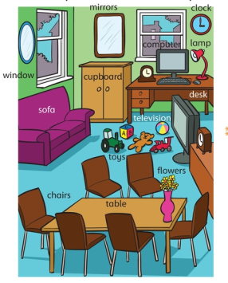

There’s / There isn’t a sofa.
There’s / There isn’t a desk.
There are / There aren’t some flowers.
There’s / There isn’t a guitar.
There are / There aren’t any books.
There’s / There isn’t a phone.
There are / There aren’t two mirrors.
There are / There aren’t some toys.
There’s / There isn’t a ball.

8.Look at the picture . Circle the question word and write the short answer.
Is / there any books?
Y es,there are.
1.Is /Are there a phone ?
________,there ___________.
2.Is /Are there a banana?
________,there ___________.
3.Is /Are there any penicls ?
________,there ___________.
4.Is /Are there a ruler?
________,there ___________.
5.Is /Are there any apples?
________,there ___________.

Are
