Đề thi Violympic Toán Tiếng Anh lớp 2 vòng 7 năm 2015 - 2016

Exam number 1: Arrangement (Choose the increasing values)
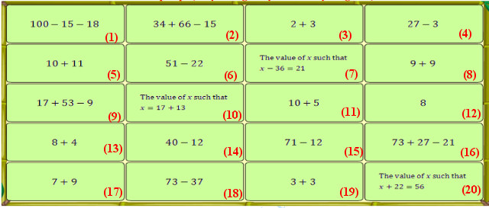

Exam number 2:
Question 1: How much is one half of twenty strawberries?

a. Ten strawberries
b. Twelve strawberries
c. Nine strawberries
d. Eleven strawberries
Question 2: Choose the expression that results in the same sum as: 17 + 53

a. 23 + 47 b. 32 + 41

c. 19 + 55 d. 27 + 45
Question 3: Find the length of the line segment AD.

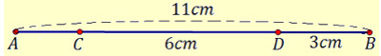
a. AD = 8cm b. AD = 5cm

c. AD = 9cm d. AD = 11cm
Question 4: What time is shown?
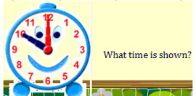
a. 11:00 b. 9:00 c. 12:00 d. 10:00
Question 5: There are twenty five apples, eighteen oranges; twelve kiwis and seventeen tomatoes. How many more apples than tomatoes are there?

a. 5 b. 13 c. 7 d. 8
Question 6: Which of the following equations is true?

a. 57 = 32 + 18 + 3 b. 74 = 22 + 17 + 35
c. 67 = 98 − 37 + 3 83 = 37 + 49 − 12
Question 7: Which shape has the most sides?
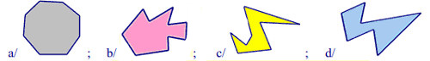

a. Shape a b. Shape b c. Shape c d. Shape d
Question 8:Which the following result is greater than 73?

a. 47 + 9 + 13
b. 23 + 31 + 25
c. 37 + 11 + 23
d. 41 + 17 + 15
Question 9: Which number is nineteen less than forty five?

a. Twenty four b. Thirty nine
c. Twenty six d. Thirty four
Question 10: Which month comes just November?

a. SEPTEMBER b. OCTOBER

c. DECEMBER d. JANUARY
Exam number 3: Fill in the blank with the suitable number
Question 1: Jenny bought pears for her parents, two sisters, three friends and herself, for one each. How many pears did she buy?

Question 2: Tom picked twelve flowers, Mia picked fourteen flowers and Anna picked fifteen flowers. How many flowers did they picked in total?

Question 3: Find the sum of the digits of the number
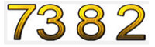
Question 4:
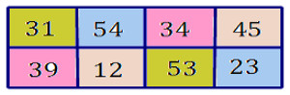
How many numbers are there that are smaller than 39?

Question 5: How many triangles are there in the following figure?

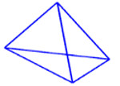
Question 6:
Find the sum x + y + z

Question 7:
How many different letters are there in the following word?

Question 8: Mary had twenty nine eggs. She used some of them for five birthday cakes so that only nineteen were left. How many eggs did she use?
Question 9: Find the suitable number in the following blank.
37 + 62 = .......... + 59

Question 10:
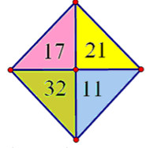
Find the sum of these numbers.

Đáp án

Exam number 1: Arrangement
(3) < (19) < (12) < (13) < (11) < (17) < (8) < (5) < (4) < (14) < (6) < (10) < (20) < (18) < (7) < (15) < (9) < (1) < (16) < (2)
Exam number 2:
1: a
2: a
3: a
4: d
5: d
6: b
7: b
8: b
9: c
10: c
Exam number 3: Fill in the blank with the suitable number
1: 8
2: 41
3: 20
4: 4
5: 8
6: 67
7: 10
8: 10
9: 40
10: 81

