SỞ GD&ĐT BÌNH DƯƠNG  Trường Tiểu học Dầu Tiếng  ----------------- |  | ĐỀ THI HỌC KỲ 1  NĂM HỌC 2014 - 2015  MÔN: TIẾNG ANH - LỚP 2  Thời gian làm bài: 35 phút
Class: ____________________  School: ___________________ | Student’s name: __________________________ |  | Scores:  _______________
I. Fill in the blank: (2points)
chicken soup noodles hungry

1. I’m ___________.

2. Have some ___________. | 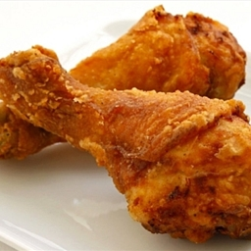
3. Have some ___________. | 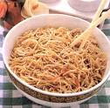
4. Have some ___________. | 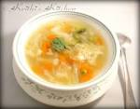
II. Circle: (2points)
5. pillow bear blanket soup
6. candy wet cold hot
7. police officer farmer sunny doctor
8. chicken green soup noodles
III. Check the correct sentence: (3points)
 | 9.  It’s raining.  It’s sunny. | 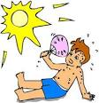 | 10.  I’m hot.  I’m cold.
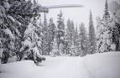 | 11.  It’s raining.  It’s snowing. |  | 12.  I’m cold.  I’m wet.
 | 13.  It’s snowing.  It’s sunny. | 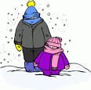 | 14.  I’m wet.  I’m cold.
IV. Multiple choice: (3points)
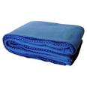 | 15. That’s my______.  A. blanket  B. pillow  C. bear |  | 16. No! It’s my_______.  A. bear  B. blanket  C. pillow
 | 17. She’s a ________.  A. farmer  B. doctor  C. police officer |  | 18. He’s a _________.  A. police officer  B. farmer  C. doctor
 | 19. I want ________.  A. candy  B. chips  C. ice cream |  | 20. I want ________.  A. ice cream  B. candy  C. chips

GOOD LUCK!

ĐÁP ÁN ĐỀ THI HỌC KỲ 1 MÔN TIẾNG ANH LỚP 2
I. Fill in the blank: (2points)
1. hungry 2. chicken
3. noodle 4. soup
II. Circle: (2points)
5. soup 6. candy
7. sunny 8. green
III. Check the correct sentence: (3points)
9. It’s raining. 10. I’m hot.
11. It’s snowing. 12. I’m wet.
13. It’s sunny. 14. I’m cold.
IV. Multiple choice: (3points)
15. A 16. C
17. B 18. A
19. C 20. B

